Ameren Illinois Company
2023 Business Program Impact Evaluation Report
Appendix d: Custom Initiative Project Reports

Draft
March 15, 2024
Contents

Appendix D. Custom Initiative Project Reports 3
Project 2200053 3
Project 2300016 11
Project 2300113 17
Project 2300603 20
Project 2300014 26
Project 2201213 30
Project 2200603 33
Project 2200412 45

- Custom Initiative Project Reports
In this section, we present detailed project-level desk review, remote measurement and verification (M&V), and on-site M&V reports for 8 Custom Initiative projects evaluated as part of the 2022 Business Program impact evaluation.

Project 2200053
Project ID#: | 2200053
Measure: | HVAC Controls Upgrades
Savings: | 1,027,367 kWh; 0.0 kW; 53,620 therms
Facility Type: | Medical
End Use: | HVAC
Sampled For: | Electric and Gas
Wave: | 3

Measure Description
This project was completed at a 1,991,944 square foot (sf) healthcare facility. The project included upgrades to fourteen air handling units (AHUs). Eleven AHUs were upgraded from constant speed to variable-frequency drive (VFD) supply and/or return fans. Ten AHUs were upgraded from direct digital controls (DDC) systems to a unified automatic logic DDC system. Four of these ten AHUs were scheduled for discharge air temperature (DAT) resets. One of these four AHUs was also scheduled for a variable air volume (VAV) box air flow reset.
The installation of VFDs is expected to result in energy savings from reductions in fan speeds and gas savings from reduced reheat demand. The DAT reset controls and VAV box air flow reset controls are expected to yield energy savings from reduced cooling coil load and gas savings from reduced heating coil loads.
The project was completed on March 31, 2023.

Key Findings
The evaluation team made multiple changes to the AHU workbooks due to uncertainty about which measures were implemented for each AHU. Additional corrections were made to several workbooks for unit conversion errors. Finally, corrections were made to several AHU workbooks that did not use the appropriate baseline assumptions based on equipment configurations prior to the project.
This project was subject to an early review, and the evaluation team made one change that was recommended during the early review in the verified savings analysis. This change pertains to how the fan energy use is calculated in the bin analysis.
The resulting realization rate for energy usage (kWh) is based on the claimed ex ante savings, which apply an HVAC capping tool. The realization rate between the verified energy usage savings and the un-capped savings is 68% for electric energy. The resulting project savings are shown in Table 1.
Table 1. Summary of Project 2200053 Savings
 | kW | kWh | Therms
Ex Anteª | 0.0 | 1,027,367 | 53,620
Verified | 0.0 | 891,408 | 45,809
Realization Rate | N/A | 87% | 85%
ª Ex ante electric savings are calculated as 1,303,777 kWh prior to HVAC capping.

Summary of the Ex Ante Calculations
To determine the ex ante savings for this project, the implementation team performed calculations in multiple Excel-based workbooks. All calculations include outside air temperatures in 1ºF bins and hours of the day in 1-hour bins. The savings were calculated based on a combination of modeled profiles for loads, temperature resets, ventilation flow rates, hard-coded assumed values, equipment-specific size inputs, and other project details.
The blue shaded cells in Table 2 indicate where the evaluation team could not confirm whether a measure was implemented on a particular AHU. This designation is based on a mismatch between the Scope of Work (SOW), each AHU’s calculation workbook, and the post-install inspection report. The evaluation team was unable to speak to the site contact to seek clarification on the SOW for each AHU. Ex ante savings were inclusive of all measures marked as yes.
Table 2. Summary of Ex Ante AHU Energy Savings Measures
AHU Number | Unified DDC | Supply Fan VFD | Return Fan VFD | VAV Reduction | DAT Reset
1 | Yes | No | Yes | Yes | Yes
2 | Yes | Yes | Yes | Yes | Yes
3 | No | Yes | Yes | No | No
4 | No | Yes | Yes | No | No
7 | Yes | Yes | Yes | No | Yes
8 | Yes | Yes | Yes | No | Yes
9 | Yes | Yes | Yes | No | Yes
10 | Yes | Yes | Yes | No | Yes
11 | No | Yes | No | No | Yes
12 | No | Yes | Yes | No | No
18 | Yes | Yes | Yes | No | Yes
19 | Yes | Yes | Yes | No | Yes
20 | Yes | Yes | Yes | No | Yes
89 | Yes | No | No | Yes | Yes

A summary of the ex ante energy usage (kWh) for each AHU is presented in Table 3. A summary of the ex ante gas usage (therms) for each AHU is presented in Table 4.
Table 3. Summary of Ex Ante AHU Energy (kWh) Savings
AHU Number | Baseline Energy Usage (kWh) | Post-case Energy Usage (kWh) | Energy Savings (kWh)
1 | 238,835 | 150,444 | 87,491
2 | 449,662 | 303,791 | 145,871
3 | 834,723 | 713,219 | 121,504
4 | 335,584 | 277,620 | 57,964
7 | 456,898 | 333,390 | 123,508
8 | 376,426 | 295,664 | 80,762
9 | 614,845 | 490,321 | 124,524
10 | 171,984 | 123,146 | 48,838
11 | 166,750 | 134,519 | 32,231
12 | 506,049 | 423,009 | 83,040
18 | 267,121 | 146,093 | 121,028
19 | 201,438 | 105,952 | 95,486
20 | 156,816 | 107,978 | 48,838
89 | 209,096 | 76,853 | 132,243
Uncapped Total | 4,985,777 | 3,682,000 | 1,303,777
Ex Ante Total |  |  | 1,027,367
Table 4. Summary of Ex Ante AHU Energy (kWh) Savings
AHU Number | Baseline Gas Usage (Therms) | Post-case Gas Usage (Therms) | Gas Savings (Therms)
1 | 21,450 | 14,739 | 6,711
2 | 45,372 | 36,297 | 9,074
3 | 58,002 | 52,202 | 5,800
4 | 28,799 | 25,920 | 2,880
7 | 54,119 | 46,001 | 8,118
8 | 18,415 | 16,573 | 1,842
9 | 31,452 | 28,307 | 3,145
10 | 11,238 | 9,553 | 1,685
11 | 16,025 | 14,423 | 1,602
12 | 1,432 | 1,289 | 143
18 | 19,013 | 17,913 | 1,100
19 | 22,762 | 18,857 | 3,905
20 | 20,768 | 17,610 | 3,158
89 | 7,464 | 3,007 | 4,457
Ex Ante Total | 356,311 | 302,692 | 53,620

Early Review Notes
We note that this project was subject to an early review prior to authorization. Our early review comments included the following:
- The evaluation team recommends documenting the existing control system’s remaining useful life. While adding VFDs and kitchen hood controls is beyond the functionality of the existing controls and therefore most certainly qualifies for incentives, the evaluation team notes that additional controls measures may be ineligible (or potentially have their savings negatively impacted in future evaluation) if the existing controls are beyond the current effective useful life of 15 years for building automation systems. For example, savings are proposed for AHU 20 which currently has pneumatic controls. In this case, the evaluation team would use code-compliant controls as the baseline if the pneumatic controls were beyond their useful life. In many instances using code-compliant controls as the baseline significantly reduces savings in an evaluation, with the potential for zeroing out, if the installed controls are not beyond code compliance.
  - Implementer Response: Existing control system was not at end of service life or failing/needing replacement, so using existing controls and usage as the baseline scenario seems appropriate in this scenario.
  - Evaluation Finding: The evaluation team concurs with the implementer’s response.
- The vendor’s estimated savings are calculated by comparing proposed fan operation with a VFD to the existing fixed speed fans. The fan power multiplier is calculated using an exponent of 2.7 on the fan speed fraction. The evaluation team recommends verifying the calculation using Equation 1 to confirm the reasonableness of the vendor’s savings estimates.
Equation 1. Fan Power Calculation
$${HP}_{C}= {HP}_{D}{\left[\left(1-\sqrt{\frac{H_{min}}{H_{D}}}\right)*\left(\frac{F_{C}}{F_{D}}\right)+\sqrt{\frac{H_{min}}{H_{D}}}\right]}^{3}$$
  - Implementer Response: No response was provided.
  - Evaluation Finding: The evaluation team noted that this revision was not implemented in the ex ante calculations. The evaluation team revised the ex ante calculations to utilize Equation 1 for all VFD fan power calculations.
- Supply fan speeds used in the calculations are based on an assumed average fan speed. Fan speed does not vary based on loads. This will likely underestimate energy usage and/or demand at peak loading conditions and flow at higher loads due to higher cooling loads that are typically associated with higher outdoor air temperatures. It may also inaccurately estimate the heating loads when fan speeds reduce at lower outdoor air temperatures. This is a medical facility where many spaces have high air change rate requirements and larger than normal loads, so the assumption of a constant fan speed may not bear out in reality.
Because the fan speed assumptions are a critical driver of the calculations savings, the evaluation team recommends gathering at least one week of post data and building a linear fan speed model for each fan with the outdoor air temperature being the primary independent variable. These models also may need to account for time of day or other variables.
  - Implementer Response: Unfortunately, post-metering data was not agreed upon during the pre-approval process, so the engineering team cannot gather this data to build additional models. However, we can hopefully rely on the HVAC capping tool to arrive at a more conservative savings value.
  - Evaluation Finding: The evaluation team noted that the HVAC Capping Tool was utilized to provide a more conservative energy usage (kWh) savings value.
- It is not always clear to the evaluation team what type of area each piece of equipment serves. For example, there are descriptions of a “cath” lab (AHU-75) where VFDs are being installed on both the supply and return fans. However, it is not clear which calculations correspond to this unit. The evaluation team recommends using conservative values for fan speed assumptions for spaces that have large air change and positive pressure requirements as equipment serving these spaces typically do not have much margin to reduce speeds.
  - Implementer Response: This was removed from the scope, so no longer applicable.
  - Evaluation Finding: The evaluation team noted that the specified AHU (AHU-75) was removed from the project scope. However, the recommendation was not implemented for the AHUs that remained in the project scope.
- In some AHU calculations, the fan speeds are hard coded, while the VAV box positions used to calculate reheat are calculated, which creates a mismatch in system supply vs. discharge flow. These values should correspond to each other, unless “Box %” is intended to represent the number of boxes needing reheat, in which case this should be more accurately labeled.
  - Implementer Response: No response was provided.
  - Evaluation Finding: The evaluation team noted that this recommendation was not implemented in the ex ante calculations. AHUs-19 and 89 calculated fan speed based on their respective VAV box damper position. All other AHUs used hard-coded fan speeds to calculate reheat and fan energy usage (kWh).
- The scope of work and summary workbook describe 16 AHUs with new controls being installed, but calculations for 17 units were provided. It’s not clear to the evaluation team which equipment serves which spaces. We are unclear whether the extra calculation should be included in the savings.
  - Implementer Response: Scope has been reconciled and summarized in a file. Unfortunately, the customer did not pursue all measures in the scope, so there are some excess calculation files now.
  - Evaluation Finding: The evaluation team concurs with the implementer’s response. The final project scope included (14) AHUs.
- The evaluation team notes that several AHU calculations have space cooling savings in excess of 50% of the calculated cooling end-use baseline (e.g. AHU 18). The evaluation team notes a few potential issues that should be either modified or properly documented with evidence.
  - The economizers in the baseline case only seem to take full effect around 45ºF outside air temperatures (OAT), while the economizers in the proposed case seem to take full effect around 55ºF OAT. It is unclear to the evaluation team how this project impacts the economizer functionality or why the economizer calculations differ.
    - Implementer Response: No response was provided.
    - Evaluation Finding: The evaluation team noted that economizer data were removed from all baseline AHU calculations. However, all but one new AHU calculation included economizer effects. There is no mention of economizers in the scope of work or post-inspection report. Because of this, the evaluation team removed economizer effects from the proposed case for AHUs-1, 2, 3, 4, 7, 8, 9, 10, 11, 18, 19, and 20.
  - Return air temperatures are assumed to be 80ºF. While this may be an appropriate assumption for assisted living spaces where patients tend to prefer warmer spaces, it is unlikely to be appropriate for a majority of spaces in the hospital. In cases where 80ºF is an appropriate assumption for return temperatures, it is unlikely those spaces would be provided 55ºF air all year when dehumidification is not needed, so this apparent discrepancy should be addressed or explained. This large temperature differential creates what appear to be artificially high loads.
    - Implementer Response: RAT values were back-calculated from values provided in the baseline BAS Data screenshot, which shows 55ºF setpoints in their system.
    - Evaluation Finding: The evaluation team was unable to speak to the site contact. Thus, it is unknown whether the implementer’s response is accurate.
- The scope of work does not always align with the controls calculations. For example, the scope of work for Gerlach AHU-1 is described as just adding a VFD to the return fan, but the calculation includes savings for changes to the supply air temperature setpoints. The evaluation team is unsure if this is intentional or due to reusing a template calculation and not updating the inputs properly. The evaluation team recommends confirming the scope of work and ensuring it aligns with the calculations.
  - Implementer Response: Scope includes adding ALC controls as well as a VFD to Gerlach AHU-1.
  - Evaluation Finding: The evaluation team noted that there are multiple discrepancies between the individual AHU calculations, the post-install inspection report, and the scope of work. Specifically, the controls calculations and post-install inspection report do not match the scope of work for AHUs-1, 2, 7, 8, 9, 10, 11, and 18.
- The custom workbook calculated capped savings for electricity that are about 73% of the values claimed by the calculations. However, it appears the capped savings value was not used. In the past, capping savings from HVAC controls measures has been a good evaluation risk mitigation strategy.
  - Implementer Response: Savings are also capped accordingly based on the HVAC capping tool.
  - Evaluation Finding: The implementer’s response is accurate.
- The calculation workbook mentions “screenshots in the back tab”, but the evaluation team does not see those screenshots.
  - Implementer Response: There are screenshots in the last tab within some of the AHU calculation files; however, these are not included in every single one.
  - Evaluation Finding: The implementer’s response is accurate. It is not clear why some AHU calculations include the screenshots while others do not.
- The calculations assume the new controls often will allow minimum VAV setpoints to be reduced from 50% to 30%. The evaluation team is unclear about how this project will allow that change. Are the controls being replaced at the VAV box level as well? Are there any changes happening in the spaces? Is this reduction only applied when proper ventilation rates are being maintained? The evaluation team recommends documenting existing controls and new controls in spaces where savings are being claimed for this measure.
  - Implementer Response: TR requested that this be verified during the post-install inspection. EA/inspector was able to verify
  - Evaluation Finding: The implementer’s response is not complete. The evaluation team noted that the post-install inspection report verified that AHUs-1, 2, 7, 8, 9, 10, 18, 19, 20, and 89 were upgraded to “HVAC (ALC) controls… with DAT resets,” and that minimum VAV air flow for AHU-89 was 30%. The inspector also verified that “(24) VFDs were also installed/operating on… AHUs-2, 3, 4, 7, 8, 9, 10, 11, 12, 18, 19, and 20.”
- In cases where a VFD is installed on the return fan where the supply fan currently has a VFD, the effect on equipment in the same system is not considered. The evaluation team does not believe the calculations consider the impact of the return fan VFD on things like the supply fan speed (will the supply fan need to pick up more of the load to move the air?) or building exhaust and outdoor air intake levels. With reduced return fan speeds, either less air is being exhausted (and therefore made up) or the mixed air chamber is less pressurized, which requires increased supply fan speeds. These impacts do not appear to be considered and may have some impact on savings.
  - Implementer Response: This applies to Gerlach AHU-1, which had a VFD on the supply fan, not the return fan. The remaining AHUs did not have any VFDs on the SA/RA fans. Although there may be some impact on savings, I believe this consideration would be minimal as it applies to 1 of the 14 AHUs and contributes a relatively small amount towards total savings. Additionally, capping the savings based on the HVAC capping tool may be a good risk mitigation strategy.
  - Evaluation Finding: The implementer’s response is accurate, but the recommendation was not implemented in the ex ante calculations. This early review comment may also apply to AHU-11, although it is unclear as the calculations for AHU-11 do not match the scope of work and post-install inspection report.

Summary of the Verified Calculations
The evaluation team reviewed the ex ante calculations to ensure the implementation team made the recommended revisions in the early review. It was found that not all of the recommendations were implemented in the ex ante calculations. In response, the evaluation team made the following updates relating to the early review findings and recommendations. The evaluation team updated each AHU workbook to utilize Equation 1 to calculate the VFD supply and return fan power at the speeds assumed by the implementers. AHU-1 had an existing supply fan VFD that the implementation team did not account for in the ex ante calculations. The verified calculations updated the baseline VFD supply fan speed and power utilizing Equation 1. The economizing effects were removed from the proposed case for AHUs-1, 2, 3, 4, 7, 8, 9, 10, 11, 18, 19, and 20.
The ex ante calculations for AHUs 8, 9, 10, and 89 did not include an efficiency factor when converting their respective supply and return fans from mechanical power (horsepower) to electrical power (kW). The verified calculations added an assumed efficiency factor to each fan power equation.
Additional changes were made in the workbooks for AHUs-1, 2, 3, 4, 7, 8, 9, 10, 11, 18, 19, and 20 due to the uncertainty over which measures were implemented for each AHU. The evaluation team accepted as verified, measures that were corroborated in the measure summary, from which ex ante savings were calculated, the SOW, which captured the project’s expected measures, and the post-installation inspection report, which entails the implementation team’s observations. Measures that were in one but not the others, were removed from verified savings, in part because we were unable to reach the customer to independently verify the full scope of measures implemented.
The post-installation inspection report stated that a DAT reset was completed for AHUs-1, 2, 7, 8, 9, 10, 18, 19, 20, and 89. The measure summary stated that only AHUs-18, 19, 20, and 89 were scheduled for DAT resets. The verified calculations removed the DAT reset measure from the workbooks for AHUs-1, 2, 7, 8, 9, and 10.
The measure summary stated that a VAV damper reduction measure would be implemented for AHUs-1, 2, and 89. The post-installation inspection report stated that only AHU-89 had this measure implemented. The verified calculations removed the VAV damper reduction measure from the workbooks for AHU-1 and AHU-2.
Finally, the measure summary and post-installation inspection report both stated that VFD supply and return fans would be installed on AHU-18. The SOW stated that AHU-18 already had VFD supply and return fans. The verified calculations updated the baseline supply and return fan calculations with an assumed speed. Each fan’s power was calculated using Equation 1.
A summary of the verified energy usage (kWh) for each AHU is presented in Table 5. A summary of the verified gas usage (therms) for each AHU is presented in Table 6.
Table 5. Summary of Verified AHU Energy Savings Compared to Ex Ante Electric Savings (kWh)
AHU Number | Ex Ante Energy Savings (kWh) | Verified Baseline Energy Usage (kWh) | Verified New Energy Usage (kWh) | Verified Energy Savings (kWh) | Realization Rate
1 | 87,941 | 283,326 | 256,468 | 26,857 | 31%
2 | 145,871 | 449,662 | 338,389 | 111,273 | 76%
3 | 121,504 | 834,723 | 737,001 | 97,722 | 80%
4 | 57,964 | 335,584 | 293,344 | 42,240 | 73%
7 | 123,508 | 456,898 | 366,411 | 90,487 | 73%
8 | 80,762 | 427,983 | 368,611 | 59,372 | 74%
9 | 124,524 | 690,220 | 597,047 | 93,172 | 75%
10 | 48,838 | 194,662 | 155,010 | 39,652 | 81%
11 | 32,231 | 166,750 | 145,582 | 21,168 | 66%
12 | 83,040 | 506,049 | 441,599 | 64,450 | 78%
18 | 121,028 | 235,320 | 235,320 | 0 | 0%
19 | 95,486 | 201,438 | 117,350 | 84,088 | 88%
20 | 48,838 | 156,816 | 115,342 | 41,474 | 85%
89 | 132,243 | 218,535 | 99,083 | 119,452 | 90%
Total | 1,303,777 | 5,157,966 | 4,266,558 | 891,408 | 68%
Table 6. Summary of Verified AHU Gas Savings Compared to Ex Ante Gas Savings (Therms)
AHU Number | Ex Ante Gas Savings (Therms) | Verified Baseline Gas Usage (Therms) | Verified New Gas Usage (Therms) | Verified Gas Savings (Therms) | Realization Rate
1 | 6,711 | 21,450 | 21,450 | 0 | 0%
2 | 9,074 | 45,372 | 36,297 | 9,074 | 100%
3 | 5,800 | 58,002 | 52,202 | 5,800 | 100%
4 | 2,880 | 28,799 | 25,920 | 2,880 | 100%
7 | 8,118 | 54,119 | 46,001 | 8,118 | 100%
8 | 1,842 | 18,415 | 16,573 | 1,842 | 100%
9 | 3,145 | 31,452 | 28,307 | 3,145 | 100%
10 | 1,685 | 11,238 | 9,553 | 1,685 | 100%
11 | 1,602 | 16,025 | 14,423 | 1,602 | 100%
12 | 143 | 1,432 | 1,289 | 143 | 100%
18 | 1,100 | 17,112 | 17,112 | 0 | 0%
19 | 3,905 | 22,762 | 18,857 | 3,905 | 100%
20 | 3,158 | 20,768 | 17,610 | 3,158 | 100%
89 | 4,457 | 7,464 | 3,007 | 4,457 | 100%
Ex Ante Total | 53,620 | 354,410 | 308,601 | 45,809 | 85%

Project 2300016
Project ID#: | 2300016
Measure: | Electric HVAC Controls & Chilled Water Reset
Savings: | 2,077,375 kWh; 229.0 kW;
Facility Type: | Healthcare Facility
End Use: | HVAC
Sampled For: | Electric
Wave: | 3

Measure Description
A hospital is replacing its pneumatic and obsolete HVAC controls with an Automated Logic Direct Digital Controls (DDC) system. This system will add additional efficient controls on a chiller and 17 air-handling units (AHUs). The improved controls include supply air temperature (SAT) reset, static pressure (SP) reset, occupancy sensors on reheat valves and variable air volume (VAV) box dampers, scheduling of AHU operation, and chilled water temperature reset on the chiller.

Key Findings
Due to the recent implementation of the project, a regression model analysis approach, recommended in the early review, could not be completed. As an alternative to the billed regression analysis, the evaluation team requested trended data from the customer to check the functional performance of the installed controls.
The absence of functioning SAT reset controls is the most impactful finding from the project verification. The removal of these controls from the applicable savings analyses caused the savings to decrease. Additionally, most systems did not observe static pressure resets in the trended data. In some cases, the claimed VAV standby/occupancy schedules weren’t evident in the trended data provided by the customer and were also excluded from the analysis. Lastly, some reported ex ante values did not match the provided calculation files, so these discrepancies were corrected.
The total verified savings for the project can be seen in Table 7.
Table 7. Summary of Project 2300016 Savings
 | kW | kWh
Ex Ante | 229.0 | 2,077,375
Verified | 165.3 | 1,449,866
Realization Rate | 72% | 70%

Summary of the Ex Ante Calculations
The implementer used metered data collected over a few weeks to develop temperature, humidity, ventilation, and reheat curve fits that describe the current air handlers’ operation. These curve fits were applied to the typical meteorological year (TMY3) data to build individual baseline models for each unit. The proposed models were adjusted based on a control measure implemented, like SAT resets. To account for the SP resets, the implementer utilized the ‘Typical variable speed drive (VSD)’ and ‘Good SP reset VSD’ curves developed by the Department of Energy and then applied them to the baseline and proposed analyses. The implementer applied a 5-20% reduction in supply fan speed for VAV occupancy resets, depending on occupancy. The unit operation schedule changes were applied within relevant spreadsheets as well. The total annual savings from the listed measures equate to 2,006,393 kWh. The demand savings were obtained by dividing the energy savings caused by the HVAC controls measure by 8,760 hours. Doing so yields 229 kW in demand savings.
The baseline chiller curve fit was obtained based on four days of metered data. The curve fit was then applied to TMY3 data to characterize the unit’s annual operation. The energy savings are a sum of the product of the unit efficiency, hourly tons, and reset savings factor, which is based on a curve fit predicting the chiller operation during the reset. The model yields a total of 70,982 kWh in annual savings, which, combined with the savings from other measures, produces a total savings of 2,077,375 kWh. Please refer to Table 8 for savings per unit.
Table 8. Annual Energy Electric Savings per Unit
Unit Name | Baseline Energy Consumption (kWh) | Proposed Energy Consumption (kWh) | Savings (kWh)
AC-01 | 601,979 | 348,791 | 253,188
AC-02 | 470,187 | 296,061 | 174,127
AC-03 | 353,954 | 305,813 | 48,142
AC-04 | 224,751 | 198,747 | 26,004
AC-05 | 122,773 | 106,836 | 15,937
AC-06 | 251,609 | 230,138 | 21,470
AC-11 | 96,550 | 54,417 | 42,133
AC-12 | 140,432 | 52,986 | 87,446
AC-16 | 289,179 | 169,656 | 119,523
AHU-01 | 249,768 | 145,727 | 104,041
AHU-24 | 491,349 | 305,502 | 185,847
AHU-25 | 761,932 | 463,702 | 298,230
AHU-26 | 763,004 | 483,595 | 279,409
AHU-29 | 465,822 | 306,219 | 159,603
AHU-31 | 161,882 | 106,995 | 54,887
AHU-32 | 312,217 | 255,582 | 56,635
AHU-35 | 172,029 | 92,258 | 79,771
CHW | 2,600,286 | 2,529,304 | 70,982
Total | 8,529,704 | 6,452,328 | 2,077,375

Early Review Notes
We note that this project was subject to an early review prior to authorization. Our early review comments included the following:
- The evaluation team would evaluate this project using a whole-building bill regression approach given that the projected savings are more than 10% of total consumption, and this is a large control project impacting many sub-systems with interactive effects.
  - Evaluation Finding: The implementation team couldn’t recollect the metered data. Moreover, post-metering wasn’t agreed upon during pre-approval and couldn’t be requested/approved after the project was sent for review so that they couldn’t build a whole building bill regression model.
- The calculated energy consumption of the baseline is 8,836,398 kWh out of a total building consumption of 14,645,294 kWh. That means 60% of the total usage is for HVAC. HVAC end uses typically account for 30-40% of hospital building electrical consumption. That indicates that the baseline models could use some calibration to actual consumption and implies that the baseline consumption is too high, posing a risk that the savings estimate is inflated.
  - Evaluation Finding: The baseline data was metered and used before the early review, so the implementor couldn’t go back to recalibrate it.
- The metered data used to develop the baseline models for each AHU is from a very mild set of outdoor conditions. System operation during these conditions will be very different from during very warm or cold conditions, such as increased economizer operation, lower mechanical heating and cooling loads, and part load operation. It is risky to extrapolate models for year-round HVAC operation from a limited data set covering one set of seasonal conditions. System behavior is likely to be much different in other seasons.
  - Evaluation Finding: Early review comment not addressed.
- The supply fan power formulas in the AHU analysis workbooks (SFFankW columns) use the rated HP of the fan motor and directly convert it to kW using a 0.746 conversion factor. Still, they do not include motor efficiency, drive efficiency, or a load factor (or oversizing factor), as is standard practice for computing power on pumps and fans. Similarly, the return fan power formulas (RFFankW columns) use the motor HP directly without even performing the conversion to kW that is done for the supply fans. The evaluation team recommends converting the HP values to kW using the 0.746 conversion factor and applying motor efficiency, drive efficiency, and load factor assumptions. Motor efficiency values can be assumed using NEMA minimum efficiency tables for premium motors at 1,800 rpm at the appropriate HP value.
  - Evaluation Finding: The implementer applied the recommended changes to the calculation.
- To estimate the savings for static pressure reset and VAV box occupancy sensors, the ex ante AHU analyses use hard-coded assumed fan speed reductions of 10% for static pressure reset and an additional 10-15% reduction during unoccupied hours for occupancy sensors. While the occupancy sensor assumed speed reduction is conservative and reasonable without actual space occupancy data, the static pressure reset value has a high level of evaluation risk. The “VFDReference” worksheet within each AHU workbook already contains static pressure reset curves from the U.S. D.O.E. The savings for static pressure reset should be analyzed by simply switching the fan system curve from “DOE2 Typical” to “DOE2 Good SP Reset” in the pull-down list for the proposed fan analysis within each AHU workbook. This would replace the 10% across-the-board fan speed reduction assumption and is more accurate.
  - Evaluation Finding: The implementer applied the recommended changes to the calculation.
- The chilled water plant efficiency is static in all AHU calculations at 1 kW/ton, with no adjustment for loading or outdoor air conditions impacting chiller efficiency. This value is also potentially high for a larger chiller plant and should be set based on actual chiller performance data.
  - Evaluation Finding: The actual chiller performance data was unavailable, so the chiller efficiency remained at 1 kW/ton.

Summary of the Verified Calculations
The evaluation team obtained trended data from the customer and used it to analyze the savings calculations for the individual air handling units and chilled water plant controls. The SAT reset savings were accepted in cases where a reset-like behavior was observed. The implementer’s calculations show the SAT resetting based on the OAT, but the evaluation team found that the reset controls do not follow such a pattern. Likely, the supply air temperature reset is also being impacted by other factors, such as minimum ventilation rates of the individual spaces and the static pressure resets. Although the supply air temperature resets are not behaving in the same manner as was expected based on the ex ante savings analysis, it is clear that the reset controls are actively adjusting the supply air temperature throughout the day in response to system demands, sensor feedback, and control logic. Figure 1 shows an example of how the supply air temperature setpoint varies over seven days and the outdoor air temperature over the same period.
Figure 1. SAT Reset Example Data
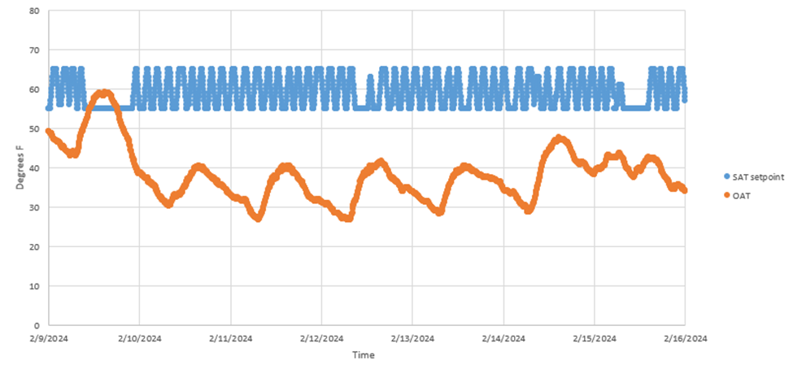
The static pressure reset savings were rejected in cases where a constant static pressure setpoint was observed. A ‘Typical’ variable speed drive (VSD) curve was used for the proposed cases, when applicable.
While the customer did not provide trended data on occupancy status, the functionality of the VAV occupancy measure was checked by analyzing the trended damper positioning for the affected VAV boxes to look for indications of the controls. If no occupancy/standby schedule is evident, the assumed percent speed reduction for the supply fan was removed.
The runtime and reheat coil operational data for each unit was not obtained. The “Reheat Occupancy” and runtime changes based on extreme OAT changes were accepted as-is. The methodology for characterizing these changes was reviewed and deemed reasonable.
As mentioned in the early review, the curve used to calculate the chilled water reset savings had a couple of outliers that could improve the fit. The outliers were removed from the plot, which did not yield a significant change in savings. The data did not include the chilled water setpoints, and the actual chilled water temperature was plotted against the OAT, refer to Figure 2.
Figure 2. Chilled Water Temperature Compared to Outdoor Air Temperature and Estimated Reset
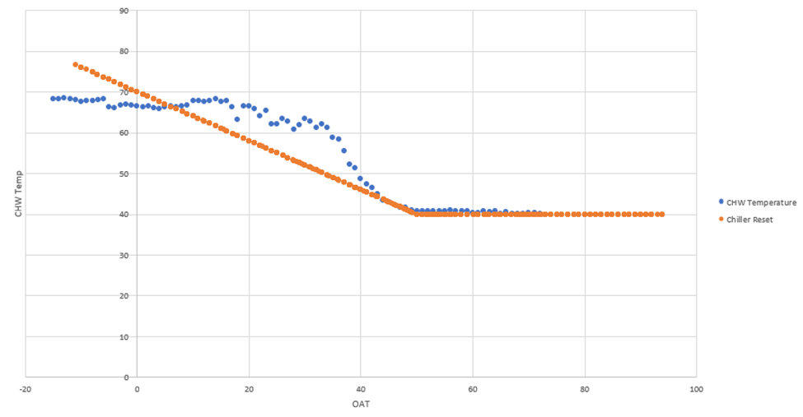
The implementer estimated the reset using a slope equation based on the expected chiller operation, specifically 46°F at 45°F OAT and 42°F at 70°F OAT. The evaluation team has adjusted the slope equation by looking at the chilled water temperatures at an OAT of 45° and 50°F, representing the OAT range where the water temperature flattens out. This equate to chilled water temperatures of 43°F and 40°F, respectively. The resulting adjustment yields 1,515 kWh in annual savings for the chilled water temperature reset controls. The savings per unit can be seen in Table 9.
Table 9. Verified Annual Electric Energy Savings per Unit
Unit Name | Baseline Energy Consumption (kWh) | Proposed Energy Consumption (kWh) | Savings (kWh)
AC-01 | 601,979 | 348,791 | 253,188
AC-02 | 470,187 | 223,834 | 246,353
AC-03 | 353,954 | 305,813 | 48,142
AC-04 | 224,751 | 224,751 | 0
AC-05 | 122,773 | 106,836 | 15,937
AC-06 | 262,073 | 240,602 | 21,471
AC-11 | 96,550 | 51,242 | 45,308
AC-12 | 140,432 | 62,635 | 77,797
AC-16 | 289,179 | 169,656 | 119,523
AHU-01 | 249,768 | 145,727 | 104,041
AHU-24 | 491,349 | 305,502 | 185,847
AHU-25 | 761,932 | 720,793 | 41,139
AHU-26 | 763,004 | 557,317 | 205,687
AHU-29 | 465,822 | 465,822 | 0
AHU-31 | 161,882 | 157,735 | 4,147
AHU-32 | 330,095 | 330,095 | 0
AHU-35 | 172,029 | 92,258 | 79,771
CHW | 2,600,286 | 2,598,771 | 1,515
Total | 8,558,045 | 7,108,180 | 1,449,866

The total savings for the project equate to 1,449,866 kWh, with a 70% realization rate. The demand savings were calculated by dividing the HVAC controls-related savings by 8,760, which results in 165.3 kW in savings, with a 72% realization rate.

Project 2300113
Project ID#: | 2300113
Measure: | Central Plant Controls Upgrade
Savings: | 484,708 kWh; 0.0 kW
Facility Type: | Education
End Use: | HVAC
Sampled For: | Electric
Wave: | 2

Measure Description
In June 2023, this customer upgraded the operating controls at a campus chiller plant. The upgraded controls allow for further optimization of the plant, primarily impacting the operation of the condenser pumps. The upgraded controls will enable the condenser flow to be actively measured. Before the measure was implemented, the pumps operated at a constant 90% speed. The savings for this project result from controls that automatically modulate the speed of the condenser pumps based on the flow measuring devices and other system inputs, which are expected to operate the pumps at an average speed of 66%. This decrease is directly correlated to a reduction in the condenser flow rate needed throughout the plant.

Key Findings
Several factors that impacted the savings were adjusted for this project. Still, the most impactful change was to the proposed energy use, which was determined based on trended data provided by the customer. The proposed energy use decreased more than anticipated, mainly because the pumps are now cycling on and off as appropriate during periods when there are low cooling loads. Hence, they have less runtime compared to the baseline. In the ex ante calculations, it was assumed that an average of three pumps would run at a reduced power state for the duration of the cooling season, but the actual pump operation was found to be less than this. This caused the post-implementation demand of the condenser water pumps to average 52 kW during the cooling season, compared to the 73 kW that was estimated in the ex ante savings analysis. In the verified savings analysis, the trended data provided by the customer showed the pumps operating an average of 63% of the days during the cooling season, compared to 75% in the ex ante analysis. This adjustment is the primary reason the verified savings exceed the ex ante savings.
The resulting project savings are shown in Table 10.
Table 10. Summary of Project 2300113 Savings
 | kW | kWh
Ex Ante | 0.0 | 484,708
Verified | 0.0 | 589,681
Realization Rate | N/A | 122%

Summary of the Ex Ante Calculations
The ex ante savings were determined by taking the difference in energy consumption between the baseline and the proposed case. The energy consumption of the condensate pumps was calculated by multiplying the power draw by the total operating hours, as shown in Equation 2. The baseline and proposed power draw were found by dividing the input power, at a given speed, by the efficiencies of the motor and the VFD. Input power was found using a multi-speed pump performance curve. The difference between the calculations in both cases is the VFD speed. The baseline case assumes a constant 90% speed, while the proposed case assumes an average reduced operating speed of 66%. Three of the four condenser water pumps are expected to operate at any given time, and at these speeds, the performance curves show the expected input power to be 55.90 kW and 24.28 kW, respectively, for each pump.
Equation 2. Pump Energy Consumption
$$Pump Energy Consumption=\left(\frac{Input Power}{Eff_{Motor}× Eff_{VFD}}\right)×Operating Hours$$
Table 11 summarizes the ex ante savings calculations for this project.
Table 11. Summary of Savings Calculations
 | Value | Units
Baseline Demand | 167.69 | kW
Proposed Demand | 72.83 | kW
Annual Operating Time | 5,110 | Hours
Baseline Annual Energy Use | 856,889 | kWh
Proposed Annual Energy Use | 372,182 | kWh

Measurement and Verification Plan
To verify key parameters used throughout the ex ante calculations, the evaluation team will request condenser pump trended data from the customer for the past year. If the customer has trended data that spans even further back than one year and includes additional data prior to the completion of the project, that will also be requested. The trended points of greatest importance include VFD speed and pump electrical demand (kW). If trended data of electrical demand isn’t available, the customer will be asked if any trended data of current (Amps), Voltage, and Power Factor are available. Data points such as flow rate and pressure may be helpful in further characterizing the operation of the pumps and will also be requested if available. The evaluation team intends to use the trended data to confirm or update the energy analysis for the baseline and proposed cases. Additionally, if a sufficient duration of trended data is available, the data will be used to verify the annual operating hours of the pumps. If only short-term data is available, estimates will be made to determine the yearly operating hours and the average VFD speed post-upgrade.
If the requested trended data cannot be sourced, the customer will be asked to confirm some of the details and assumptions from the ex ante savings analysis, including the baseline pump speed and the average post-case speed, the number of pumps that operate at a time (and how much it varies), and what months of the year the pumps are typically operating.

Summary of the Verified Calculations
The verified savings analysis was performed using VFD speed trended data for all four condenser pump motors. The VFD speeds were tracked over a 7-month period from the end of May 2023 to the start of January 2024 in 12-minute increments. Additionally, a 7-month cooling season was assumed throughout the calculations as estimated by the customer.
The trended data provided by the customer did not include sufficient data before the project started to confirm the baseline operating profile. Still, the customer confirmed most of the details and assumptions in the ex ante baseline energy use analysis. The methodology used in the ex ante calculations to determine baseline energy use was deemed reasonable, and no adjustments were made to the baseline energy calculations.
The proposed energy use was calculated using a regression analysis relating daily average electrical demand to outside air temperature. When outdoor air temperatures are below 40ºF, the pumps were shown to operate at a constant low speed, so the regression was developed for all days with daily average temperatures above 40ºF. The resulting regression is shown in Figure 3.
Figure 3. Average Daily Pump Demand Regression
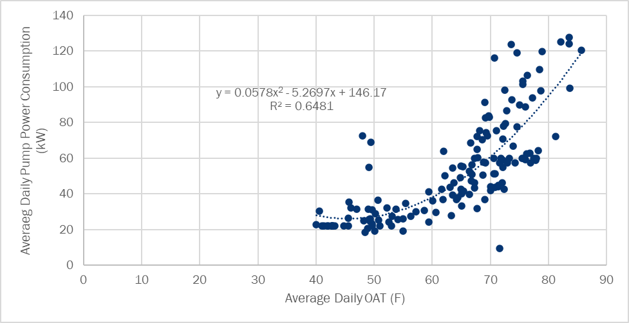
This regression was applied to TMY3 weather data to determine the weather-normalized energy consumption of the condenser water pumps with the new controls. For days below 40ºF OAT, the demand of the pumps at low-speed operation was used, which is 22.1 kW. The average demand of the pumps across the 7-month cooling season, from May 1st through November 30th, was then multiplied by 5,112 hours (the number of hours in the 7-month cooling season) to determine the verified post-case energy use of the pumps. The difference between the annual baseline energy use and the verified post-case energy use is the verified savings for this project.
The verified savings analysis shows that the pumps would average a total electrical demand of 52.3 kW across a typical meteorological year. The trended data provided by the customer indicates that during the post-implementation period from July 1 through the end of November, each pump ran on 64% of the days.

Project 2300603
Project ID#: | 2300603
Measure: | HVAC Equipment Upgrades
Savings: | (5,575) kWh; 14.7 kW; 18,493 therms
Facility Type: | Educational
End Use: | HVAC
Sampled For: | Fuel Switch; Electric and Gas
Wave: | 3

Measure Description
This project consists of replacing existing rooftop units (RTUs) and unit ventilators in a school with variable refrigerant flow (VRF) systems. The unit ventilators were provided hydronic heating and cooling through a two-pipe system capable of heating or cooling from the central plant. The central plant included a 120-ton air-cooled chiller and a boiler. In addition, they also used packaged rooftop units to heat and cool parts of the building. Due to the aging central plant equipment and the unit ventilator systems, the existing equipment consumed substantially more energy than desired. As an energy efficiency measure, the central plant equipment and unit ventilator systems were replaced with five variable refrigerant flow (VRF) systems. This project switches the heating energy use from natural gas to electric, and as a result of this, there is an electric penalty and natural gas savings. This project is anticipated to reduce the electric peak demand of the building, so there are demand savings, even with a net electric energy penalty expected.

Key Findings
Upon review of the project documentation and from discussions with some of the contractors for the project, the evaluation team found that with the installation of the VRF systems, a Dedicated Outdoor Air System (DOAS) with gas heat was installed to ventilate the affected areas of the building. This DOAS system is believed to be meeting most of the heating loads for the affected spaces, and the amount of heating done by the VRF systems is relatively low. This differs from how the ex ante calculations characterized the new system, and the ex ante calculation methodology was deemed unviable for the verified energy savings analysis. Rather than use a theoretical baseline for this project, a billed regression analysis was completed to compare the electric and gas use of the new equipment to that of the old central plant and unit ventilators. This analysis showed a normalized gas use reduction of 4,603 therms and an increased electric use of 341,185 kWh.
Per guidance in IL-TRM V11.0, the evaluation team determined the verified savings for fuel switching projects by estimating the change in site MMBtus produced through the project. As such, we present an MMBtu realization rate for this project in Table 12, from which we allocated the MMBtu savings for this project across electric energy and gas savings for the purposes of counting savings towards goal attainment, which are presented in Table 12. The actual impact of this fuel switching project on the electric and gas systems are accounted for in the cost effectiveness inputs outlined in Appendix B of the 2023 Business Program Impact Evaluation Report.
Table 12. Summary of Project 2300603 Savings
 | MMBtu | kW | kWh | Therms
Ex Ante | 1,830 | 14.7 | -5,575 | 18,493
Verified | -704 | 32.0 | 2,144 | -7,111
Realization Rate | -38% | 218% | -38% | -38%

Summary of the Ex Ante Calculations
The summary of the baseline and proposed cases is shown in Table 13.
Table 13. Summary of Baseline and Proposed Cases
VRF Size (tons) | Baseline Scenario |  |  | Proposed Scenario |  |  | Ex Ante Savings
 | Elect. Usage (kWh) | Elect. Demand (kW) | Gas Usage (Therms) | Elect. Usage (kWh) | Elect. Demand (kW) | Gas Usage (Therms) | Elect. Usage (kWh) | Elect. Demand (kW) | Gas Usage (Therms)
16 | 17,577 | 16.9 | 3,094 | 17,346 | 13.8 | 0 | 232 | 3.1 | 3,094
28 | 30,628 | 32.3 | 5,713 | 34,663 | 29.2 | 0 | (4,035) | 3.1 | 5,713
20 | 23,415 | 23.1 | 3,886 | 23,042 | 18.7 | 0 | 372 | 4.3 | 3,886
18 | 19,224 | 19.0 | 3,497 | 20,155 | 16.2 | 0 | (932) | 2.8 | 3,497
12 | 12,326 | 12.6 | 2,303 | 13,537 | 11.2 | 0 | (1,212) | 1.4 | 2,303
Total Savings |  |  |  |  |  |  | (5,575) | 14.7 | 18,493
The ex ante savings were quantified by determining the difference in annual energy use between the baseline and new HVAC equipment. Because this is a fuel switching project, there are gas (therms) and electric demand savings (kW), but an electric energy (kWh) penalty. Savings were calculated for each of the five proposed VRF systems with capacities of 16, 28, 20, 18, and 12 tons. Because the existing equipment was considered at the end of its useful life, the baseline consumption was determined based on the Illinois TRM v11, Section 4.4.60, for which the implementer considered gas-fired RTUs as the baseline HVAC equipment. The implementer calculated the baseline and proposed energy consumption based on the formulas listed in the TRM. For the baseline gas-fired RTUs, the natural gas consumption (in therms) was estimated using Equation 3 below. This baseline gas energy consumption (in therms) is the reported gas savings since the proposed VRF systems do not use any natural gas.
Equation 3. Gas Savings Calculation
$$Gas Savings (therms)=\left(HeatLoad*\frac{1}{AFUE_{base}}\right)×\frac{therm}{100,000 Btu}$$
Where:
HeatLoad = Heating capacity of each VRF system in Btu.
AFUE_{base} = Annual Fuel Utilization Efficiency (%) of the corresponding heat load in BTU/hour
The heating and cooling capacities (in Btu/hour) for five VRF systems were taken from the manufacturer specification data sheets based on the VRF model numbers. To calculate the ‘HeatLoad’ for each VRF system in Equation 3, Equation 4 was used.
Equation 4. Estimating HeatLoad
$$HeatLoad=Heating Capacity*EFLH_{heat}$$
Where:
EFLH_{heat} = Equivalent Full Load Hours for Heating in an Existing Elementary School = 1,209 hours
The implementer used the values listed in Table 14 based on the five VRF systems and IL-TRM V11.0 deemed assumptions.
Table 14. System Specifications
VRF Size (ton) | Cooling Capacity (Btu/hour) | Heating Capacity (Btu/hour) | COP_{EE} | EER_{EE} | EER_{base} | AFUE_{base}
16 | 192,000 | 215,000 | 3.66 | 12.7 | 10.4 | 84%
28 | 336,000 | 378,000 | 3.22 | 10.5 | 9.5 | 80%
20 | 240,000 | 270,000 | 3.46 | 11.7 | 9.5 | 84%
18 | 216,000 | 243,000 | 3.56 | 12.2 | 10.4 | 84%
12 | 144,000 | 160,000 | 3.49 | 11.7 | 10.4 | 84%
Where:
COP_{EE} = Coefficient of Performance of the new VRF systems
EER_{EE} = Energy Efficiency Ratio of the new VRF systems
EER_{base} = Energy Efficiency Ratio of the baseline RTU systems
The values of EER_{base} and AFUE_{base} (in Table 3) were taken from the IL-TRM V11.0, Section 4.4.60 and Section 4.4.10, respectively. EER_{base} values were based on the cooling capacities, and AFUE_{base} values were based on the heating capacities.
The electric energy savings are based on the fact that the baseline gas-fired RTUs have electric cooling, furnace fan electric consumption, but no electric heating. Meanwhile, the proposed VRF systems (heat pump-based) have electric heating and cooling, but no combustion fan. Thus, the electric energy and demand savings can be calculated using Equation 5 through Equation 9.
Equation 5. Estimating Electricity Usage Savings
$$Electricity Usage Savings=FurnaceFan_{base}-Heating_{EE}+Cooling_{base}$$
Furnace fan energy consumption (kWh) can be estimated using Equation 4.
Equation 6. Estimating Furnace Fan Electricity Usage
$$FurnaceFan_{base}=Flag*HeatLoad*\frac{1}{AFUE_{base}}*Fe*\frac{1}{3,412}$$
Heating energy consumption (kWh) can be calculated using Equation 5.
Equation 7. Estimating Heating Energy
$$Heating_{EE}=\frac{HeatLoad}{3,412}*\frac{1}{COP_{EE}*Heat_{adj}}$$
Cooling energy savings (kWh) can be calculated using Equation 6.
Equation 8. Estimating Cooling Energy Consumption
$$Cooling_{base}=EFLH_{cool}*Capacity_{cool}*\left(\frac{1}{EER_{base}}-\frac{1}{EER_{EE}*Cool_{adj}}\right)*\frac{1}{1,000}$$
Where:
Flag = 1 if system replaced is an RTU
Fe = Fan energy consumption as a percentage of annual fuel consumption = 7.7% for RTU replacement
Heat_{adj} = Heating adjustment factor = 1.2
Cool_{adj} = Cooling adjustment factor = 1.5
Capacity_{cool} = Baseline cooling capacity in Btu/hour
EFLH_{cool} = Equivalent Full Load Hours for Cooling an Existing Elementary School = 1,264 hours
The electricity demand savings (kW) can be calculated using Equation 7.
Equation 9. Estimating Electricity Demand Savings
$$Electricity Demand Savings=\frac{Cooling Capacity_{Btu/hr}}{1,000}*CF*\left(\frac{1}{EER_{base}}-\frac{1}{EER_{EE}}\right)$$
Where:
Cooling CapacityBtu/hr = Cooling capacities listed in Table 14
CF = Summer System Peak Coincidence Factor for Commercial Cooling (during system peak hour) = 91.3%

Summary of the Verified Calculations
During review of the project documentation, the evaluation team found indications that the project included the installation of a dedicated outdoor air system (DOAS), which was not accounted for in the ex ante energy savings calculations. From a conversation with a mechanical contractor for the project, the evaluation team learned that a DOAS was, in fact, installed to provide ventilation to the area of the building involved in this project and that the DOAS has DX cooling and gas-fired heating. With all of the ventilation air heating being done by the DOAS, a majority of the heating loads of the affected building area will still be met with natural gas, and only a small portion of the heating loads will be met with electrically driven heating via the VRF systems. This is supported by the facility's billed gas usage patterns and electric usage patterns, which show substantial gas use during the winter months following the completion of the project and small changes in electric energy consumption in response to winter heating loads.
Because the heating and cooling loads of the building are largely being met with the same fuels as prior to the completion of the project, the verified savings analysis was done by comparing the electric and gas consumption of the building before the completion of the project to its consumption afterward. This is in contrast to use of a theoretical baseline as was done in the ex ante savings analysis. A weather-normalized monthly regression analysis was completed using regression variables of heating degree days, cooling degree days, and a binary variable to represent summer months when school is not in session. Gas use was correlated only to heating degree days since there is no expected gas use correlation to cooling loads or summer months. The pre-case electric consumption was correlated to cooling degree days and the binary summer variable, as the baseline electric consumption did not show a correlation to heating loads. The post-case electric consumption was correlated to heating and cooling degree days and the binary summer variable.
The regression analysis on the historical natural gas usage data showed a strong goodness-of-fit to heating degree days, achieving a regression R-squared of 0.938. Normalized to typical meteorological data, gas use was found to decrease by 20% as a result of the completion of the project, or 4,603 therms per year. The pre-case and post-case regressions compared to the actual monthly gas use of the facility are shown in Figure 4. The implementation period is shown in the graph, but the usage data from this period was not included in the pre- or post-case regression analyses.
Figure 4. Gas Regression Analysis Results
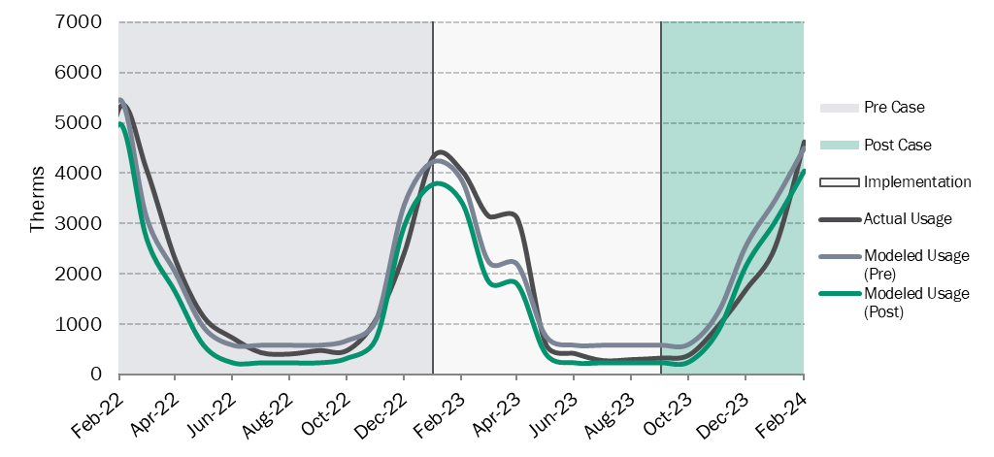
The facility's electric consumption shows a large increase that corresponds to the completion of the project, with year-over-year consumption nearly doubling. The regressions developed from the variables pertinent to the pre-case and post-case usage are shown in Figure 5. The pre-case regression, using variables for cooling degree days and a binary flag for summer months, achieves an overall R-squared of 0.981, and all variables have t-stat values greater than 2, indicating all variables to be statistically significant. In the post-case regression, an overall R-squared of 0.976 is achieved, with all t-stat values showing statistical significance. As shown in Figure 5, during the pre-case period, the modeled pre-case usage closely aligns with the actual usage, and in the post-case period, the modeled post-case usage closely aligns with the actual usage.
Normalized to typical meteorological data, the modeled pre-case annual electric energy consumption is 355,583 kWh, and the post-case annual consumption is 696,768 kWh, an increase of 341,185 kWh. This is the verified electric energy penalty for this project.
The evaluation team was unable to reach the customer to ask questions about the operation of the old and new equipment, so the reasoning behind such a large increase in electric usage could not be determined during the verification efforts. The evaluation team suspects that because of the DOAS, the amount of ventilation has increased as a result of this project, which increases fan energy consumption, winter heating loads, and summer cooling loads.
Figure 5. Electric Regression Analysis Results
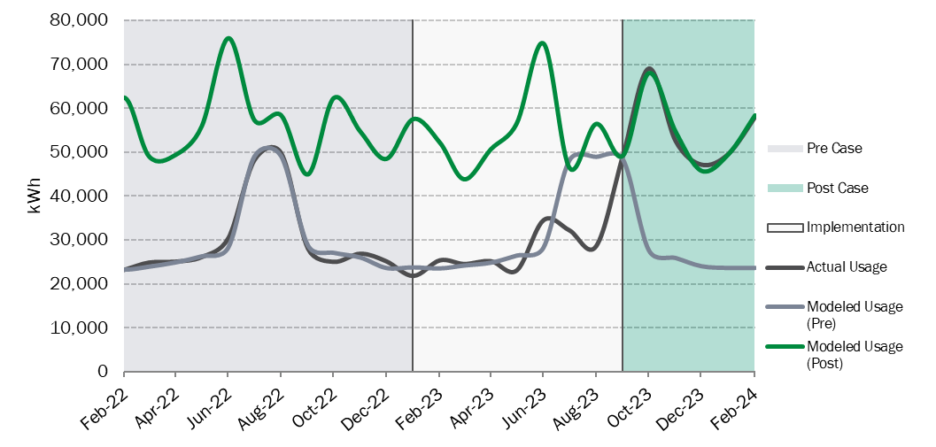
The demand savings for this project depend on the cooling and fans of the new HVAC equipment being more efficient than the baseline equipment. With no information being provided about the cooling efficiency of the new DOAS, the evaluation team deemed it reasonable to assume that the full-load efficiency (EER rating) of the DOAS is approximately equal to that of the VRF systems. The efficiency of the old, air-cooled chiller is specified to be 8.5 EER in the project documentation, so this efficiency was used in the verified demand savings calculations. The resulting demand savings for this project are 32.0 kW.

Project 2300014
Project ID#: | 2300014
Measure: | Install VFDs on Extrusion Press
Savings: | 1,081,874 kWh; 124.2 kW
Facility Type: | Manufacturing/Industrial
End Use: | Production
Sampled For: | Electric
Wave: | 1

Measure Description
This project consists of installing variable frequency drives (VFDs) on four 250-hp hydraulic extruder motors and was completed on March 6, 2023. During production, the extruder operates with either one or two motors loading, in use, and the other two or three unloading. Before the installation, the motors would continue to draw significant amounts of power even when idling. The savings are a result of motors being shut off during periods when they would otherwise operate in an idle state.

Key Findings
The reason for the change in savings is due to the correction of various parameters used throughout the calculation. When comparing assumptions made in the ex ante calculations to values sourced from the metered data, there were notable decreases in voltage, amperage while loaded, and especially power factor. There was an increase in total operating hours, which positively affected verified savings. These changes are summarized in Table 15.
Table 15. Summary of Project 2300014 Savings
Description | Ex Ante | Verified
Amperage while Loaded | 150 | 130
Amperage while Unloaded | 100 | 100
Voltage | 480 | 459
Power Factor, Loaded | 96% | 59%
Power Factor, Unloaded | 96% | 15%
Total Annual Hours of Operation | 4,945 | 5,402
1:3 Mode Annual Hours of Operation | 3,665 | 4,004
2:2 Mode Annual Hours of Operation | 1,280 | 1,398
The resulting project savings are shown in Table 16.
Table 16. Summary of Project 2300014 Savings
 | kW | kWh
Ex Ante | 124.2 | 1,081,874
Verified | 11.6 | 180,815
Realization Rate | 9% | 17%

Summary of the Ex Ante Calculations
The customer employed a handheld ammeter to gauge the current draw of each motor in two distinct conditions: when the motors were actively extruding (loaded) and when they were at rest during idle periods. The measurements revealed a current draw of 150 A during the loaded state and 100 A during the unloaded state. The customer provided production data from March 2022, which was used to determine the number of hours per day that the extruder operates in both modes (1+3 and 2+2). Daily hours were multiplied by 363 days of operation per year, resulting in a total annual operating time of 4,945 hours. This operating time consists of 3,665 hours in 1+3 mode and 1,280 hours in 2+2 mode.
The extruder operates in two modes: one is for extrusion when one motor is loaded and three are unloaded (referred to as the 1+3 mode). The second is for extrusion when two motors are loaded and two are unloaded (the 2+2 mode). The ex ante analysis calculates the power consumption of the pre-retrofit system by multiplying the measured current (loaded or unloaded), the assumed circuit voltage (480V), a power factor of unknown origin (96%), the square root of three, and a conversion from watts to kilowatts. Input power during the 1+3 mode is 359 kW for an estimated 3,665 hours per year, for 1,316,361 kWh per year. Input power during the 2+2 mode is 399 kW for an estimated 1,280 hours per year, for 510,750 kWh per year. Total baseline energy usage is 1,827,110.4 kWh per year.
The analysis is then applied to the proposed condition, where the unloaded motors are considered to consume no power since they are switched off. The power consumption in the 1+3 mode decreased from 359 kW to 120 kW, and in the 2+2 mode, it dropped from 399 kW to 240 kW. Hours of operation were assumed to be the same as for the baseline case, resulting in total post-case energy consumption of 745,237 kWh. The demand savings analysis incorporates a coincidence factor of 31%, which was established by the weighted average of the two operating modes described above.

Measurement and Verification Plan
The evaluation team will conduct an on-site visit to verify the installation of the VFDs and operation of the extruder. To verify the post-case energy usage, interval metering of current, power factor, and voltage during loaded and unloaded operation will be conducted on the extruder. The resulting data will allow the power draw to be verified while loaded and while off. We will request production records for the metered period to determine the hours of operation. We will also request annual production records or trends to establish annual hours of operation. In the case that metering cannot be done, the evaluation team will have to consider taking spot-measurements to verify the various assumptions made throughout the ex ante calculations.

Early Review Notes
We note that this project was subject to an early review prior to authorization. While the ex ante savings calculations appeared comprehensive and followed a reasonable approach, the evaluation team identified issues that may have warranted further investigation. The following comments highlight the observed inconsistencies, the evaluation team’s recommendations, and commentary on whether those recommendations were followed:
- The customer-provided production data from March 2022 is very helpful, but it was unclear how predictive this one month’s data would be for future production. In many production-related projects, changes to production volumes or the types of goods produced can result in changes to the estimated energy savings, which is susceptible to evaluation risk. While the customer noted that no unusual events occurred in March, we recommended confirming with the customer that March 2022 production is comparable to typical year-round production. As an additional step, collection of a second month of data would help confirm typical operating conditions.
  - Evaluation Finding: Although a second month of data was not collected, it was confirmed with the customer that March 2022 was characteristic of typical production.
- For post-installation verification, the evaluation team recommended metering current, power factor, and voltage during loaded and “stop” operation. This more thorough metering could be used to verify the power factor (PF) and voltage values used in the pre-installation analysis and verify that the new VFDs would result in zero power draw during “stop” operation while the extruder is extruding. It was recommended to collect additional production data at this time as well to confirm that the March 2022 data was representative.
  - Evaluation Finding: Metering, as described above, was not performed to further verify values used through the ex ante calculations. More importantly, the implementer did not verify the PF used in the baseline and proposed conditions. The customer reported that the facility has a capacitor bank for PF correction, and it appears that the implementation team may have used the facility PF for both cases. The facility PF is not representative of motor PF, particularly at the low load factors expected by lightly loaded motors. A typical power factor as a function of motor load can be seen in Figure 6.
Figure 6. Motor PF vs. Motor LF
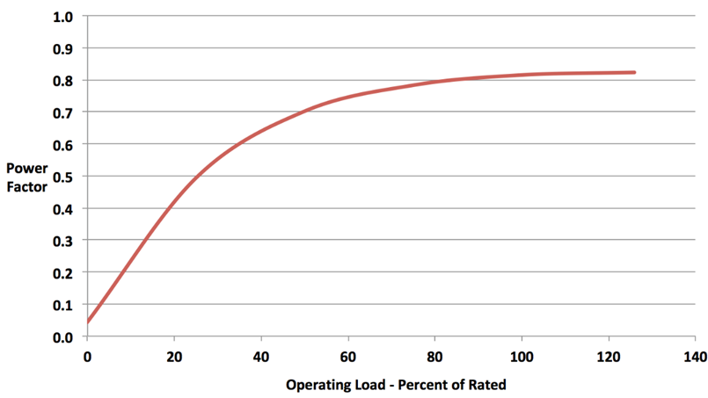
- The kW calculations used in the ex ante analysis had an apparent error. The power savings calculations combined the demand savings from mode 1+3 with the savings from mode 2+2, but the two modes of operation are mutually exclusive. Since the operating modes cannot happen simultaneously, the demand savings at any given point in time during extrusion will either be the savings calculated for mode 1+3 or those for mode 2+2, depending on how many motors are in operation during extrusion. Additionally, the extrusion operation is not continuous. It operates an estimated 4,945 hours per year, according to the values in the ex ante analysis. The demand savings for this project only occur during extrusion, and the evaluation team did not advise a 100% coincidence factor. The ex ante analysis acknowledged this issue and computed a weighed value of 31% but did not utilize the more conservative value. The extrusion motors do operate during idle modes, but their operation is unaffected by this project. Idle modes do occur during summer peak periods, as do extrusion periods, so the analysis needs to time-weight the demand savings. We recommended the ex ante analysis develop a weighted average demand based on the annual operating hours in 1+3 and 2+2 operating modes and apply the developed coincidence factor to the resulting average demand.
  - Evaluation Finding: Per the recommendation made above, the more conservative coincidence factor of 31% was implemented in the ex ante calculations to yield a more accurate kW reduction.

Summary of the Verified Calculations
To verify the project savings, the evaluation team installed a DENT ElitePro power meter on the motor disconnect for the lead motor. The site representative was unable to confirm if the metered motor was the lead (#1) motor throughout the metered period. The data appeared to have captured motor parameters for both operating conditions: (1) loading during the extrusion stroke and (2) unloading during ram retraction.
The evaluation team calculated pre-case and post-case average power (kW) using metered data. The data was used to estimate key values, including voltage and PF that were otherwise assumed in the ex ante calculations. The metered data was first analyzed to estimate the motor amperage during both the loading and unloading operation. It was assumed the motor was loading when the metered amperage was above 125 A. This threshold was selected by observing the levels at which the motor operated at throughout the metering period and finding a point where there was an observable distinction between operating states. Note that all measure savings were expected to be a result of the power reduction due to pumps being turned off instead of running in an idle mode, and the energy consumption of the pumps during active loading and unloading was not affected. The evaluation team used the selected amperage threshold between the loading and unloading operation to calculate the average metered power factor when the system was operating in each mode. This analysis showed that while loading, the average power factor is 0.59, and while unloading the average power factor is 0.15. Voltage remained relatively constant, and the average metered voltage, 459 Volts (phase-to-phase), was used in the baseline and post-installation calculations.
Given that the motor soft-starts are turning off the pump motors when they would otherwise operate in an idle state, none of the metered data shows energy consumption in an idle state. Because of this, the electrical demand of the pumps in an idle state was assumed to be consistent with the demand of the pumps when they are unloading.
Average baseline power was computed for each mode (1 running +3 idle and 2 running +2 idle), as was done in the ex ante calculations. Average post-installation power was computed for each mode (1 running +3 off and 2 running + 2 off), as was done in the ex ante calculations.
The hours of operation in each mode were estimated using a second source of metered data, which included amperage for a secondary motor. The evaluation team used the metered data to estimate total extrusion time. Due to uncertainty regarding the operation of the lead motor, the operating times in each mode were estimated by applying the ratio of 2+2 and 1+3 hours presented in the ex ante calculations.
Because the customer periodically switches which motor is the lead unit, the metered data was not used to directly calculate the annualized energy consumption. The proposed case was analyzed using the same method as the baseline case, except that average power was estimated from the metered data, only while operating. Average power in 1+3 mode was simply the average power from the main motor data. The metered data collected on the secondary motor was only amperage data, which was suitable for capturing operating hours but was not directly used for calculating the energy consumption of the secondary motor. Instead, the average power in 2+2 mode was calculated as double the average power from the main motor data. Lastly, demand was calculated using the same methodology laid out in the ex ante calculations, computing a new coincidence factor based on changes in operating hours and power reductions in both modes.

Project 2201213
Project ID#: | 2201213
Measure: | VSD Air Compressor
Savings: | 469,160 kWh; 53.9 kW
Facility Type: | Manufacturing
End Use: | Compressed Air
Sampled For: | Electric
Wave: | 1

Measure Description
The customer replaced a 150 HP single-speed, lubricated rotary screw air compressor with a 125 HP Atla Copco GA90 compressor with variable speed drive (VSD). A 1,550-gallon storage tank was added to the compressed air system. The compressor is expected to operate nearly continuously, 8,700 hours per year.

Key Findings
The reduction in measure savings is primarily due to verified average air flow (SCFM) being lower than ex ante air flow. Although the energy usage metered by the evaluation team for the post-installation compressor was slightly higher than in the ex ante analysis, the calculations also resulted in lower baseline energy usage at the lower flow rate. The resulting project savings are shown in Table 17.
Table 17. Summary of Project 2201213 Savings
 | kW | kWh
Ex Ante | 53.9 | 469,160
Verified | 45.5 | 389,821
Realization Rate | 84% | 83%

Summary of the Ex Ante Calculations
The implementation team established ex ante savings using metered power and air flow data for the pre-installation compressor. The team collected data at three-second intervals for one week from September 9 through September 15, 2021. Values were hard-coded, and whether the SCFM values are measured or calculated is unclear. The implementation team calculated the average observed power, 99.9 kW, for the pre-installation compressor and multiplied it by 8,700 hours to establish pre-install energy usage of 868,974 kWh.
The implementation team calculated post-installation compressor power using SCFM for each data point and CAGI data for the new compressor. The team determined the average calculated post-installation power to be 46.0 kW and multiplied it by 8,700 hours to establish post-install annual energy usage of 399,814 kWh. Measure savings are the simple difference between pre- and post-install energy usage, 469,160 kWh. Peak demand savings are equal to the average demand savings of 53.9 kW.

Measurement and Verification Plan
The evaluation team will conduct an in-person, on-site visit to verify compressor installation and operation. The team will collect compressor nameplate information and operating pressure. The customer representative will be asked to confirm hours of operation, observed holidays, and plant shutdowns.
If the customer can trend or meter compressor operation, the evaluation team will request operating data, including compressor power (kW or Amps), discharge pressure, and SCFM. If the customer cannot provide this information, the team will install a data logger to meter compressor amperage for at least two weeks of regular operation. We will also ask about typical production levels, including daily and seasonal variations. The evaluation team will request production data to identify typical production levels if made available.

Summary of the Verified Calculations
The evaluation team installed an amp meter to log compressor operation and collected data at two-minute intervals from January 10, 2023, through February 2, 2023. At the time of installation with a power meter, spot measurements were taken to determine the voltage and power factor at the compressor electrical disconnect.
The evaluation team used the collected information to calculate VSD compressor power for each data point, which was then used with the compressor performance curve to determine air flow rates. The evaluation team used those air flow rates to estimate baseline compressor power for each data point by applying the ex ante power vs. flow curves presented in the implementation team’s calculations. The ex ante baseline curves used are shown in Figure 7 and Figure 8 below.
Figure 7. Baseline Compressor Curve
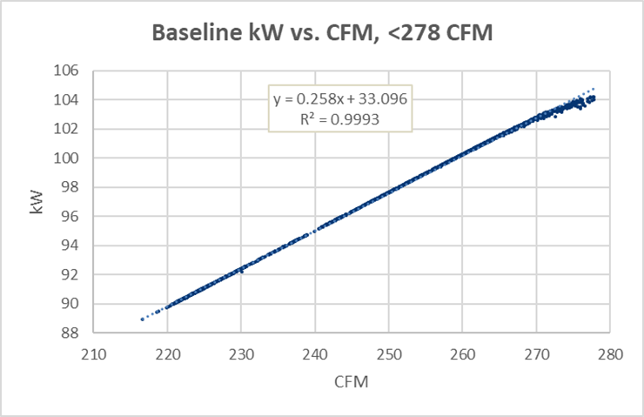
Figure 8. Baseline Compressor Curve
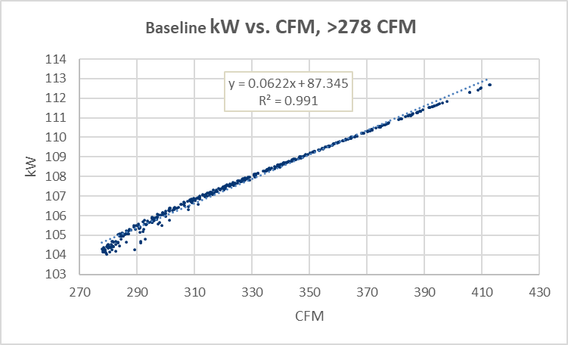
The customer reported a cyber-attack during the metered period. Therefore, it was assumed that data points with no metered power were not representative of typical operation, and those with zero power were ignored. The evaluation team did not count the zero points as typical operation to determine hours of operation. The ex ante value of 8,700 annual hours of operation was used in the energy calculations.
The average overall post-case input power was multiplied by 8,700 hours to establish post-case annual energy usage. A similar calculation with calculated baseline power to establish baseline annual energy usage was performed. The verified energy savings are the difference between the baseline and post-case results.
The evaluation team used estimated post-case and baseline power for the weekday hours between 1 P.M. and 5 P.M. to establish peak demand for each case. The verified peak demand savings are the difference in those results.
A summary of ex ante and verified values are shown in Table 18.
Table 18. Summary of Results
Description | Ex Ante |  | Verified
 | Baseline | Proposed | Baseline | Proposed
Average Power kW | 99.9 | 46.0 | 92.6 | 47.8
Average SCFM | 268 | 268 | 238 | 238
Hours of Operation | 8,700 | 8,700 | 8,700 | 8,700
Energy Usage kWh | 868,974 | 399,813 | 805,388 | 415,567
Peak Demand kW | 99.9 | 46.0 | 96.4 | 50.9

Project 2200603
Project ID#: | 2200603
Measure: | Energy Management System
Savings: | 447,230 kWh; 51.1 kW; 1,297 Therms
Facility Type: | Hotel & Casino
End Use: | Space Heating & Cooling
Sampled For: | Electric and Gas
Wave: | 2

Measure Description
This project involves the design, installation, programming, commissioning, and warranty of the extension of an existing temperature control and building automation system at a hotel and casino. This project covers the upgrades made at the pavilion, with an area of 78,480 square feet, while another incentive application covers the hotel side of the facility. Before installing the new controls, the HVAC equipment ran 24/7 with limited controls and monitoring of the air handlers, RTUs, chiller, and boiler. The new building automation system scheduled all 14 air handlers on occupancy schedules for their respective zones. The air handlers will operate with setbacks and resets to reduce energy usage, particularly during unoccupied hours.
The application was submitted on 4/14/2022, and it was expected to be completed on 12/16/2022.
After contacting the site contact and vendor with a list of questions, the evaluation team discovered that this project started on 2/6/2023 and was completed on 12/15/2023.

Key Findings
There are several reasons behind the verified savings being less than the ex ante savings, the most significant factor being that the customer is operating the new controls system on the same continuous operation schedule as the previous system prior to the project initiation, negating any savings from occupied/unoccupied controls for supply temperature and ventilation rates in the new control system. Additionally, there were several incorrect assumptions in the energy models that either did not match with the scope of work or did not reflect the building system accurately. For example, savings were claimed for economizer and ventilation controls for several systems that the evaluation team found to be 100% recirculation systems that do not have outdoor air intakes or exhausts. The resulting project savings are shown in Table 19.
Table 19. Summary of Project 2200603 Savings
 | kW | kWh | Therms
Ex Ante | 51.1 | 447,230 | 1,297
Verified | 0 | 29,972 | 9,074
Realization Rate | 0% | 7% | 699%

Summary of the Ex Ante Calculations
The implementation team used EnergyPlus models to simulate the pavilion's baseline and post-installation energy-efficient case. The baseline model has three AHUs and five RTUs running continuously, while the energy-efficient model has these AHUs and RTUs on a schedule with setbacks and resets. The project scope entails 14 AHUs/RTUs, and the BAS graphics included in the project documentation show five AHUs and nine RTUs, with 14 units in total. It should be noted that the evaluation team found three AHUs, five constant volume RTUs, and seven packaged terminal heat pumps (PTHPs) with ON/OFF fans in the system design for the models. These PTHPs were not labeled in the BAS graphics. It is possible that some of the systems at the facility were combined or modified in the energy model for simplicity – such details will need to be confirmed with the customer or the vendor for the project. For this analysis, the evaluation team considered all PTHPs as RTUs to maintain consistency with the BAS graphics.
AHU and RTU Fan Energy
The zone peak design cooling temperature setpoint has been changed from 72ºF in the baseline model to 75ºF in the proposed model. The zone peak design heating temperature setpoint has been changed from 70ºF in the baseline model to 32ºF for most zones in the proposed model. To satisfy the zone temperature occupied/unoccupied schedules and setpoints, the calculated design primary air ventilation (maximum cooling) per zone or system has been reduced between the baseline and the proposed models while keeping the minimum outdoor airflow (CFM) the same as the baseline. The units are auto-sized in the models based on their calculated design CFM, which is greater in the baseline model than the proposed model. The minimum heating mode CFM for each zone has been reduced from 0.5 times the design CFM in the baseline model to 0.3 times the design CFM in the proposed model. The reduced heating and cooling airflows yield approximately 25% fan energy savings overall.
According to the vendor, there is a static pressure reset control for the AHUs, but the energy models do not mention this. The evaluation team will evaluate the savings potential from static pressure resets based on the provided information.
CHW and HW System Savings
As per the models, the boiler and chiller loops are the heating/cooling coils for the three AHUs. The hydronic system flow rates were auto-sized in the models to match the maximum heating and cooling load across the AHU coils in both models. The boiler and chiller design size capacity were auto-sized in the models, as were the run-time and flow (GPM) and the HW and CHW pump design flow and rated power. The adjustments to the controls between the baseline and proposed models, along with the auto-sizing in the models, result in the energy consumption of the hydronic system pumps reducing by approximately 65%.
RTUs Cooling and Heating Savings
Several cooling and heating coils for RTUs were also auto-sized based on the maximum heating and cooling demand from those units and their respective zones. Overall electric savings from heating and cooling are 67% and 59%, respectively, and the natural gas savings from heating are 3.9%.
The savings were calculated by subtracting the total modeled building end-use energy (kBtu) of the energy-efficient case from the baseline case. This is summarized below in Table 20.
Table 20. Summary of Model Energy Use
 | kW | kWh | Therms
Baseline | 222.1 | 1,945,645 | 33,189
Proposed | 171.1 | 1,498,415 | 31,892
Savings | 51.1 | 447,230 | 1,297

Table 21 and Table 22 below are summaries of the key inputs/conditions in the building models used to determine the ex ante savings for this project.
Table 21. Baseline Energy Model Inputs Summary Project 2200603
Model | Input/Parameter | Ex Ante Assumption
Baseline | Building Heating Setpoint Temperatures | 70F/70F (Setback)
 | Building Cooling Setpoint Temperatures | 72F/72F (Setback)
 | Building Heated Operation Schedule | On 24/7
 | Building Cooling Operation Schedule | On 24/7
 | Building Ventilation Operation Schedule | On 24/7
 | AHU economizer | Off 24/7
 | Chilled water loop temperature (max/min) | 50F/40F
 | Chilled water loop outside temperature operation | NA
 | Chilled water loop setpoint manager control type | Scheduled
 | Hot water loop exit temperature | 176F
 | Hot water loop outside temperature operation | NA
 | Hot water loop setpoint manager control type | Scheduled
 | Setpoint Manager control Type for AHUs and RTUs | Scheduled
 | RTU economizer lockout type | No lockout
 | RTU Minimum fraction of outdoor air schedule | Always 0.5
Table 22. Proposed Energy Model Inputs Summary Project 2200603
Model | Input/Parameter | Ex Ante Assumption
Proposed | Building Heating Setpoint Temperatures | 68/65 (Setback)
 | Building Cooling Setpoint Temperatures | 75/80 (Setback)
 | Building Heated Operation Schedule | Occupancy
 | Building Cooling Operation Schedule | Occupancy
 | Building Ventilation Operation Schedule | Occupancy
 | AHU economizer | Operational and Controlled
 | Chilled water loop temperature (max/min) | 60/42
 | Chilled water loop outside temperature operation | 55/50
 | Chilled water loop setpoint manager control type | Outside air reset
 | Hot water loop exit temperature | 160
 | Hot water loop outside temperature operation | 50/55
 | Hot water loop setpoint manager control type | Outside air reset
 | Setpoint Manager control Type for AHUs and RTUs | Warmest
 | RTU economizer lockout type | Lockout w heating
 | RTU Minimum fraction of outdoor air schedule | Always 0.2

Measurement and Verification Plan
There are multiple electric meters for this facility, which, in total, cover more areas of the building than this project covers. Separate controls projects are being completed in the two structures of the facility (hotel and pavilion). Still, most of the spaces in these structures share a single utility account and are fed by one meter, so it is impossible to differentiate the usage of the two structures from each other in the billed usage data. Other electric meters provide a few of the restaurants within the hotel and pavilion. The usage seen by all the electric meters will be affected by this project. Three total gas meters serve the pavilion and restaurants. It is unclear if all three gas meters are for areas covered by this project or if they also serve the hotel.
Based on the project completion date mentioned in the rebate application, the evaluation team had planned to build a regression model using the pre (estimated before May 2022) and post (estimated after Dec 2022) utility data to calculate savings normalized to historical weather data from a local weather station.
After contacting the site contact and vendor to confirm the system’s operating conditions, the evaluation team found that the project started after February 2023 and was completed in December 2023. Hence, there would be insufficient post-case usage data for regression analysis.
Below are the questions the evaluation team asked the vendor and/or site contact and for which answers were provided:
- Recent gas and electric billed data with clarification on the meters for the pavilion and hotel.
- When did the installation work start and complete for the pavilion and the hotel?
- The post-inspection report dated 4/12/2023 observed that the graphics and schedules for several units were missing. Was this ever completely commissioned? If so, when was that completed?
- What are each AHU's occupied/unoccupied/holiday schedules?
- Are there any occupied space temperature setpoint deadbands, outdoor air setpoint resets, demand control ventilation sequences, and unoccupied setbacks implemented?
- Are minimum and maximum heating and cooling CFM setpoints set for the VAVs? Or are these VAVs in a constant flow setting with balancing for constant ACH?
- Are there temperature and static pressure resets programmed? If so, what are their ranges?
- Do the AHUs have economizer controls, and if yes, then at what outdoor temperature/enthalpy?
- Are the VFDs operating to maintain supply static pressure setpoint on the supply and return fans of the building air handlers/roof-top units?
- Are any kitchen hood exhausts or other exhausts running constantly? Do they have make-up air units, and if yes, then what is their control sequence?
- Were any changes made to the filtration and air exchanges to provide fresh air?
- Were there any lighting controls changes as part of the scope of this project?
- What setpoints are hot water and chilled water loop flows being controlled to?
- How has the building’s occupancy changed before and after the project?
- Is there trended data from the Energy Management System available for fan speeds, ventilation rates, supply temperatures and pressures, damper positions, air flow rates, chilled water and hot water flow rates, and supply and return temperatures?
- Were any occupancy sensors installed and integrated with the Energy Management System?
- What assumptions were made in changing design flow rates for the hot and chilled water systems, cooling and heating capacities for all coils, and airflow minimum rates for all VAVs in the energy models?
- Clarification on controls for hot water/chilled water pump speeds is needed.
- Are there any control drawings for the project?
Below is a list of questions the evaluation team had for the customer and vendor for this project, but for which no answers were provided:
- What assumptions and calculations were used in building the model regarding the number of air handling units, roof-top units, and VAVs?
- Is there documentation of the sequence of operation from the prior BAS system to verify changes in air flow, water flow, temperature, pressure set-point changes, and trends?
- Are there any mechanical schedules for air handling equipment, rooftop units, and VAVs to verify the design assumptions in the baseline and proposed model? What is the source for the sizes of these AHUs and RTUs?
- Clarification on the two additional AHUs is needed.
- Clarification on restaurants that were part of and affected by this upgrade is needed.

Summary of the Verified Calculations
The evaluation team compared the baseline energy model usage with the average pre-case usage for the building between 2022 and 2020, as submitted in the custom rebate workbook. The electric usage from the baseline model was found to be 28% lower than the average billed usage (after proportioning the usage between the pavilion and hotel based on floor area). The gas usage from the baseline model was about 376% higher than the average pre-case gas usage for the pavilion. This leads us to believe that the energy model is considering the gas usage for the two restaurant meters as part of the pavilion.
The energy models auto-size all the mechanical units from baseline to proposed to match the loads in the building at peak demand. This assumption is inaccurate since this is a controls upgrade project with no changes to the building energy systems. The system design values should have been the same for the proposed and baseline models. After studying the responses from the vendor and the on-site contact, the evaluation team concluded that the energy models used in the ex ante savings analysis do not adequately reflect the building or the new controls that were installed, and it would not be feasible to use the models in the verified savings analysis. The evaluation team took operational conditions of the old and new system they received from the vendor and key assumptions of the energy model that were found to be accurate and developed spreadsheet-based savings calculations for all the controls that were found to be contributing to savings for the facility.
According to the vendor, the customer is operating the AHUs with manually overridden schedules of 24/7 occupancy. There has been no change in occupancy or physical space utilization of the building pre- and post-upgrade. These are 100% outside air systems with heat recovery wheels. Therefore, the savings potential from scheduling is negated.
AHU Fan Energy
Based on the BAS screenshots, it can be seen for AHU-1 that the current optimized setpoint for supply air static pressure from the control sequence (1.3125” W.C. in Figure 9) is different than the setpoint that the AHU is controlling the fan speed for (1.00” W.C. in Figure 10). This indicates that the system is not actually using the static pressure reset controls, and it is believed that the fans are maintaining a constant static pressure all the time.
Figure 9. AHU-1 Supply Air Static Pressure Reset Screenshot
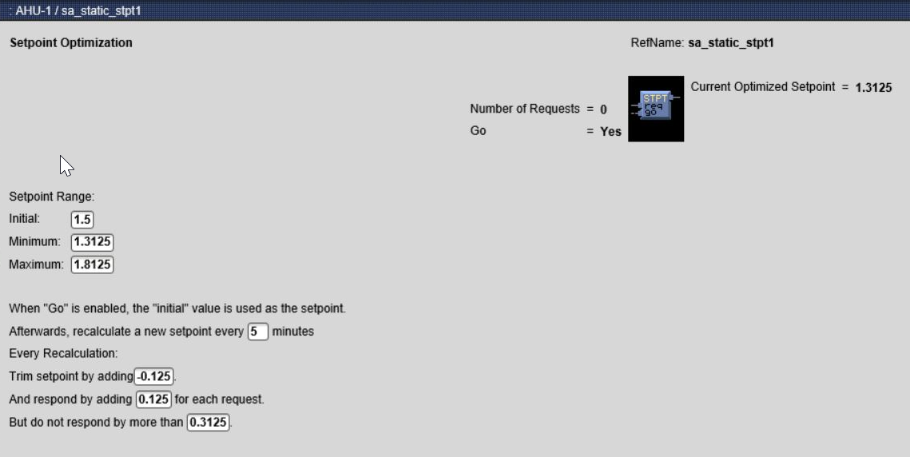
Figure 10. AHU-1 Graphic Screenshot
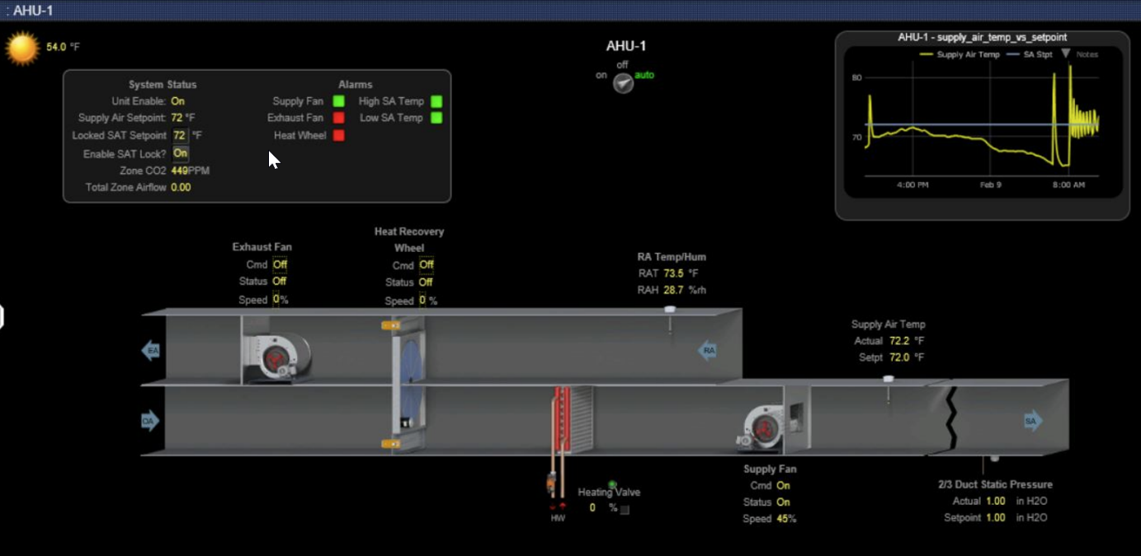
A similar variation from the optimized static reset setpoint to the actual static setpoint can be seen for AHU-2 (Figure 11 and Figure 12) and AHU-3 (Figure 13 and Figure 14).
Figure 11. AHU-2 Supply Air Static Pressure Reset Screenshot
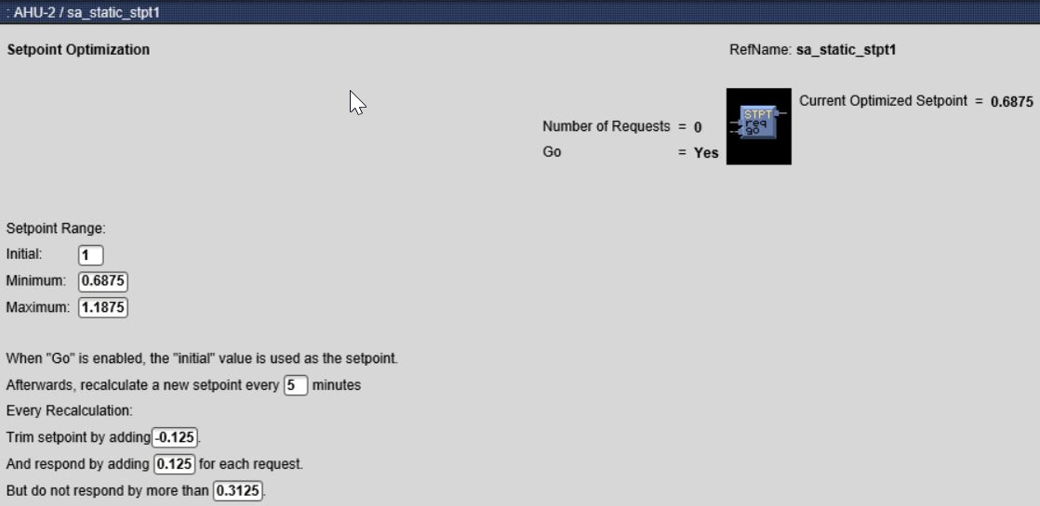
Figure 12. AHU-2 Graphic Screenshot
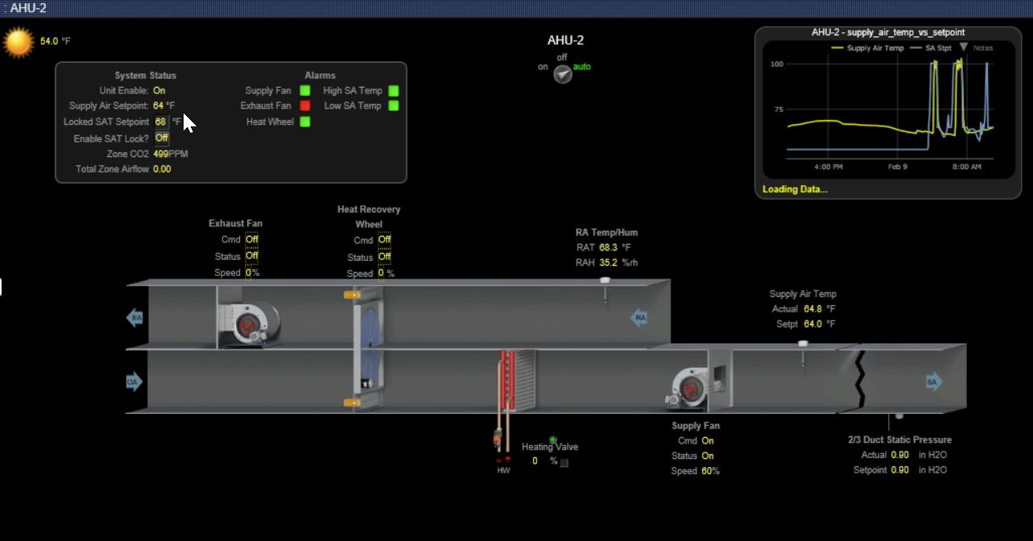
Figure 13. AHU-3 Supply Air Static Pressure Reset Screenshot
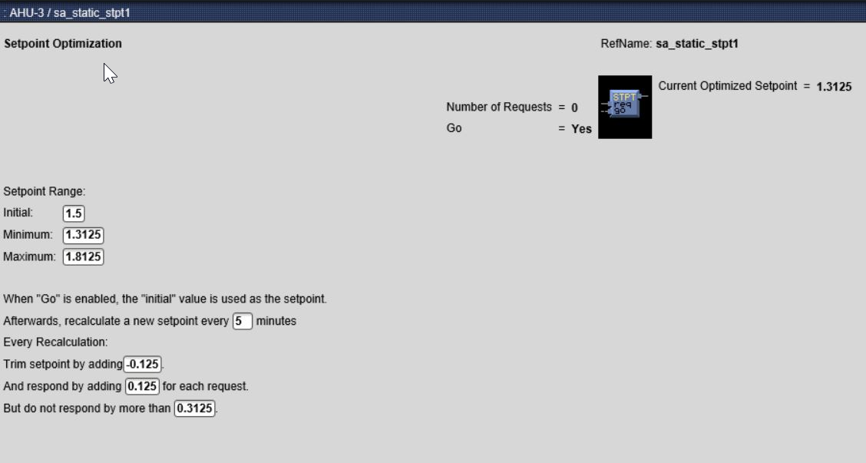
Figure 14. AHU-3 Graphic Screenshot
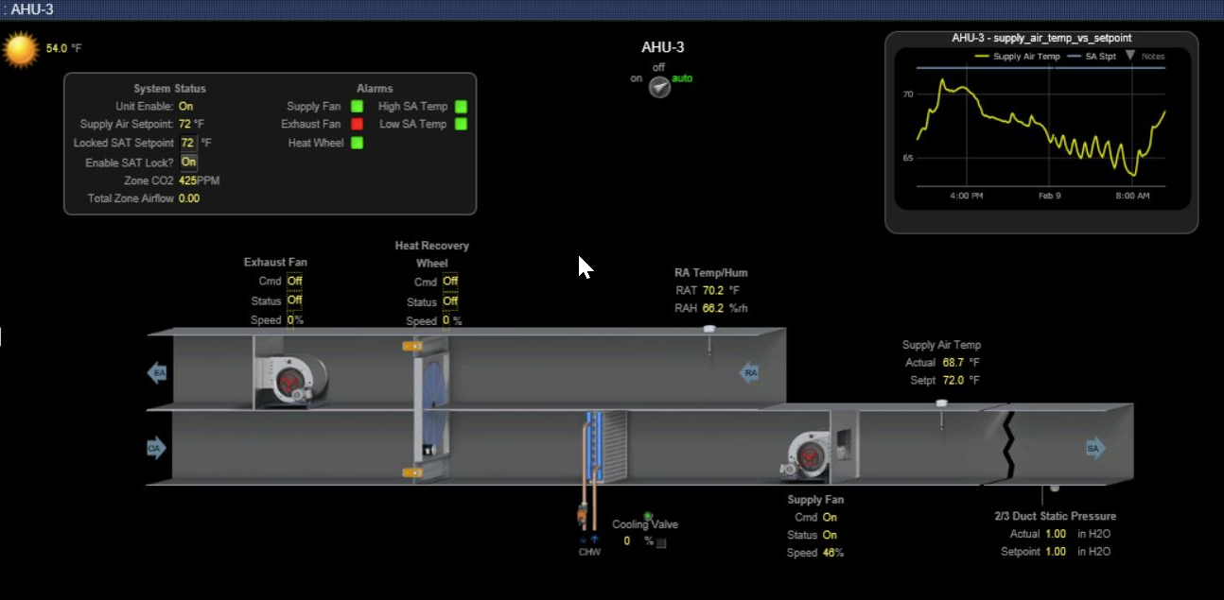
Trends of supply fan speeds for the three air handling units (see Figure 15) show that the fans are running nearly continuously, and their modulation indicates that the BAS controls are using system feedback to adjust the fan speed automatically. The evaluation team believes this modulation is occurring to maintain the constant supply static pressure setpoints as the VAV dampers downstream modulate. The evaluation team was unable to get confirmation from the vendor or customer about how the fans were controlled prior to the completion of the project. Still, it is known that the fan VFDs existed prior to the completion of the project. The way that the fans appear to be controlled now is typical of the most basic supply fan control strategies for VAV systems, and there do not appear to be any functioning controls that yield any energy savings above what would be expected in the baseline control system. Because of this, there are no verified savings for implementing static pressure reset controls.
Figure 15. AHU-1, 2, 3 SF Speed Jan 2024 Trend
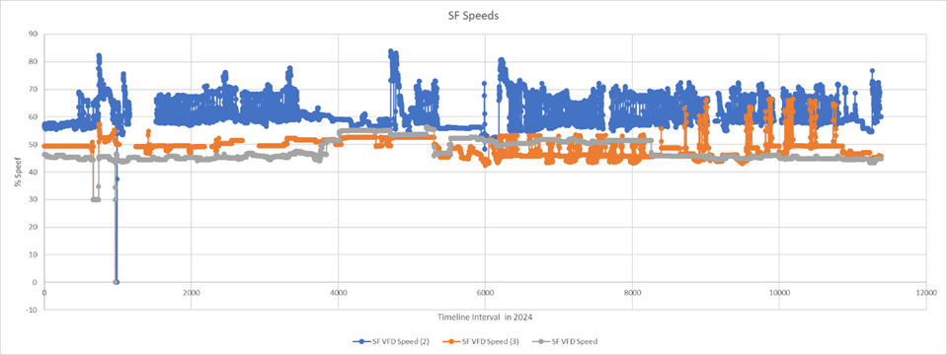
RTU Fan Energy
Nine rooftop units have constant-speed fans running all the time to circulate air through occupied spaces without any outside air intake. The ex ante models only included five RTUs and assumed they have an OA intake, have economizing capabilities, and can vary air flow. Because none of the proposed controls upgrades could be implemented with the RTUs, given that they have constant speed motors and no outdoor air intake, no savings were quantified for the RTUs.
AHU Cooling and Heating Energy
The energy model calculates heating and cooling energy for the three AHUs based on zone heating/cooling demand. The vendor also shared a supply air temperature reset sequence for these AHUs that looks at the zone terminal unit heating/cooling demand and determines the supply air setpoint on a scale (Cooling 53ºF min/70ºF max; Heating 65ºF min/85ºF max).
Supply temperature setpoints for AHU-1 and AHU-3 can be seen as constant on the top right corner of the BAS graphics (Figure 10 and Figure 14) while the supply temperature varies. Also, after looking through the supply temperature setpoint control logic, there seems to be a manual override (Analog Value AV) on the setpoint (see Figure 16). Based on this information, it is evident that the supply temperature setpoints for AHUs 1 and 3 are manually overridden, negating savings from the supply temperature setpoint reset.
From Jan-Feb 2024, trends for these three units show that the AHU-2 supply temperature varies considerably. Due to a lack of data, the real reason behind this variation is unclear, but as per the vendor, it could be that the heating valve BAS output is hunting for its setpoint and may need optimizing. The vendor also informed the evaluation team that while modulating, the heating valve for AHU-2 is set to stay open at a minimum position to heat even on a 0% valve command for HW loop balancing purposes in heating mode.
Although there seems to be a supply air temperature reset for AHU-2, the vendor has not determined whether the customer has modified the reset schedule. Since the supply temperature is already based on zone heating/cooling demand and the VAV boxes are cooling-only boxes without reheat, the evaluation team assumed a zone temperature heating/cooling deadband would control the supply temperature and developed a separate spreadsheet-based calculation. As mentioned above, this zone temperature heating-cooling deadband has not been taken for AHU-1 and 3 calculations since their supply setpoints have been fixed manually.
Figure 16. AHU-1 Supply Temperature Setpoint Control Logic
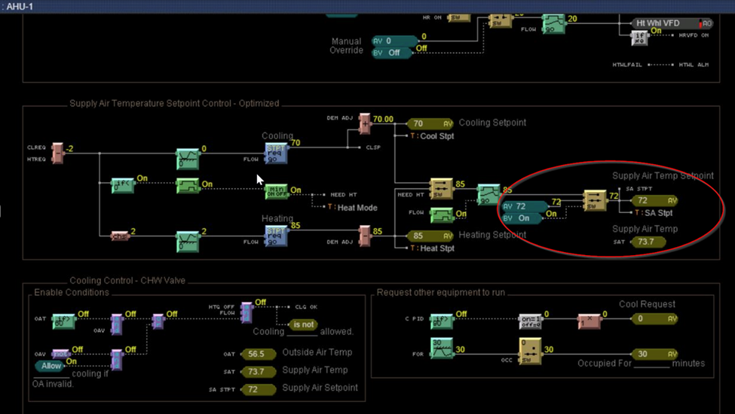
The proposed energy model assumes savings for these three AHUs from building heating and cooling airflow and reduced minimum outdoor air ventilation. The evaluation team used spreadsheet calculation templates to quantify the savings from the reduced ventilation for all three AHUs and the larger temperature deadband for AHU-2. Reducing minimum ventilation for AHUs-1 and 3 gives roughly 5,593 therms savings. Reducing minimum ventilation and supply air temperature reset based on zone heating-cooling deadband for AHU 2 gives 2,731 kWh and 3,481 therms savings. The annual fan energy savings for these units equate to 29,972 kWh.
RTU Cooling and Heating Energy
The zone temperature setpoints and deadbands for the RTUs from the proposed model do not match the BAS screenshots. There is no data on pre-upgrade conditions, and it is unclear whether the zone temperature setpoints and deadbands have changed from pre- to post-upgrade. Due to this, it is likely that the onsite customer has manually overridden setpoints to be the same as before. Therefore, cooling and heating savings were removed from these units.
CHW and HW System Savings
The chiller and boiler are on a two-pipe closed loop system that operates in heating or cooling mode. The models show some hot water loads during summer months and chilled water loads during winter months, which does not reflect the facility operation accurately and inflates the system runtimes. As per the vendor, the BAS only enables the change-over based on outside air temperature (50ºF-55ºF deadband), which was previously manually controlled. The “OA-enable” sequence for the hot-to-cold water changeover may not provide savings potential as this changeover was manually done pre-upgrade at an outdoor air temperature, which is believed to be roughly the same as now.
The BAS does not control the HW pump speeds and supply temperature setpoints. The customer has been operating the HW pumps with a manual override at 75% speed during heating operation to match pre-upgrade conditions, and the supply temperature setpoint has been fixed at 140ºF to match pre-upgrade conditions. This negates the potential for any pump savings or boiler savings for hot water reset controls.
The BAS was also found not to control the circulation pump speeds and supply temperature setpoints when the system is in cooling mode. The customer has been operating pumps with a manual override at 55% speed to match the pre-upgrade conditions in this mode. This negates any CHW pump savings related to central plant controls upgrades. Per the vendor, the supply temperature setpoint was not reset or changed as part of the controls upgrade and is most likely fixed to match pre-upgrade conditions. This negates any chiller savings from the CHW supply temperature reset.
The energy models assume the hydronic loop pumps are constant speed. While the pumps do have VFDs, it was confirmed with the vendor that the pumps run at a constant speed all the time.
Due to controller memory limitations of the new control system, trends cannot be stored and recovered before the main server is operational and connected, which happened in October 2023. Hence, there is no way to validate the system’s operating conditions before October 2023 using trends.
The evaluation team used the baseline and proposed conditions, as seen in Table 23 and Table 24, to calculate savings using Excel workbooks.
Peak kW Savings
All of the controls upgrades identified by the evaluation team are not expected to impact peak demand usage, as the measure impacts will be during heating operation and the shoulder seasons. There are no verified demand savings for this project.
The assumptions made in the ex ante models and any discrepancies identified during the evaluation process are summarized below in Table 23 (baseline) and Table 24 (proposed).
Table 23. Baseline Energy Model Inputs Summary Project 2200603
Model | Input/Parameter | Ex Ante Assumption | Verified Discrepancy
Baseline | Building Heating Setpoint Temperatures | 70F/70F (Setback)
 | Building Cooling Setpoint Temperatures | 72F/72F (Setback)
 | Building Heated Operation Schedule | On 24/7
 | Building Cooling Operation Schedule | On 24/7
 | Building Ventilation Operation Schedule | On 24/7
 | AHU economizer | Off 24/7
 | Chilled water loop temperature (max/min) | 50F/40F
 | Chilled water loop outside temperature operation | NA
 | Chilled water loop setpoint manager control type | Scheduled
 | Hot water loop exit temperature | 176F | The vendor specified a constant 140ºF supply temperature.
 | Hot water loop outside temperature operation | NA
 | Hot water loop setpoint manager control type | Scheduled | No reset on HW setpoint
 | Setpoint Manager control Type for AHUs and RTUs | Scheduled
 | RTU economizer lockout type | No lockout | No outdoor air intake in RTUs
 | RTU Minimum fraction of outdoor air schedule | Always 0.5 | No outdoor air intake in RTUs
Table 24. Proposed Energy Model Inputs Summary Project 2200603
Model | Input/Parameter | Ex Ante Assumption | Verified Discrepancy
Proposed | Building Heating Setpoint Temperatures | 68/65 (Setback)
 | Building Cooling Setpoint Temperatures | 75/80 (Setback)
 | Building Heated Operation Schedule | Occupancy | Should be operated 24/7
 | Building Cooling Operation Schedule | Occupancy | Should be operated 24/7
 | Building Ventilation Operation Schedule | Occupancy | Should be operated 24/7
 | AHU economizer | Operational and Controlled | They are 100% OA units.
 | Chilled water loop temperature (max/min) | 60/42
 | Chilled water loop outside temperature operation | 55/50
 | Chilled water loop setpoint manager control type | Outside air reset
 | Hot water loop exit temperature | 160 | Vendor confirmed - constant 140ºF supply temperature.
 | Hot water loop outside temperature operation | 50/55
 | Hot water loop setpoint manager control type | Outside air reset | No reset on HW setpoint
 | Setpoint Manager control Type for AHUs and RTUs | Warmest
 | RTU economizer lockout type | Lockout w heating | No outdoor air intake in RTUs
 | RTU Minimum fraction of outdoor air schedule | Always 0.2 | No outdoor air intake in RTUs
Table 25 summarizes the key parameters used in quantifying savings for the controls the evaluation team identified that are in place and working for this project. Table 26 summarizes the savings that were determined for each of these control strategies.
Table 25. Summary of Project 2200603 Savings
Input/Parameter | Baseline Condition | Proposed Condition
Building Heating Setpoint Temperatures | 70/70 (Setback) | 68/65 (Setback)
Building Cooling Setpoint Temperatures | 72/72 (Setback) | 75/80 (Setback)
Minimum ventilation air fraction - AHU-1, 2, 3 | 0.5 | 0.3
Table 26. Summary of Project 2200603 Savings
Measure | kWh Savings | Therms Savings
AHU-1, 3 Minimum Ventilation Reset | 17,225 | 5,593
AHU-2 SA Temp reset & Minimum Ventilation Reset | 12,747 | 3,481
Total | 29,972 | 9,074

Project 2200412
Project ID#: | 2200412
Measure: | Combined Heat & Power
Savings: | 2,408,423 kWh; 282.7 kW; 639,015 therms
Facility Type: | Manufacturing/Industrial
End Use: | Water Treatment
Sampled For: | Electric and Gas
Wave: | 3

Measure Description
This project involves the shut-down of a 700 HP Mechanical Vapor Recompressor (MVR) as part of an Anaerobic Hybrid Reactor (AHR) water treatment system at an ethanol plant. The MVR currently recycles steam from the connected Zero-Liquid Discharge (ZLD) evaporator it services. The proposed system disconnects the MVR from the ZLD and replaces the MVR with a Thermal Vapor Recompressor (TVR). The TVR will utilize fresh steam from the boiler system and recycle steam from the ZLD without using any motors, saving the electrical energy currently used by the 700 HP MVR. The current system design also rejects a large amount of useful steam from the Crystallizer and ZLD straight to cooling towers in the plant. Additional mechanical upgrades are made to redirect the rejected steam paths back to the main plant’s steam system for use in the Hydroheater, offsetting a portion of the fresh steam currently used in the baseline. The repurposing of waste steam and reduction of fresh steam use by the TVR reduces the total amount of fresh steam needed to be generated by the plant, and results in overall reduced natural gas usage for steam production. This project started in March 2022, when the customer first started looking into the project and seeking pre-approval, and the project installation was completed in May 2023.

Key Findings
The ex ante calculations for steam conservation, therm savings, and electrical energy savings were sound and used for the verified savings calculations. The verified savings calculations include additional post-implementation gas usage data to capture the average gas usage in a longer period, and also capture gas usage in cold months where the gas usage is traditionally higher than the summer months used in the ex ante calcs. This calculation resulted in a different value from the ex ante gas savings calculation, but due to the small percentage of the overall plant natural gas usage the ex ante savings were not changed. The project savings are summarized in Table 27.
Table 27. Summary of Project 2200412 Savings
 | kW | kWh | Therms
Ex Ante | 282.7 | 2,408,423 | 639,015
Verified | 282.7 | 2,408,423 | 639,015
Realization Rate | 100% | 100% | 100%

Summary of the Ex Ante Calculations
The ex ante calculations utilized requested site-metered data and utility data taken both before and after the measure was implemented to calculate the reduction in electrical energy and therms as a direct result of the project. The ex ante calculations also used a steam conservation method for predicting therm savings.
Figure 17 represents the steam use and flows in the system for both the baseline and proposed cases.
Figure 17. Baseline and Proposed Steam Conservation Diagrams
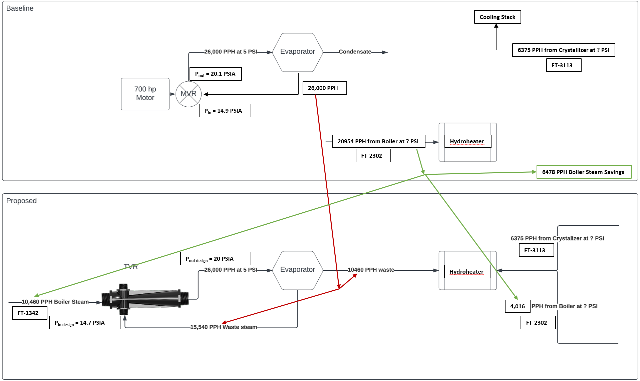
Steam Conservation and Energy Balance
Steam savings of the TVR portion of the AHR water treatment system result from reduced Fresh Steam (FS) due to Waste Steam use (WS), and savings are calculated in pounds per hour (pph) as shown in Equation 10.
Equation 10. Steam Savings Formula
${Steam Savings}_{TVR}={FS}_{Baseline Hydroheater}+{FS}_{Baseline Crystallizer}- {WS}_{Proposed ZLD}-{WS}_{ Proposed Crystallizer}-{FS}_{Proposed Hydroheater}$
The TVR system is part of the larger AHR water treatment system, so the TVR savings are applied to the total boiler steam metered and sent to the AHR water treatment system as a whole, also measured in pph, as shown in Equation 11. This is also equal to the proposed steam use.
Equation 11. Proposed Steam Use Formula
$${Steam Savings}_{AHR}={Steam Use}_{Baseline AHR}- {Steam Savings}_{TVR}={Steam Use}_{Proposed}$$
The proposed steam use was then multiplied by the baseline ratio of the therms/hr rate of natural gas used by the boilers per pph of boiler steam produced to calculate the proposed rate of therms/hr at the boiler. This is subtracted from the metered baseline therms/hr rate of the boiler system to produce the saved therms/hr of the proposed boiler system, as shown in Equation 12.
Equation 12. Saved Therms Rate Formula
$${Saved Therms Rate}_{Boiler}= {Therms Rate}_{Baseline}-\left({Steam Use}_{Proposed}×\frac{{Therms Rate}_{Baseline}}{{Steam Use}_{Baseline}}\right)$$
The saved therms rate from Equation 13 is then multiplied by the operating hours per year of the plant, 8,529, as supplied by the customer, to calculate the saved therms/year for the plant, shown in Equation 13.
Equation 13. Annual Boiler Therm Savings Formula
$$Boiler Therm Savings= {Saved Therms Rate}_{Boiler}×8520 hours/year$$
To check for accuracy, the boiler efficiency was calculated using the metered data for calculating savings. Boiler efficiency was calculated by taking the metered amount of steam going to the AHR system coming from the boiler system (pph), converting it to units of million British thermal units (MMBtu) using a steam enthalpy value of 1000 Btu/lb steam and conversion rate of 1,000,000 Btu/MMBtu, then dividing by the metered amount of natural gas used by the boilers supplying the steam, also in MMBtu/hr, shown in Equation 14. The steam enthalpy value used by the reviewer is lower than what the evaluation team found in the steam tables, and this adjustment is covered in the Verified Savings section of this report.
Equation 14. Boiler Efficiency Formula
$${Eff}_{Boiler}= \frac{{Steam Use}_{Baseline AHR}×0.001\frac{MMBtu}{lb of steam}}{{Natural Gas}_{Baseline AHR}}$$
The boiler efficiency was calculated as 82.64%, a reasonable value for a natural gas boiler.
Since incentives are based on the amount of energy (kWh) or kWh equivalent to the therms saved, the Boiler Therm Savings were converted to kWh using the ratio of 29.3 kWh/therm, resulting in the Boiler kWh Savings, as shown in Equation 15.
Equation 15. Boiler Therms to kWh Conversion Formula
$$Boiler kWh Savings=Boiler Therm Savings×\frac{29.3 kWh}{therm}$$
Demand Savings
The demand savings from eliminating the MVR was ultimately calculated from the metered data and was also checked using real-time values from the MVR along with MVR motor nameplate information to check that the values were close. The estimated MVR Demand, or true power due to three-phase power, was calculated using the nameplate voltage of 4000 volts of the MVR motor, multiplied by the measured real-time screenshot MVR value of 42.61 Amps, multiplied by the nameplate Power Factor of 0.84, multiplied by the square root of three, multiplied by the conversion of 1 kW per 1,000W, to get demand in kW, as shown in Equation 16.
Equation 16. MVR Demand Estimated Savings Formula
$${MVR Demand}_{estimated}=MVR Voltage×MVR Amps×Power Factor×√3×\frac{1 kW}{1000 W}$$
The demand calculated from the metered data used for the savings analysis was found by dividing the metered energy used by the MVR by the number of hours metered, as shown in Equation 17, and is an equivalent method to Equation 16.
Equation 17. MVR Demand Calculated Savings Formula.
$$MVR Demand Savings=\frac{Metered MVR Energy Savings (kWh)}{Metered MVR Hours}$$
Annual Therms and Energy Savings
The annual therms used for both the baseline and proposed cases were calculated by metering the hourly gas usage over 335 days before implementation (baseline) and 93 days post-implementation (proposed), then averaging the total of each metered point that was not 0 therms, then multiplying by the expected number of annual hours of operation per the customer’s input. The two annual therms usages were then subtracted to find the therm savings, as shown in Equation 18.
Equation 18. Annual Therms Savings Formula
$${Savings}_{Therms}=\left(\frac{\sum{{Hourly Therms}_{Baseline}}}{{\sum{Therm Hours}}_{Baseline}}-\frac{\sum{{Hourly Therms}_{Proposed}}}{\sum{{Therm Hours}_{Proposed}}}\right)×{Annual Hours}_{Plant}$$
The annual energy savings was calculated similarly, with only the electrical energy used by the MVR for the pre-measure and post-measure operation being metered, as shown in Equation 19.
Equation 19. Annual Energy Savings Formula
$${Savings}_{Energy}=\left(\frac{\sum{{Hourly Energy}_{Baseline}}}{{\sum{Energy Hours}}_{Baseline}}-\frac{\sum{{Hourly Energy}_{Proposed}}}{\sum{{Energy Hours}_{Proposed}}}\right)×{Annual Hours}_{Plant}$$
The calculated therms savings from the ex ante calculations was 639,014 therms/year, or a 2.00% reduction of the plant’s annual therm use, and the calculated energy savings was 2,408,423 kWh/year, or a 3.40% reduction of the plant’s annual electrical energy use.
The evaluation team also performed a regression analysis using production data to see if the savings from the model were close to the post-data. Because production data was the only independent variable, the model had poor error and accuracy statistics, and it was decided not to include the regression results as part of the savings calculations.

Early Review Notes
We note that this project was subject to an early review prior to authorization. Our early review comments were each resolved, as recorded here.
- The first recommendation was to capture demand (kW) and energy usage (kWh) data from the existing equipment (MVR) before shutting it down and re-routing the waste heat.
  - Evaluation Finding: This metering was done three months before the May 2023 measure installment.
- Confirmation of ZLD operating 24 hours a day, 355 days per year, is needed to confirm the customer’s statement of 8,520 hours is correct.
  - Evaluation Finding: Pre-measure data showed that the MVR operated while having 21 days of downtime for 344 days active if no more downtime was had until the end of the year (6 more months.) The customer mentioned this was due to the measure installation coming up and other unexpected downtime contributing to the extra downtime. The customer states that when extra downtime is had, the system works at a higher rate upon recovery to compensate for the downtime and assumes higher energy use during catch-up after unexpected downtime. They also state that some years are less than 355 days, and some are more than 355 days, but 355 days is always the average used in calculations.
- Confirmation of motor amperage as 49 amps is light duty for this motor size.
  - Evaluation Finding: Pre-measure data shows that the 3-phase amperage is close to 49 amps at all operating times.
- Confirmation that the motor is not being replaced due to the end of useful life.
  - Evaluation Finding: The customer answered over email, “The plant’s design was built with a 20-year life expectancy. However, we can and have in the past rebuilt this MVR back to its original specs. We own two of these and we swap them out every 18 months and send them in for inspection and rebuild if needed. I would say our average yearly maintenance cost on this piece of equipment was in the $80k-per-year range.”
  - Evaluation Finding: Rebuilding large motors of this size is a reasonable option, so the MVR was not replaced due to end-of-life for this project.
- Additional information about the waste heat was requested; this was answered in the documentation of the steam conservation values gathered from on-site pictures.
  - What source is the waste heat coming from?
    - Evaluation Finding: The waste heat from the ZLD system via the evaporator, crystallizer, and distillate tank is redirected to the Hydroheater, eliminating direct injection steam.
  - How was that waste heat being dealt with previously?
    - Evaluation Finding: It was rejected through cooling towers, confirmed in email descriptions of the baseline system.
  - How does the customer capture the waste heat and divert it to this process?
    - Evaluation Finding: Mechanical piping with valves connecting the systems; no new motors or pumps were installed.
  - Why was this not done originally when the equipment was first installed?
    - Evaluation Finding: The customer answered over email, “This system was designed by GE and the MVR is what they always installed on previous units that they built. We didn’t get any say on the design as it was a package deal when the plant was built in 2008.”
    - Evaluation Finding: This shows the customer did not prevent this upgrade from happening in the new construction phase.
  - How much waste heat is produced by the facility?
    - Evaluation Finding: Captured with screenshots from the on-site visit and confirmed in steam conservation calc.
  - Suppose the energy from the waste heat is less than the motor currently provides, and more energy is needed to run the evaporator. What will provide supplemental energy to run the evaporator? Additional equipment providing supplemental energy would reduce the savings.
    - Evaluation Finding: The fresh steam going to the TVR replaces the energy from removing the 700 hp MVR.
  - If the energy from the waste heat is less than the 700 HP motor provides but is still enough to run the evaporator, then the 700 HP motor was likely oversized, and claiming savings from shutting it down permanently may not be appropriate (it may be an overestimate).
    - Evaluation Finding: The waste heat plus fresh steam to the TVR equals the 700 hp motor input plus the trim steam needed for the MVR system.
  - If more energy is produced by waste heat than is required, how will it be controlled only to provide what is necessary to run the evaporator? The addition of equipment to control the amount of waste heat supplied to the evaporator may impact energy savings.
    - Evaluation Finding: TVR has a turn-down capability to match the waste heat available to the energy needed to produce the steam for the ZLD.
  - Will the waste heat be used anywhere else in the facility? If so, the evaluation team thinks this could be claimed as gas savings (if gas heat is primarily used) or further electric savings (if electric heaters are used).
    - Evaluation Finding: The customer answered over email, “No, it is only used to heat up our slurry.”
    - Evaluation Finding: This confirms no other measurable waste heat savings are present in the project.
- Does removing the MVR motor require additional pumping, or will it put an additional load on other existing pumps? Are any new motors required? Will additional cooling equipment or cooling loads on existing cooling systems be required to use the waste heat system? Cooling is often required in ZLD systems to crystallize solids from the wastewater stream, especially in heat recovery evaporator systems. The addition of new loads or equipment would bring overall savings down.
  - Evaluation Finding: No pumps, motors, or additional equipment were installed due to the project.
  - Evaluation Finding: All accounted for excess heat in the system is recycled to the Hydroheater for offsetting fresh steam.

Summary of the Verified Calculations
The verified calculations for the steam conservation energy balance of the baseline and proposed systems are the same equations (Equation 10 through Equation 13 for therm savings and Equation 14 for boiler efficiency). The verified calculations used metered values for steam production and natural gas usage from both boiler paths and heat recovery steam generators (HRSG) as opposed to the ex ante only utilizing one path; these metered values are in screenshots taken at the plant and are listed in the evaluation team version of the gas calculation in the verified savings workbook. Some values from ex ante also did not reflect what was in the metered data screenshots and these were corrected in the verified savings. These differences are captured in Table 28. Units are in pounds per hour (pph) and MMBtu/hr.
Table 28. Changes in Steam Conservation Energy Balance values
Model | Input/Parameter | Ex Ante Assumption | Verified Assumption
Baseline Therm Savings | FT-2302 Hydroheater Steam Demand (pph) | 20,954 | 20,180
 | FT-9202 HRSG-1 Steam Demand (pph) | 102,020 | 105,013
 | FT-9302 HRSG-2 Steam Demand (pph) | n/a | 109,088
 | FT-9222 HRSG-1 Natural Gas Usage (MMBtu/hr) | 123.3 | 128.3
 | FT-9322 HRSG-2 Natural Gas Usage (MMBtu/hr) | n/a | 131.9
Efficient Therm Savings | FT-2302 Hydroheater Steam Demand (pph) | 4,016 | 3,242
 | FT-9202 HRSG-1 Steam Demand (pph) | 95,542 | 103812
 | FT-9302 HRSG-2 Steam Demand (pph) | n/a | 103812
 | FT-9222 HRSG-1 Natural Gas Usage (MMBtu/hr) | 115.6 | 126.15
 | FT-9322 HRSG-2 Natural Gas Usage (MMBtu/hr) | n/a | 126.15
Boiler Efficiency | FT-9104 BFW Boiler 1 (pph) | 206.8 | 206.8
 | FT-9204 BFW Boiler 2 (pph) | n/a | 205.8
The results from steam conservation verified calculations were within 1% of the values from ex ante, shown in Table 29, confirming that ex ante steam conservation energy balance calculations are sound.
Table 29. Therm Savings from Ex Ante and Verified Savings Calculations
Measure Calculation | Therm Savings – Metered Data (therms/yr) | Therm Savings – Steam Conservation (therms/yr) | Boiler Efficiency –Steam Cons. (%)
Ex Ante Savings | 639,014 (June-Aug) | 667,587 | 82.6%
Verified Savings | 460,349 (Jun-Jan) | 670,762 | 97.7%
% Difference | -27.96% | 0.48% | 18.2%
The difference in boiler efficiency is due to the ex ante calculations using a steam enthalpy value of 1,000 Btu/lb. This is possibly due to the reviewer not considering the amount of steam produced by the Heat Recovery Steam Generator downstream of the steam boiler, as can be seen in the screenshots in the calculations workbook. This heat recovery reduces the load on the boiler for producing fresh steam, and without further information on the heat recovery system, an assumed value of 15% heat recovery was used. The pressure of steam leaving the steam generation system can be seen as 95 PSIG in the metered data screenshots from the customer, and this equates to a steam enthalpy value of 1,188 Btu/lb, leading to a boiler efficiency of 82.6%. This efficiency reflects the efficiency of the steam boiler alone without the additional heat recovery and is reasonable for the steam boiler alone.
The small difference in results for steam conservation energy balance calculations did not affect the savings, as it was only a method of calculating steam conservation for checking that the therm savings calculated from meter data checked out. The difference in steam conservation was due to the ex ante calculations only using one stream of steam and boiler feed water (BFW) values in their steam conservation savings, and the verified savings calculations using both streams since the customer notes in correspondence that there are two boilers feeding the BFW.
The difference in results from using the three months of metered data immediately following the implementation compared to adding in the additional billed data from eight months past the implementation could not be justified for use in this evaluation as the ex-post savings value. The 640,000 therms of potential savings are a small enough part of the plant’s total usage (~2%) that other variations in natural gas usage elsewhere in the plant for drying and other parts of production could be the source of variation between the two calculation results. The metered data calculation using an additional eight months of billed data was over a more diverse seasonal period, but the metered data calculation using three months for gas savings is much closer to the steam conservation energy balance results in both ex ante and verified calculations, which is another justification of keeping the ex ante savings value. If there was a natural gas meter specifically for the AHR-Water Treatment system that was metered before and after implementation, then the additional data could have created a more accurate savings calculation, but since all gas data available is for the entire plant, there is a large amount of unknown variables in this gas usage data. Due to low percentage of savings from the customer’s total energy usage (3.40% of electric and 2.00% of natural gas) a verified savings regression was not performed on this project.

Tyler Sellner
Principal Consultant
tsellner@opiniondynamics.com
Contact:
Zach Ross
Director
zross@opiniondynamics.com

In Equation 1, HD = Design pressure, H_{min} = Minimum static pressure setpoint, F_{D} = Flow at design conditions, F_{C} = Flow at current conditions, HP_{D} = Horsepower at design conditions, and HP_{C} = Horsepower at the current condition
2023 Illinois Statewide Technical Reference Manual for Energy Efficiency. Version 11.0, Volume 2: Commercial and Industrial Measures. Section 4.4. Lighting, 2022. pp 240–244.
2023 Illinois Statewide Technical Reference Manual for Energy Efficiency. Version 11.0, Volume 2: Commercial and Industrial Measures. Section 4.4. Lighting, 2022. pp 240–244.

