To: | Jennifer Morris, David Brightwell, ICC Staff  Erin Daughton, Vince Gutierrez, ComEd  Celia Johnson, SAG
From: | Rick Berry, Jeff Erickson, Guidehouse; Zach Ross, Opinion Dynamics
CC:
Date: | September 10, 2020
Re: | Treatment of Business Closure in Estimating Lifetime Savings

Introduction
Occasionally, impact evaluations of Illinois utility programs have encountered businesses that have closed during the course of the program year or evaluation cycle. To date, the Illinois Stakeholder Advisory Group (SAG) has not reached consensus as to how evaluations should treat these cases.

In addition, the COVID-19 virus and its effects on the US economy have increased the likelihood that businesses will close during the CY2020 program year and subsequent evaluation period.

The purpose of this memo is to provide information that can help guide the discussion of evaluation treatment of business closures within SAG.

Notable in this discussion is the current economic climate driven by the COVID-19 pandemic. While business closures after the completion of energy efficiency projects will always occur at some baseline level, the pandemic has likely caused an acute shock to the economy and may have caused additional temporary or permanent business closures. SAG has recently completed a conversation around how to handle estimation of savings for custom projects affected by COVID-19 and has reached a tentative conclusion that effects of COVID-19 should be normalized away – that savings should essentially be estimated as if COVID-19 had not occurred.

We see two related questions that need to be considered as part of this conversation.
- What is the correct policy treatment in evaluation of business closures on a regular basis?
- Should that same policy treatment be applied to the current COVID-19 driven economy, or, similar to the conversation around estimation of savings during COVID-19, should a separate treatment be considered?

Possible Approaches

Approach 1: Treat the Business Closure as a Persistence Issue
This approach has been proposed in a previous memo. The savings for the measure is verified as installed and the lifetime savings are calculated using effective useful life (EUL) in the TRM. This assumes that the EUL in the TRM captures the portfolio-wide effect of business closures.

Approach 2: For Closed Businesses, Verify Savings for the Time the Equipment (and the Business) was in Service
In this approach, the evaluators would verify savings prorated for only the period of time the business remained open and savings would decrease to zero after that point. Notably, this is not consistent with how the TRM considers first-year savings. If a project was installed on December 31st, the TRM says it generates a full year of savings (less proration for in-service and persistence effects captured in other measure parameters).

Approach 3: Assign Zero Savings to All Closed Businesses
The evaluators could assign zero savings to any business found to be closed.

Approach 4: Estimate Lifetime Savings Based on Re-opening Probability
The evaluators could estimate the probability that a business will re-open (either under the same owner or under a different owner but with the same equipment) and the expected timeframe for re-opening and calculate lifetime savings using that information.

Potential Issues in Application

Clear and Consistent Approach to EULs
The evaluation teams observe that there is some fundamental lack of clarity about what EULs or measure lives in the Illinois TRM currently represent. Version 8.0 of the TRM provides the following definition of lifetime and EUL:

- Lifetime: The number of years (or hours) that the new high efficiency equipment is expected to function. These are generally based on engineering lives, but sometimes adjusted based on expectations about frequency of removal, remodeling or demolition. Two important distinctions fall under this definition; EUL and Remaining Useful Life (RUL).
  - EUL – EUL is based on the manufacturer’s rating of the effective useful life; how long the equipment will last. For example, a CFL that operates x hours per year will typically have an EUL of y. A house boiler may have a lifetime of 20 years but the EUL is only 15 years since after that time it may be operating at an inefficient point. An estimate of the median number of years that the measures installed under a program are still in place and operable.

Lifetime indicates that EULs are sometimes adjusted based on expectations about frequency of removal, remodeling, or demolition, but does not clarify how or why or what the intended treatment should be. Updating the EUL definition in the TRM to clarify what the intended approach should be could help lend clarity to whether business closures are intended to be considered as a persistence issue or as a separate item.

Classifying a Business as “Closed”
One potential disadvantage of approaches 2 and 3 is that they may overestimate the impact of temporary business closures. It is possible that some businesses may close temporarily due to COVID conditions but expect to resume once conditions return to normal. For example, a movie theatre may be closed for a large part of 2020 due to COVID-19 but expect to re-open once conditions permit. At that point, the efficiency improvement is likely to continue to generate savings.

If the evaluators need to discern between permanent and temporary business closures, protocols will have to be developed to ensure objectivity and consistency between evaluations. There may be some subjectivity to determining whether a business has closed, permanently or temporarily. Here are some questions related to making this determination.

- Does the business have zero operating hours at the time of verification (mid-year, end of year)?
- Does the business plan on not reopening until a vaccine is available?
- Does the business plan on not reopening until profitable conditions are present?
- Can the business closure be verified in a local newspaper article?
- Does the business have any formal plan for opening in the future?
- If the project involves a multi-tenant commercial space and the tenant has moved out, are the savings still eligible?
- What if the customer cannot be reached to confirm closure?

The following are options for accounting for business closures in verification of energy savings.

In an effort to navigate these concerns, Opinion Dynamics has proposed a decision tree model. Figure 1 provides an example of a possible decision tree that could be used in determining how to proceed with sample-based project evaluation. This decision tree is provided as an example only – the actual treatment presented in this decision tree is for discussion purposes only and does not constitute a specific proposal from the evaluators.
Figure 1. Business Closure Decision Tree
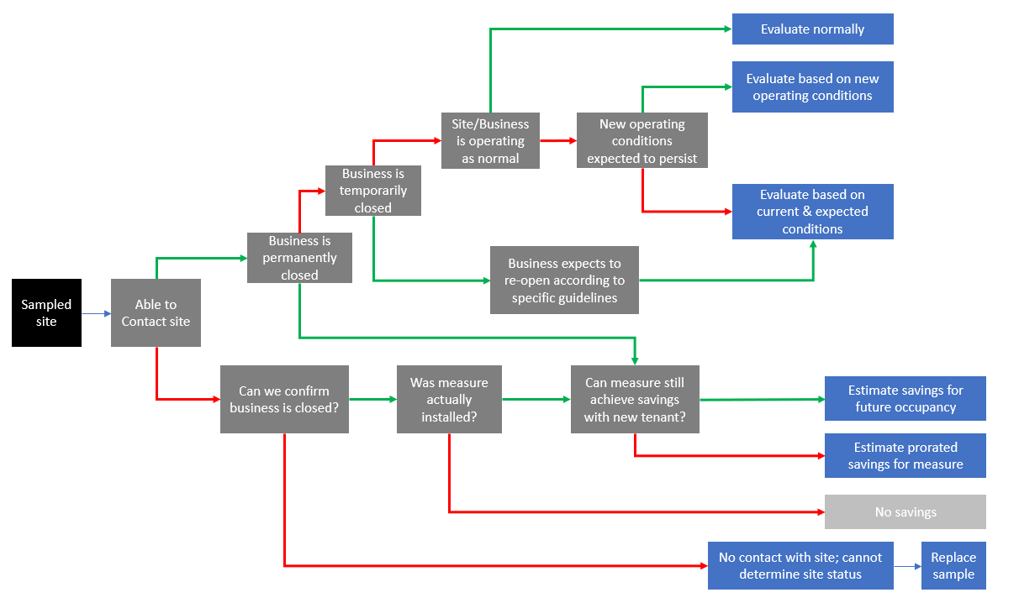
Source: Opinion Dynamics

“Section 1-3 VEIC Draft_10232015_ICC Staff_11-2-15 Navigant Bus Closure”

