ComEd Home Energy Report Program Decay Rate and Persistence Study – Year Five Research Report

  - Presented to
  - Commonwealth Edison Company

  - Draft

October 25, 2019

Prepared by:

Carly Olig  Navigant | Vivek Nath  Navigant

www.guidehouse.com

Submitted to:

ComEd
2011 Swift Drive
Oakbrook, IL 60523

Submitted by:

Navigant Consulting, Inc., A Guidehouse Company
150 N. Riverside, Suite 2100
Chicago, IL 60606

Contact:

Randy Gunn, Managing Director  312.583.5714  Randy.Gunn@Navigant.com | Jeff Erickson, Director  608.616.4962  Jeff.Erickson@Navigant.Com | Carly Olig, Associate Director  608.616.4810  Carly.Olig@Navigant.com

Disclaimer: This report was prepared by Navigant Consulting, Inc., n/k/a Guidehouse Inc. (Navigant) for ComEd based upon information provided by ComEd and from other sources. Use of this report by any other party for whatever purpose should not, and does not, absolve such party from using due diligence in verifying the report’s contents. Neither Navigant nor any of its subsidiaries or affiliates assumes any liability or duty of care to such parties, and hereby disclaims any such liability.

Table of Contents
1. Introduction 1
2. Research Description 1
3. Research Results 2
Annual Savings Decay Rate 2
4. Findings and Recommendations 5
5. Appendix 1. Impact Analysis Methodology 6
5.1 Statistical Models Used in the Impact Evaluation 6
5.1.1 Lagged Dependent Variable Model 6
5.1.2 Linear Fixed Effects Regression Model 7
5.2 Estimating Decay of Savings 8
5.3 Accounting for Uplift in Other Energy Efficiency Programs 9
5.3.1 Accounting for Uplift in the Analysis Period 9
5.3.2 Accounting for Legacy Uplift 10
6. Appendix 2. Impact Analysis Detail 10
7. Appendix 3. Detailed Data Cleaning 10

List of Tables and Figures
Figure 3-1. Decay Rate 3
Figure 3-2. Decay Rate Comparison 4

Table 3-1. HER Decay Rates 2
Table 3-2. HER Persistence Factors 2
Table 3-3. Existing and Recommended TRM Persistence Factors 4
Table 3-4. HER Persistence Savings and Measure Life 5
Table 3-5. HER Total Savings from November 2016 - October 2017 5
Table 7-1. Customers and Observations Removed by Data Cleaning Step (Wave 1) 11
Table 7-2. Customers and Observations Removed by Data Cleaning Step (Wave 3) 11
Table 7-3. Customers and Observations Removed by Data Cleaning Step (Wave 5) 12

Introduction
This report presents the results of the fifth year of research on persistence and decay in ComEd’s Home Energy Report (HER) Program. The primary objective is to identify the extent to which household energy savings persisted or decayed once customers no longer received HERs. The appendix presents the impact analysis methodology. Navigant’s fifth-year assessment evaluates savings between November 1, 2017 and October 31, 2018.

Research Description
This report extends earlier research which evaluated savings rates one, two, three, and four years after HER termination.,,, By continuing this analysis for a fifth year, Navigant can better identify the rate at which savings diminish following report termination, as this decay is not necessarily constant over time. These results can be used as one data point to determine the persistence factors and measure life for HER programs in the Illinois Technical Reference Manual (IL TRM).

The HER Program is designed to generate energy savings by providing residential customers with information about energy use and conservation. Program participants receive this information in the form of regularly-mailed HERs that give customers insight into their energy use, including:
- An assessment of how the customer’s recent energy use compares to past energy use
- Tips on how to reduce energy consumption, some of which are tailored to the customer’s unique circumstances
- Information on how their energy use compares to that of neighbors with similar homes

ComEd discontinued the HER Program for three sets of participants in October 2013. Customers in the Wave 1 terminated report (TR) group received reports for just over four years before they were discontinued; Wave 3 TR customers, for two and a half years; and Wave 5 TR customers, for just over one year. This research examines how savings from the reports persist for the TR customers in the fifth year after the last reports were sent (i.e., in period from November 2017 to October 2018).

Results from this analysis are specific to the study population and ComEd’s HER treatment of four print reports annually, monthly electronic HERs, and additional web features. Regulators, evaluators, and utilities should be judicious about extrapolating from Navigant’s results to other populations and HER treatments.

Research Results

Annual Savings Decay Rate
Table 3-1 and Table 3-2 present annual decay rates and persistence factors for the three TR groups in each of the five years since customers stopped receiving reports. Navigant calculated persistence for each wave by comparing savings rates of the TR group to those of the continued report (CR) group. The first two years after customers stopped receiving reports, decay rates increased for all three waves. In years three, four, and five, decay rates showed mixed results – increasing for some waves and decreasing for others. Many of the values across the years are not statistically different from one another. The average decay rate across waves was 37 percent in the fifth year of the persistence analysis.

Table 3-1. HER Decay Rates
 | Wave 1 | Wave 3 | Wave 5 | Average
Year 1 (Nov 2013 - Oct 2014) | 4% | 2% | 22% | 10%
Year 2 (Nov 2014 - Oct 2015) | 15% | 17% | 60% | 31%
Year 3 (Nov 2015 - Oct 2016) | 39% | 18% | 47% | 35%
Year 4 (Nov 2016 - Oct 2017)  Year 4 Standard Error | 28%  17% | 24%  13% | 38%  32% | 30%  -
Year 5 (Nov 2017 - Oct 2018)  Year 5 Standard Error | 14%  19% | 31%  16% | 65%  31% | 37%  -
Source: Navigant analysis
Table 3-2. HER Persistence Factors
 | Wave 1 | Wave 3 | Wave 5 | Average
Year 1 (Nov 2013 - Oct 2014) | 96% | 98% | 78% | 90%
Year 2 (Nov 2014 - Oct 2015) | 85% | 83% | 40% | 69%
Year 3 (Nov 2015 - Oct 2016) | 61% | 82% | 53% | 65%
Year 4 (Nov 2016 - Oct 2017) | 72% | 76% | 62% | 70%
Year 5 (Nov 2017 - Oct 2018) | 86% | 69% | 35% | 63%
Source: Navigant analysis

The change in the year-over-year decay rate can be more clearly seen in Figure 3-1. The decay rates vary across waves; however, they do appear to be closer to a linear pattern over time than an exponential one (as suggested by just the first two years of persistence research).

Figure 3-1. Decay Rate
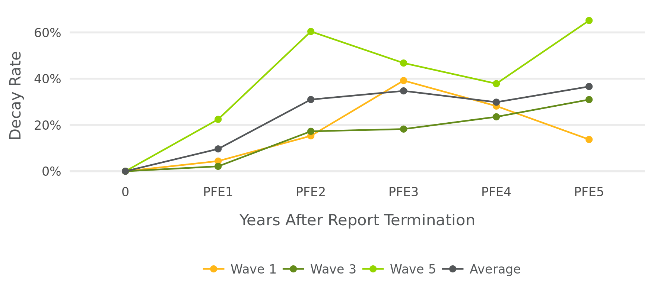
Note: PFE_{X} = Persistence Factor Electric in Year X.
Source: Navigant analysis

Figure 3-2 shows the 90 percent confidence interval for the decay rates calculated in the third, fourth, and fifth year after reports stopped. Based on Wald tests, PFE₅ decay rates were not statistically different from PFE₄ estimates for each wave. In addition, for Wave 5 the confidence bound on PFE₅ includes one on the high end meaning that that wave did not have any statistically significant savings five years after reports stopped.
Figure 3-2. Decay Rate Comparison
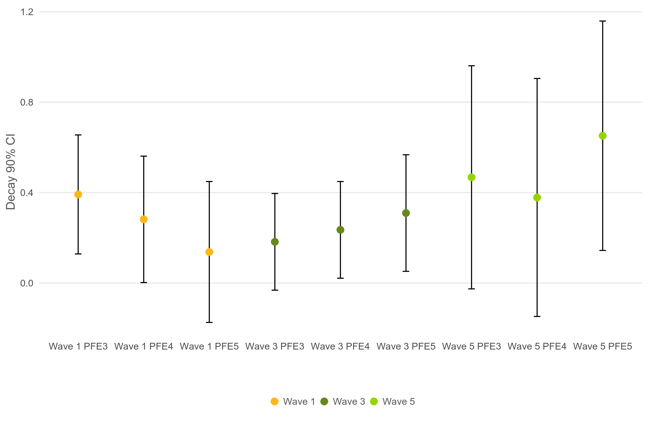
Note: PFE_{X} = Persistence Factor Electric in Year X.
Source: Navigant analysis

The IL TRM provides HER energy savings persistence values based on existing research and extrapolation of those findings. Table 3-3 shows those figures relative to Navigant’s research using ComEd data. The year column identifies the temporal relationship of the data to report termination. For example, Persistence Factor Electric 1 (PFE₁) is one year after customers stopped receiving HERs. The persistence factors from Navigant’s analysis decreased each year, except for PFE₄ when there was a slight increase. Throughout the years, Navigant’s persistence factors are higher than the TRM and may suggest a measure life longer than five years. This is likely driven by the length of treatment prior to report termination which was up to four years for the ComEd waves being studied. A five year measure life is supported by the fact that Wave 5, which had the shortest treatment before report termination, did not have any statistically significant savings in this year’s analysis.

Table 3-3. Existing and Recommended TRM Persistence Factors
Year | TRM Persistence Factors | Navigant Analysis Persistence Factors
 | 100% | 100%
PFE₁ | 80% | 90%
PFE₂ | 54% | 69%
PFE₃ | 31% | 65%
PFE₄ | 15% | 70%
PFE₅ | 0% | 63%
Source: Navigant analysis

Table 3-4 presents a summary of lifetime persistence savings and measure life using results from the fifth year after report termination. Readers should not compare lifetime persistence savings across waves due to variation in the number of participants, and therefore total savings. For example, because Wave 1 had 11 percent more customers than Wave 5, it will likely have a higher savings figure, regardless of its persistence factor. Wave measure life, however, can be directly compared. To calculate measure life, Navigant took decay figures from the first five years, and projected savings would continue to decay at the rate observed in the fifth year. Of the three waves, Wave 1 had the longest measure life and Wave 5 had the shortest.

Table 3-4. HER Persistence Savings and Measure Life
 | Wave 1 | Wave 3 | Wave 5 | Average
Lifetime Persistence Savings | 20,874 | 23,546 | 7,404 | -
Measure Life | 8.21 | 6.12 | 3.18 | 5.84
Year 5 Standard Error | 1.17 | 0.74 | 0.98 | -
Source: Navigant analysis

Table 3-5 summarizes wave results for the fifth year after report termination. Results are separated by CR and TR customers to identify the number of participants and savings related to each group. Because the analysis period does not match up with a typical ComEd program year, this study did not estimate legacy uplift savings.

Table 3-5. HER Total Savings from November 2017 - October 2018
Savings Category | Wave 1 CR | Wave 1 TR | Wave 3 CR | Wave 3 TR | Wave 5 CR | Wave 5 TR
Number of Participants | 19,304 | 5,934 | 130,545 | 7,092 | 5,100 | 5,060
Sample Size - Treatment | 18,262 | 5,625 | 123,723 | 6,717 | 4,633 | 4,638
Sample Size - Control | 27,807 |  | 33,959 |  | 6,036
Percentage Savings | 2.55% | 2.20% | 2.40% | 1.65% | 1.95% | 0.68%
Standard Error | 0.31% | 0.49% | 0.19% | 0.41% | 0.68% | 0.67%
Verified Net Savings, Prior to Uplift Adjustment, MWh* | 6,448 | 1,708 | 51,770 | 1,933 | 1,926 | 676
Standard Error | 776 | 381 | 4,057 | 478 | 673 | 667
Savings Uplift in Other EE Programs in Analysis Period, MWh | 53 | 14 | 471 | 24 | 4 | 21
Verified Net Savings, MWh† | 6,395 | 1,694 | 51,300 | 1,909 | 1,923 | 654
*Total savings are pro-rated for participants that closed their accounts during the analysis period.
†Gross savings adjusted for savings uplift are equal to gross savings less the uplift of savings in other EE programs.
Source: Navigant analysis.

Findings and Recommendations
Finding 1. Relative to the year four persistence study, decay rates decreased for Wave 1 but increased for Waves 3 and 5. These decay rates are higher than the values found in IL TRM Version 8.0, and average 37 percent across all waves. However, year five wave decay rates continue to show high levels of uncertainty based on large confidence bounds.
Recommendation 1. Navigant recommends that the IL TRM combine this analysis with other relevant studies to update the persistence factors for Version 9 for the Illinois utilities to use for their next planning cycle.

Appendix 1. Impact Analysis Methodology

Statistical Models Used in the Impact Evaluation
Navigant used statistical analysis appropriate for an RCT to calculate HER Program persistence savings, which is consistent with annual program year evaluations. This approach estimated program impacts using two methods: a lagged dependent variable (LDV) regression and a linear fixed-effects regression (LFER) applied to monthly billing data. Navigant calculated persistence, decay, and measure life by comparing the TR group to the CR group for each wave.

Lagged Dependent Variable Model
The LDV model controls for non-treatment differences in energy use between treatment and control customers using lagged energy use as an explanatory variable. The model frames energy use in calendar month t of the post-program period as a function of both the treatment variable and energy use in the same calendar month of the pre-program period. The underlying logic is that systematic differences between control and treatment customers will be reflected in differences in their past energy use, which is highly correlated with their current energy use. Formally, the model is shown in Equation 5-1.

Equation 5-1. Lagged Dependent Variable Model
$${ADU}_{kt}=β_{1}{Treatment}_{k}∙TR_{k}+β_{2}{Treatment}_{k}∙CR_{k}+\sum_{J}{β_{3j}{Month}_{jt}}+\sum_{J}{β_{4j}{Month}_{jt}∙{ADUlag}_{kt}}+ε_{kt}$$

Where,
is average daily consumption of kWh by household k in bill period t
is a binary variable taking a value of 0 if household k is assigned to the control group, and 1 if assigned to the treatment group
is a binary variable taking a value of 1 if household k is assigned to the terminated report group
is a binary variable taking a value of 1 if household k is assigned to the continued report group
is household k’s energy use in the same calendar month of the pre-program year as the calendar month of month t
is a binary variable taking a value of 1 when j = t and 0 otherwise
is the cluster-robust error term for household k during billing cycle t; cluster-robust errors account for heteroskedasticity and autocorrelation at the household level.

The coefficients $β_{1}$ and $β_{2}$ are the estimates of average daily kWh energy savings due to the program in the fourth year after reports were terminated for the TR and CR groups, respectively.

Linear Fixed Effects Regression Model
The version of the LFER model used by Navigant is one in which average daily consumption of kWh by household k in bill period t, denoted by ADU_{kt}, is a function of the following five terms:

- The binary variable Treatment_{k}
- The binary variable Post_{t}, taking a value of 0 if month t is in the pre-treatment period, and 1 if in the post-treatment period
- The interaction between these variables, Treatment_{k} · Post_{t}, taking the value of 1 at time t for household k if a treatment household is operating in the post-treatment period
- The binary variable TR_{k} taking a value of 1 if the customer was in the TR group and 0 otherwise
- The binary variable CR_{k} taking a value of 1 if the customer was in the CR group and 0 otherwise
Formally, the LFER model is shown in Equation 5-2.

Equation 5-2. Linear Fixed Effects Regression Model
$${ADU}_{kt}=α_{0k}+α_{1}{Post}_{t}+α_{2}{Treatment}_{k}∙TR_{k}∙{Post}_{t}+α_{3}{Treatment}_{k}∙CR_{k}∙{Post}_{t}+ε_{kt}$$

Three observations about this specification deserve comment. First, the coefficient α_{0k} captures all household-specific effects on energy use that do not change over time, including those that are unobservable to the researcher. Second, α₁ captures the average effect across all households of being in the post-treatment period. Third, the effect of being both in the treatment group and in the post period – the effect directly attributable to the program – is captured by the coefficient α₂ for the TR group and α₃ for the CR group. In other words, whereas the coefficient α₁ captures the change in average daily kWh use between the pre- and post-treatment time periods for both the treatment and the control group, the sums α₁ +α₂ and α₁ +α₃ capture this change exclusively for the TR treatment group and CR treatment group, and so α₂ and α₃ are the estimates of average daily kWh energy savings due to the program in the fourth year after reports were terminated for the TR and CR groups, respectively.

Estimating Decay of Savings
The decay rate for any year t is equal to one minus the ratio of the percentage savings for the TR group in the t^{th} year after the reports were discontinued to percentage savings for the CR group in that same year. Equation 5-3 shows this calculation, where $δ_{t}$ is the decay rate to the t^{th} year after reports were discontinued.

Equation 5-3. Decay Rate to Year t
$$δ_{t}=1-\frac{\% Savings for TR in t^{th} year after reports stop}{\% Savings for CR in t^{th} year after reports stop for TR}$$

Navigant uses the average annual decay rate to determine lifetime persistence savings and measure life for each wave. Equation 5-4 identifies the formula to calculate annual decay, where $∆$ is the decay rate, and t is the number of years since customers stopped receiving reports.

Equation 5-4. Average Annual Decay Rate
$$∆=-\frac{{ln⁡(1-δ}_{t})}{t}$$

Both annual decay rate and lifetime persistence savings are used to estimate measure life, which represents the time that an HER Program is expected to continue producing energy savings. Lifetime persistence savings is the total savings attributable to the program after reports stop. The lifetime persistence savings are calculated via an infinite series which converges to Equation 5-5, where α is the annual attrition due to residence changes, and $∆$ is the annual decay rate. Most importantly, the lifetime persistence savings measure assumes that savings in the t^{th} year following the termination of reports will remain constant for year t+1 onward.

Equation 5-5. Lifetime Persistence Savings
$$Lifetime Persistence Savings_{t}=Total savings for TR up to t^{th} year after reports stop for TR+ \frac{Total Savings for TR in t^{th} year after reports stop for TR}{∆+α-(∆*α)}$$

Measure life in Equation 5-6 represents the time that an HER program is expected to remain useful following termination considering (1) lifetime persistence savings, measured in year t since HER termination, and (2) total savings in the first year after HER termination. Due to the savings term in the denominator, measure life can be expressed in first-year savings equivalents, allowing its interpretation as a duration of savings directly following HER termination.

Equation 5-6. Measure Life
$$Meas Life_{t}=\frac{Lifetime Persistence Savings_{t}}{Total Savings for TR in 1st year after reports stop for TR}$$

Accounting for Uplift in Other Energy Efficiency Programs

Accounting for Uplift in the Analysis Period
The reports sent to participating households included energy-saving tips, some of which encouraged participants to enroll in other ComEd energy efficiency (EE) programs. If participation rates in other EE programs are the same for the HER participant and control groups, the savings estimates from the regression analyses are already “net” of savings from the other programs, as this indicates the HER Program did not increase or decrease participation in the other EE programs. However, if the HER Program affects participation rates in other EE programs, then savings across all programs are lower than indicated by the simple summation of savings in the HER and EE programs. For instance, if the HER Program increases participation in other EE programs, the increase in savings may be allocated to either the HER Program or the EE program, but cannot be allocated to both programs simultaneously.

Navigant used a difference-in-difference (DID) statistic to estimate uplift in other EE programs between November 2017 and October 2018. To calculate the DID statistic, Navigant subtracted the change in the participation rate in another EE program between the analysis period and the pre-program year for the control group from the same change for the treatment group. For instance, if the rate of participation in an EE program during the analysis period is five percent for the treatment group and three percent for the control group, and the rate of participation during the year before the start of the HER Program is two percent for the treatment group and one percent for the control group, then the rate of uplift due to the HER Program is one percent, as reflected in Equation 5-7.

Equation 5-7. DID Statistic Calculation
$$\left(analysis period treatment group participation-prePY treatment group participation\right)-\left(analysis period control group participation-prePY control group participation\right)=DID statistic$$
$$\left(5\%-2\%\right)-\left(3\%-1\%\right)=1\%$$

The DID statistic generates an unbiased estimate of uplift when the baseline average rate of participation is the same for the treatment and control groups, or when they are different due only to differences between the two groups in time-invariant factors, such as residency square footage.

A simple difference in participation rates during the analysis period provides an alternative unbiased estimate of uplift when the baseline average rate of participation in the EE program is the same for the treatment and control groups. Navigant used this alternative statistic –the “post-only difference” (POD) statistic –in cases where the EE program did not exist for the entire pre-program year.

Navigant examined uplift associated with the following EE programs: Fridge Freezer Recycling (FFR), Home Energy Assessments (HEA), Single Family Retrofits, Multi-family Retrofits, Weatherization (Wx) Rebates, and Heating and Cooling (HVAC) Rebates.,

Accounting for Legacy Uplift
The uplift adjustment methodology described only accounts for uplift which occurs in the current year because EE program tracking files in any given program year only capture new measures installed in that year, regardless of expected measure lives. However, for other EE programs with multi-year measure lives, HER Program savings capture the portion of their savings due to uplift in each year of that program’s measure life. For instance, a measure with a ten-year measure life that was installed in PY2 would generate savings captured in the HER Program savings not just in PY2, but in PY3 through PY11 as well.

Since the analysis period for this study is off from a regular program year Navigant was unable to accurately estimate legacy uplift for this analysis period.

Appendix 2. Impact Analysis Detail
Wave LDV and LFER model results are available upon request. Across the two models, the parameter estimates are not statistically different; that is, the estimates for each model are within the 90 percent confidence bounds for the other model. Furthermore, the pattern across the different program waves between the two models is very similar.

Appendix 3. Detailed Data Cleaning
Table 7-1 through Table 7-3 give counts and percentages of customers and observations removed during the data cleaning process. The tables also provide the percentage of customers or observations removed. It is evident from the tables that the percentage of customers or observations removed was very similar across the treatment and control groups for each wave. This suggests that non-random biases were not introduced into the data by our cleaning.

Table 7-1. Customers and Observations Removed by Data Cleaning Step (Wave 1)
Data Cleaning Step  Wave 1 | Customers |  | Observations |  | Customer % Change |  | Observation % Change
 | Treatment | Control | Treatment | Control | Treatment | Control | Treatment | Control
Raw Data | 46,503 | 43,861 | 4,805,838 | 4,523,152 | - | - | - | -
Subset to pre/post periods and desired customers | 23,902 | 27,824 | 565,042 | 657,799 | 49% | 37% | 88% | 85%
Remove exact duplicate observations | 23,902 | 27,824 | 565,042 | 657,799 | 0% | 0% | 0% | 0%
Bill Flattening | 23,902 | 27,824 | 551,873 | 642,223 | 0% | 0% | 2% | 2%
Exclude outliers | 23,901 | 27,820 | 551,568 | 641,902 | 0% | 0% | 0% | 0%
Remove pre-period data (for LDV analysis) | 23,896 | 27,817 | 274,696 | 319,762 | 0% | 0% | 50% | 50%
Remove observations without a monthly pre-use value (for LDV analysis) | 23,887 | 27,807 | 265,700 | 309,145 | 0% | 0% | 3% | 3%
Source: Navigant analysis

Table 7-2. Customers and Observations Removed by Data Cleaning Step (Wave 3)
Data Cleaning Step  Wave 3 | Customers |  | Observations |  | Customer % Change |  | Observation % Change
 | Treatment | Control | Treatment | Control | Treatment | Control | Treatment | Control
Raw Data | 198,689 | 49,061 | 17,588,910 | 4,350,816 | - | - | - | -
Subset to pre/post periods and desired customers | 130,481 | 33,973 | 3,083,782 | 802,918 | 34% | 31% | 82% | 82%
Remove exact duplicate observations | 130,481 | 33,973 | 3,083,782 | 802,918 | 0% | 0% | 0% | 0%
Bill Flattening | 130,481 | 33,973 | 3,007,488 | 782,777 | 0% | 0% | 2% | 3%
Exclude outliers | 130,481 | 33,973 | 3,007,146 | 782,680 | 0% | 0% | 0% | 0%
Remove pre-period data (for LDV analysis) | 130,458 | 33,964 | 1,489,447 | 387,761 | 0% | 0% | 50% | 50%
Remove observations without a monthly pre-use value (for LDV analysis) | 130,440 | 33,959 | 1,443,413 | 375,565 | 0% | 0% | 3% | 3%
Source: Navigant analysis

Table 7-3. Customers and Observations Removed by Data Cleaning Step (Wave 5)
Data Cleaning Step  Wave 5 | Customers |  | Observations |  | Customer % Change |  | Observation % Change
 | Treatment | Control | Treatment | Control | Treatment | Control | Treatment | Control
Raw Data | 19,886 | 12,756 | 1,183,630 | 758,298 | - | - | - | -
Subset to pre/post periods and desired customers | 9,290 | 6,045 | 213,797 | 139,091 | 53% | 53% | 82% | 82%
Remove exact duplicate observations | 9,290 | 6,045 | 213,797 | 139,091 | 0% | 0% | 0% | 0%
Bill Flattening | 9,290 | 6,045 | 208,468 | 135,626 | 0% | 0% | 2% | 2%
Exclude outliers | 9,290 | 6,045 | 208,418 | 135,577 | 0% | 0% | 0% | 0%
Remove pre-period data (for LDV analysis) | 9,283 | 6,041 | 104,681 | 68,263 | 0% | 0% | 50% | 50%
Remove observations without a monthly pre-use value (for LDV analysis) | 9,271 | 6,036 | 97,655 | 63,491 | 0% | 0% | 7% | 7%
Source: Navigant analysis

On October 11, 2019, Guidehouse LLP completed its previously announced acquisition of Navigant Consulting Inc. In the months ahead, we will be working to integrate the Guidehouse and Navigant businesses. In furtherance of that effort, we recently renamed Navigant Consulting Inc. as Guidehouse Inc.
Navigant. 2016a. Home Energy Report Opower Program Decay Rate and Persistence Study. Presented to Commonwealth Edison Company.
Navigant. 2016b. Home Energy Report Opower Program Decay Rate and Persistence Study – Year Two. Presented to Commonwealth Edison Company.
Navigant. 2017. Home Energy Report Opower Program Decay Rate and Persistence Study – Year Three. Presented to Commonwealth Edison Company.
Navigant. 2018. ComEd Home Energy Report Program Decay Rate and Persistence Study – Year Five Research Report. Presented to Commonwealth Edison Company.
The relevant measure is “Adjustments to Behavior Savings to Account for Persistence” which is measure 6.1.1 in Volume 4 of Version 8 of the IL TRM.
The persistence factor is equal to one minus the decay rate.
These estimates assume a resident move-out-rate of 6 percent for years one through four and 10.1 percent for year five. The year five move out rate was updated to 10.1 percent to match the move-out rate calculated for ComEd’s CY2018 HER Program evaluation.
See Appendix 1. Impact Analysis Methodology for a more detailed examination of how these calculations were conducted.
Future analysis will provide additional decay rate estimates and suggest the point in time at which savings diminish to zero.
When legacy uplift was included in Navigant’s first-year persistence study, the difference in total savings made a negligible impact on the decay rate and measure life, so the legacy adjustment was not included in this analysis.
See Measure 6.1.1, Volume 4.
For example, DNV-GL 2014, Home Energy Report Program 2013 Impact Evaluation. Presented to Puget Sound Energy.
See for example: Navigant Consulting Inc. 2016. “Home Energy Report Opower Program PY8 Evaluation Report.” Presented to Commonwealth Edison Company.
The model is identical to the post-program regression (PPR) model used in previous evaluations. We have changed the nomenclature to better align with academic research and because LDV is more descriptive of the model structure than PPR.
In other words, if there are T post-program months, there are T monthly dummy variables in the model, with the dummy variable Month_{t} to take a value of 1 at time t. These are, in other words, monthly fixed effects.
Ordinary Least Squares (OLS) regression models assume that the data are homoscedastic and not autocorrelated. If either of these assumptions are violated, the resulting standard errors of the parameter estimates are incorrect (usually downward biased). A random variable is heteroscedastic when its variance is not constant over the variable’s entire distribution. A random variable exhibits autocorrelation when its error term in one period is correlated with the error terms in at least some of the previous periods.
The Cadmus Group, Inc. 2014. “Long-Run Savings and Cost-Effectiveness of Home Energy Report Programs.” Prepared by M. Sami Khawaja, PhD. And James Stewart, PhD.
The convergence assumes that savings decay infinitely at a constant annual rate of (1-δ)(1-α).
It is not possible to avoid double counting of savings generated by programs for which tracking data are not available, such as upstream compact fluorescent lamp (CFL) programs.
These are the names used for these programs in CY2018.
ComEd has other residential programs that were not included in the analysis. The Appliance Rebate, Elementary Education, Lighting Discounts, Middle School Take-Home Kits, Food Bank LED Distribution, and Low Income Kits programs do not track participation at the customer level, and so do not have the data necessary for the uplift analysis. Double counting between the Residential New Construction and Affordable Housing New Construction Programs and HER is not possible due to the requirement that HER participants have sufficient historical usage data.

