|  |  |  |  |  |  |  |  |  |  |
| --- | --- | --- | --- | --- | --- | --- | --- | --- | --- |
|  | | | | | | | | | |
| ComEd Public Housing Retrofits Program Impact Evaluation Report  Energy Efficiency/Demand Response Plan:  Program Year 2021 (CY2021)  (1/1/2021-12/31/2021) | | | | | | | | | |
| Prepared for:  ComEd  DRAFT  March 14, 2022 | | | | | | | | | |
| Prepared by: | | | | | |  | | | |
| **Zac Hathaway**  Opinion Dynamics | | | **Mahsa Safari**  Opinion Dynamics | | | |  | | | |
|  |  | | | |  | | | | | |
|  |  | | |  | | | | |  | |
| **guidehouse.com** | |  | | | |  | |  | |

Submitted to:

ComEd

2011 Swift Drive

Oak Brook, IL 60523

Submitted by:

Guidehouse Inc.

150 N. Riverside Plaza, Suite 2100

Chicago, IL 60606

**Contact:**

|  |  |  |
| --- | --- | --- |
| Charles Maglione, Partner  703.431.1983  [**cmaglione@guidehouse.com**](mailto:cmaglione@guidehouse.com) | Jeff Erickson, Director  608.616.4962  [**jeff.erickson@guidehouse.com**](mailto:jeff.erickson@guidehouse.com) | Neil Curtis, Associate Director  802.526.5119  [neil.curtis@guidehouse.com](mailto:neil.curtis@guidehouse.com) |

This report was prepared by Guidehouse for ComEd. The work presented in this report represents Guidehouse’s professional judgment based on the information available at the time this report was prepared. Use of this report by any other party for whatever purpose should not, and does not, absolve such party from using due diligence in verifying the report’s contents. Neither Guidehouse nor any of its subsidiaries or affiliates assumes any liability or duty of care to such parties, and hereby disclaims any such liability.

Table of Contents

1. Introduction 1

2. Program Description 2

3. Program Savings Detail 4

4. Cumulative Persisting Annual Savings 5

5. Program Savings by Measure 14

6. Impact Analysis Findings and Recommendations 18

6.1 Overarching 18

6.2 Lighting 19

6.3 Attic Insulation and Air Sealing 19

6.4 Split AC 19

Appendix A. Impact Analysis Methodology A-1

Appendix B. Impact Findings Detailed Results B-1

Appendix C. Total Resource Cost Detail C-1

List of Tables and Figures

Figure 2‑1. Share of Measures Installed by End Use Type 3

Figure 4‑1. Cumulative Persisting Annual Savings 13

Figure 5‑1. Verified Net Savings by Measure – Electric 15

Table 2‑1. Number of Participants and Projects 2

Table 2‑2. Number of Measures by Type 3

Table 3‑1. Total Annual Incremental Electric Savings 4

Table 4‑1. Cumulative Persisting Annual Savings – Electric 6

Table 4‑2. Cumulative Persisting Annual Savings – Gas 9

Table 4‑3. Cumulative Persisting Annual Savings – Total 11

Table 5‑1. Number of Measures by Type 14

Table 5‑2. Energy Savings by Measure – Electric 15

Table 5‑3. Summer Peak Demand Savings by Measure 16

Table 5‑4. Secondary Energy Savings from Water Reduction by Measure – Electric 16

Table 5‑5. Energy Savings by Measure – Gas 17

Table 5‑6. Energy Savings by Measure – Total 17

Table B‑1. Savings and Realization Rates by Research Category B-1

Table B‑2. Verified Measure Per-Unit Impact Detail – Electric B-2

Table C‑1. Total Resource Cost Savings Summary C-1

# Introduction

This report presents the results of the impact evaluation of the CY2021 Public Housing Retrofits Program. It summarizes the total energy and demand impacts for the program broken out by relevant measure and program structure details. The appendices provide the impact analysis methodology and details of the total resource cost (TRC) analysis inputs. CY2021 covers January 1, 2021 through December 31, 2021.

# Program Description

The Public Housing Retrofits Program works with public housing authorities (PHAs) in ComEd, Nicor Gas, Peoples Gas, and North Shore Gas territories to achieve electric and gas savings. The program is referred to as Public Housing Authority in the net-to-gross (NTG) spreadsheet. The PHA itself is the program participant, though the residents of the properties are directly affected by the program through in-unit (IU) and common area (CA) upgrades.

In CY2021, the program achieved electric and summer peak demand savings for 135 projects across 57 PHA properties, installing 157,400 measures (see Table 2‑1). These counts exclude gas savings-only projects, which are detailed in the separate gas utility evaluation reports.

Table 2‑1. Number of Participants and Projects



Source: ComEd tracking data and evaluation team analysis

In CY2021, the program provided direct install (DI) measures to residential units, such as light-emitting diodes (LEDs), advanced power strips, low flow faucet aerators, and programmable thermostats. The program also provided CA measures such as space heating and cooling, lighting, and envelope upgrades.

The program included the measures shown in Table 2‑2 and Figure 2‑1.

Table 2‑2. Number of Measures by Type



HVAC – heating, ventilation, and air conditioning

AC – air conditioner

Source: ComEd tracking data and evaluation team analysis

Figure 2‑1. Share of Measures Installed by End Use Type

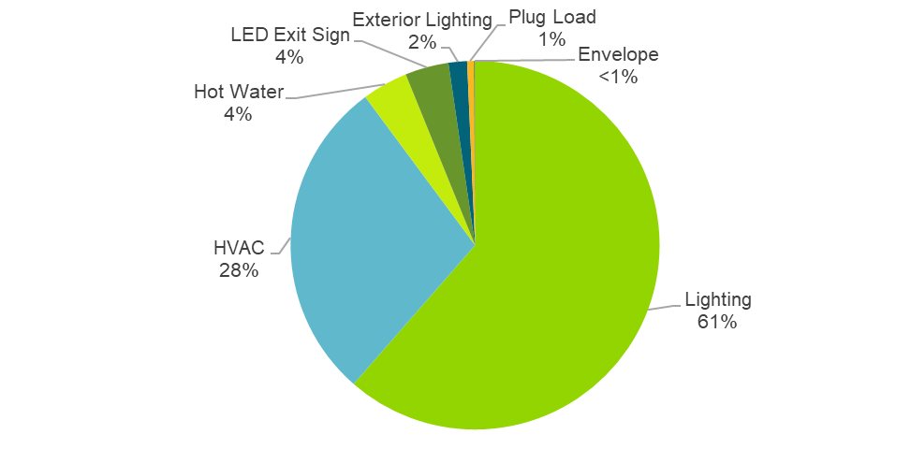

Source: ComEd tracking data and evaluation team analysis

# Program Savings Detail

Table 3‑1 summarizes the incremental energy and demand savings the Public Housing Retrofits Program achieved in CY2021. The gas savings are only those that ComEd may be able to claim, which excludes savings the gas utilities claim, either via joint or non-joint programs.[1]

Table 3‑1. Total Annual Incremental Electric Savings



N/A = not applicable (refers to a piece of data that cannot be produced or does not apply).

‡ Gas savings are converted to kilowatt-hours (kWh) by multiplying therms by 29.31 (which is based on 100,000 Btu/therm and 3,412 Btu/kWh). The evaluation team will determine which gas savings will be converted to kWh and counted toward ComEd's electric savings goal while producing the portfolio-wide Summary Report. According to Section 8-103B(b-25) of the Illinois Public Utilities Act, “In no event shall more than 10% of each year's applicable annual incremental goal as defined in paragraph (7) of subsection (g) of this Section be met through savings of fuels other than electricity.”

§ The coincident summer peak period is defined as 1:00-5:00 p.m. Central Prevailing Time on non-holiday weekdays, June through August.

Source: ComEd tracking data and evaluation team analysis

# Cumulative Persisting Annual Savings

Table 4‑1 to Table 4‑3 and Figure 4‑1 show the measure-specific and total verified gross savings for the Public Housing Retrofits Program and the cumulative persisting annual savings (CPAS) for the measures installed in CY2021. The electric CPAS across all measures installed in 2021 is shown in Table 4‑1. The CY2021 gas contribution to CPAS (converted to equivalent electricity) is shown in Table 4‑2. The combined savings are shown in Table 4‑3. The historic rows in each table are the CPAS contribution back to CY2018. The Program Total Electric CPAS and the Program Total Gas CPAS are the sum of the CY2021 contribution and the historic contribution. Figure 4‑1 shows the savings across the effective useful life (EUL) of the measures.

Table 4‑1. Cumulative Persisting Annual Savings – Electric







Note: The green highlighted cell shows program total first-year electric savings. The gray cells are blank, indicating values irrelevant to the CY2021 contribution to CPAS.

* A deemed value. Source: Illinois Stakeholder Advisory Group (SAG) website: <https://www.ilsag.info/evaluator-ntg-recommendations-for-2021>.

† Lifetime savings are the sum of CPAS savings through the EUL.

‡ Historic savings go back to CY2018.

§ Incremental expiring savings are equal to CPAS Yn-1 - CPAS Yn.

Source: Evaluation team analysis

Table 4‑2. Cumulative Persisting Annual Savings – Gas







Note: The green highlighted cell shows program total first-year gas savings in kWh equivalents. The gray cells are blank, indicating no values or do not contribute to calculating CPAS in CY2021.

* A deemed value. Source: Illinois SAG website: <https://www.ilsag.info/evaluator-ntg-recommendations-for-2021>.

† Lifetime savings are the sum of CPAS savings through the EUL.

‡ kWh equivalent savings are calculated by multiplying therm savings by 29.31.

§ Historic savings go back to CY2018.

|| Incremental expiring savings are equal to CPAS Yn-1 - CPAS Yn.

Source: Evaluation team analysis

Table 4‑3. Cumulative Persisting Annual Savings – Total







Note: The green highlighted cell shows program total first-year electric savings (including direct electric savings and those converted from gas). The gray cells are blank, indicating no values or do not contribute to calculating CPAS in CY2021.

* A deemed value. Source: Illinois SAG website: <https://www.ilsag.info/evaluator-ntg-recommendations-for-2021>.

† Lifetime savings are the sum of CPAS savings through the EUL.

‡ Historic savings go back to CY2018.

§ Incremental expiring savings are equal to CPAS Yn-1 - CPAS Yn.

Source: Evaluation team analysis

Figure 4‑1. Cumulative Persisting Annual Savings

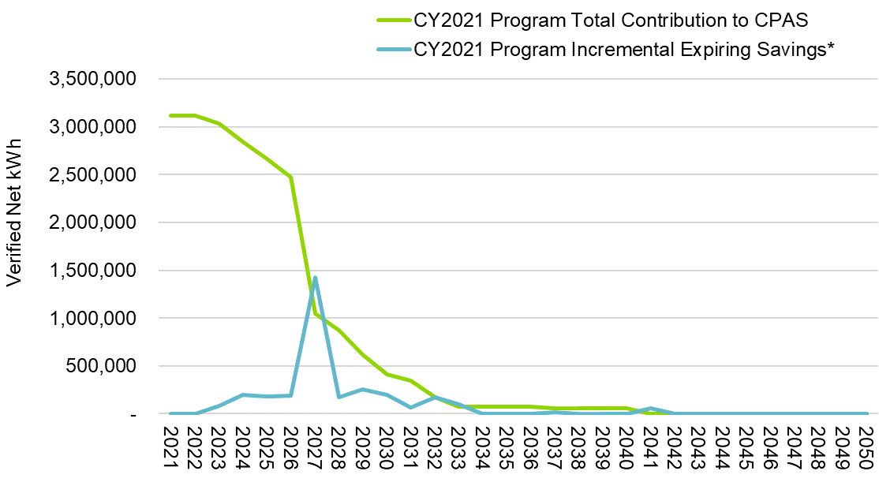

* Expiring savings are equal to CPAS Yn-1 - CPAS Yn.

Source: Evaluation team analysis

# Program Savings by Measure

The program included the research categories shown in Table 5‑1 and Figure 5‑1. Appendix B details savings by measure.

Table 5‑1. Number of Measures by Type



Notes: This is the same table as Table 2‑2.

The rows are sorted by verified electric savings.

Source: ComEd tracking data and evaluation team analysis

Figure 5‑1. Verified Net Savings by Measure – Electric

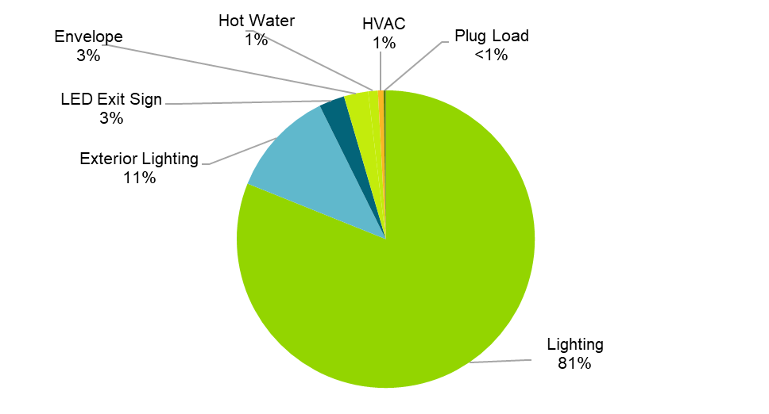

Source: ComEd tracking data and evaluation team analysis

Measure-level energy and demand savings are provided in Table 5‑2 and Table 5‑3.

Table 5‑2. Energy Savings by Measure – Electric



N/A = not applicable (refers to a piece of data that cannot be produced or does not apply).

Note: The savings in this table include secondary electric energy (kWh) savings from water supply and wastewater treatment plants for measures claimed by ComEd. The savings account for electric heating penalties, where applicable.

* A deemed value. Source: Illinois SAG website: <https://www.ilsag.info/evaluator-ntg-recommendations-for-2021>.

Source: ComEd tracking data and evaluation team analysis

Table 5‑3. Summer Peak Demand Savings by Measure



N/A = not applicable (refers to a piece of data that cannot be produced or does not apply).

* A deemed value. Source: Illinois SAG website: <https://www.ilsag.info/evaluator-ntg-recommendations-for-2021>.

Source: ComEd tracking data and evaluation team analysis

The Public Housing Retrofits Program includes measures that save water. That reduction in water produces secondary kWh savings from water supply and wastewater treatment. Table 5‑4 shows the secondary measure-level savings. The savings in this table are included in the electricity savings in the previous tables in this section.

Table 5‑4. Secondary Energy Savings from Water Reduction by Measure – Electric



N/A = not applicable (refers to a piece of data that cannot be produced or does not apply).

Note: The savings in this table reflect only secondary electric energy (kWh) savings from water supply and wastewater treatment plants for measures claimed by ComEd, not those claimed by gas utilities.

* A deemed value. Source: Illinois SAG website: <https://www.ilsag.info/evaluator-ntg-recommendations-for-2021>.

Source: ComEd tracking data and evaluation team analysis

The Public Housing Retrofits Program includes measures that save gas. Table 5‑5 shows the measure-level gas savings.

Table 5‑5. Energy Savings by Measure – Gas



N/A = not applicable (refers to a piece of data that cannot be produced or does not apply).

* A deemed value. Source: Illinois SAG website: <https://www.ilsag.info/evaluator-ntg-recommendations-for-2021>.

† Gas savings converted to kWh by multiplying therms by 29.31 (which is based on 100,000 Btu/therm and 3,412 Btu/kWh).

Source: ComEd tracking data and evaluation team analysis

Table 5‑6 is combined savings from Table 5‑2 and Table 5‑5.

Table 5‑6. Energy Savings by Measure – Total



* A deemed value. Source: Illinois SAG website: <https://www.ilsag.info/evaluator-ntg-recommendations-for-2021>.

† The total includes the electric equivalent of the total therms.

Source: ComEd tracking data and evaluation team analysis

# Impact Analysis Findings and Recommendations

The evaluation of the CY2021 program resulted in an overall realization rate of 1.01 and 1.05 for energy and demand savings, respectively. There is only one measure that has a realization rate of lower than 1.00. Table B‑1 presents the end use-level realization rates and program savings percentages to give context to the recommendations. Table B‑2 shows the per-unit ex ante and verified savings for each unique measure in the CY2021 tracking data. The evaluation team developed the following recommendations based on findings from the CY2021 evaluation. These recommendations suggest ways to improve the measure-level realization rates.

## Overarching

**Finding 1.** The program tracking data did not include the units of quantities (e.g., each, ton, fixture) and savings (e.g., kWh vs. MWh). The evaluation team confirmed with ComEd that, for many measures, quantities are not in terms of widgets—they are based on equipment size or square footage.

**Recommendation 1.** Include the units of quantities and savings in the tracking database to avoid potential mistakes in the savings calculation.

**Finding 2.** The program tracking data did not separately identify savings associated with water reductions, making a comparison of ex ante and ex post savings difficult.

**Recommendation 2.** Break out savings associated with water reductions as a separate field in the program tracking data.

**Finding 3**. In multiple cases, ex ante savings applied assumptions from the Illinois Technical Reference Manual v9.0 (IL-TRM)[2] for a building type that was not consistent with the type provided in the tracking database and the number of reported stories:

* For programmable thermostats, the ex ante calculations used a multifamily household factor (HF) of 0.65 instead of a single-family HF of 1. The ex post calculations corrected this per the IL-TRM, resulting in a 1.48 energy savings realization rate.
* For individual water heaters, the ex ante calculations used the multifamily value for number of people per household of 2.1 instead of the single-family value of 2.56. The ex post calculations corrected this per the IL-TRM, resulting in a 1.22 energy savings realization rate.
* In the case of split AC, ex ante savings for one of the measures applied full load hour and coincidence factor (CF) assumptions from the IL-TRM for single-family homes. Application of the correct values resulted in a 0.99 energy savings realization rate and had a negligible impact on verified peak demand savings.

**Recommendation 3.** Apply the IL-TRM assumptions consistent with the building type provided in the tracking database.

## Lighting

The five lighting categories account for a combined 95% of ex ante gross kWh savings. Realization rates for all five categories were 1.00 or greater.

**Finding 4.** For several interior LEDs, linear LEDs, and LED exit signs that operate continuously, the ex ante savings applied hours or CF assumptions for mid-rise or high-rise buildings. The evaluation team applied hours for 24/7 operation to calculate verified savings. This change resulted in a 1.12 energy savings realization rate for LED exit signs and was a main driver of the 1.07 peak demand realization rate for interior LEDs but had a negligible impact on the verified savings for linear LEDs.

**Recommendation 4.** For 24/7 measures, apply measure-specific hour of use and CF assumptions rather than building type-specific assumptions.

## Attic Insulation and Air Sealing

**Finding 5**. In some cases, ex ante savings did not include kWh and kW from cooling savings for attic insulation even though the database indicates central cooling is present. The evaluation team added cooling savings for these records, resulting in higher verified energy and peak demand savings.

**Recommendation 5.** Account for cooling savings according to the IL-TRM.

**Finding 6**. In one case, the ex ante calculations applied the IENetCorrection multiplier of 1.10 to estimate gas furnace fan runtime savings for air sealing and attic insulation. The IL-TRM Errata memorandum removes the multiplier. The evaluation team followed the IL-TRM Errata approach, resulting in lower verified electric energy savings.

**Recommendation 6.** Do not apply the IENetCorrection multiplier to develop kWh heating savings for natural gas systems because the adjustment has already been applied in the therms algorithm.

**Finding 7**. The ex ante approach included the PJM summer peak CF of 0.466 instead of the summer system peak CF of 0.68, resulting in an underestimation of demand savings. The evaluation team used the summer system peak CF to calculate verified savings, contributing to the peak demand realization rate of 2.17.

**Recommendation 7.** Use the IL-TRM algorithm in Section 5.6.5 and apply the correct summer system peak CF value of 0.68.

## Split AC

**Finding 8**. The ex ante approach did not calculate the kW savings using the algorithm in the IL-TRM. In addition, the ex ante approach used the PJM CF of 0.466 value instead of the summer system peak CF value of 0.68. The evaluation team applied the IL-TRM algorithm and used the summer system peak CF to calculate verified savings. These changes were the main driver of the 2.62 peak demand realization rate.

**Recommendation 8.** Use the IL-TRM algorithm in Section 5.3.3 and apply the correct CF value of 0.68.

##### Impact Analysis Methodology

The evaluation team calculated gross verified savings for the Public Housing Retrofits Program by applying savings algorithms from the IL-TRM and IL-TRM Errata memorandum. The team determined verified gross savings for each program measure by:

* Reviewing the savings algorithm inputs in the measure workbook for agreement with the IL-TRM and IL-TRM Errata.
* Validating savings algorithms were applied correctly.
* Prioritizing project-specific information to inform savings calculations where the IL-TRM advises to use actual values. For variables where project information did not include project-specific actual values, the team relied on defaults from the IL-TRM.
* Cross-checking per-unit savings values in the tracking data with the verified values in the measure workbook or in the team’s calculations if the workbook did not agree with the IL-TRM.
* Multiplying the verified per-unit savings value by the quantity reported in the tracking data.

The team calculated verified net energy and demand (coincident peak and overall) savings by multiplying the verified gross savings estimates by a NTG ratio of 1.0. For CY2021, the Public Housing Retrofits Program’s NTG estimate was defined by a consensus process through the Illinois SAG.

##### Impact Findings Detailed Results

Table B‑1 presents the end use-level realization rates and program savings percentages to give context to the team’s recommendations.

Table B‑1. Savings and Realization Rates by Research Category



RR – realization rate

N/A = not applicable (refers to a piece of data that cannot be produced or does not apply).

Source: Evaluation team analysis

Table B‑2 shows the per-unit ex ante and verified savings for each unique measure in the CY2021 tracking data.

Table B‑2. Verified Measure Per-Unit Impact Detail – Electric







N/A = not applicable (refers to a piece of data that cannot be produced or does not apply).

* IL-TRM v9.0 and IL-TRM v9.0 Errata, where applicable.

Source: Evaluation team analysis

##### Total Resource Cost Detail

Table C‑1 shows the TRC cost-effectiveness analysis inputs available at the time of finalizing this impact evaluation report. This table does not include additional required cost data (e.g., measure costs, program-level incentives, and non-incentive costs). ComEd will provide this data to the evaluation team later.

Table C‑1. Total Resource Cost Savings Summary



Note: To avoid double counting, the verified gross kWh and net kWh used in the TRC analysis exclude secondary energy savings from water reduction measures.

* The total of the EUL column is the weighted average measure life (WAML) and is calculated as the sum product of EUL and measure savings divided by total program savings.

† Early replacement (ER) measures are flagged as YES, otherwise a NO is indicated in the column.

‡ The EUL for this measure varies over time. See the CPAS tables (Table 4‑1 to Table 4‑3).

†§ The kWh savings account for electric heating penalties, where applicable. The electric heating penalties columns show the magnitude of adjustments applied to the program savings. Gas heating penalties represent the program therms heating penalties. The therms penalties are not required to be applied to the program savings.

*Source: ComEd tracking data and evaluation team analysis*

1. The evaluation team will determine which gas savings will be counted toward goal while producing the portfolio-wide Summary Report.
2. In this report, unless stated otherwise, IL-TRM and IL-TRM Errata refers to version 9.0 (v9.0).