Summary of Disadvantaged Areas NTG Policy Proposal
REVISED PROPOSED POLICY LANGUAGE – 5/10/23
In order for utility program administrators to more effectively target efforts to serve customers that have not previously participated in energy efficiency programs, members of the IL SAG agree that programs successfully serving communities identified and designated to be disadvantaged areas will receive a NTG Ratio of 1.0, similar to that for all income qualified programs. This policy would acknowledge that residential and business customers, including community service institutions, in certain communities or geographies face materially different or higher barriers to successful participation in energy efficiency offers while also facing higher than average levels of energy burden.
In light of the additional marketing, education, outreach, and coordination efforts (e.g., with community partners) that are needed to serve these disadvantaged areas and customer segments, energy efficiency programs that successfully engage these areas should receive higher savings attribution relative to programs completed in non-disadvantaged areas.
The disadvantaged areas designated by this policy are:
- the income-eligible communities identified by Illinois Solar for All (ILSfA) based on socioeconomic indicators. These are census tracts where at least half of the households earn an income of 80% or less than the Area Median Income., and
- the entire area of certain municipalities (tbd) where at least 50% of the municipality is identified as income-eligible through ILSfA.
The policy will apply to all program activity involving the following customer segments within disadvantaged areas:
- residential customers,
- general delivery electric rate class designations below 400kw (e.g., DS-2 and DS-3A rates for Ameren Illinois), or
- general delivery gas rate class designations below 1,000 therms per day (e.g., GDS-2 and GDS-3 rates for Ameren Illinois), or
- any general delivery service municipal business customer.

It is expected that, though customers in disadvantaged areas are currently underrepresented in evaluation research due to lower participation levels, going forward, this policy will require that research to establish NTGRs for program activity explicitly sample customers in non-disadvantaged areas.

SOME ADDITIONAL INFORMATION
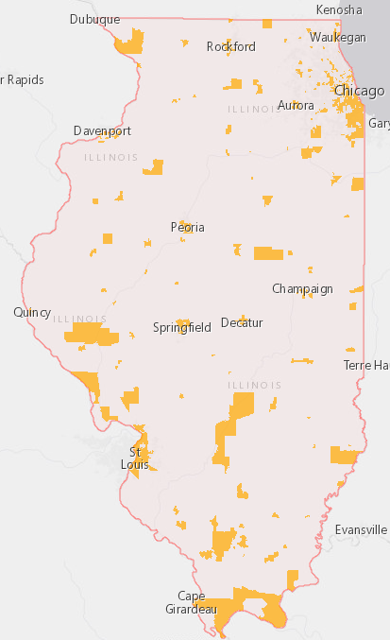
Definition of Disadvantaged Areas
FIGURE 1. ILSfA – Income-Eligible Communities
The disadvantaged areas identified as income-eligible communities identified by Illinois Solar for All (ILSfA) (ILSfA Designations) are shown in Figure 1 or can be viewed interactively at: ILSfA Census Tract Income Eligibility Search Tool (arcgis.com).

Eligible Customers
A breakdown of the energy usage by rate class for the Ameren Illinois service territory is provided in Table 1 below.

TABLE 1. Ameren Illinois Accounts and Energy Use by Rate Class
AIC RATE CLASS | Number of Business Accounts | Annual Electricity Use (MWH) | % of Total | Average Electricity Use per Account (MWH)
DS2 | 165,213 | 4,821,516 | 21% | 29
D3A | 2,715 | 1,977,172 | 9% | 728
D3B | 909 | 1,837,758 | 8% | 2,022
DS4 | 514 | 14,274,570 | 62% | 27,772
DS5 | 6,526 | 108,842 | 0% | 17
DS6 | 131 | 71,007 | 0% | 542
AIC RATE CLASS | Number of Business Accounts | Annual Gas Use (Therms) | % of Total | Average Gas Use per Account (Therms)
GS2 | 63,812 | 220,915,078 | 21% | 3,462
GS3 | 1,537 | 147,645,627 | 14% | 96,061
GS4 | 323 | 651,691,424 | 62% | 2,017,621
GS5 | 240 | 23,844,176 | 2% | 99,351

Program implementers may convert from the two geographies listed (census tracts and municipal boundaries) to zip code tabulation areas for operational purposes (especially with program ally driven initiatives). The method for used for this conversion should comply with industry standards (see https://www.huduser.gov/portal/periodicals/cityscpe/vol20num2/ch16.pdf for more information on this type of conversion.
See https://www.illinoissfa.com/programs/non-profit-and-public-facilities/ for more information and an interactive map identifying these communities.

