To: | Nicor Gas
From: | Guidehouse
CC: | Jennifer Morris, ICC Staff; Celia Johnson, Illinois Stakeholder Advisory Group
Date: | July 8, 2021
Re: | 2019 Nicor Gas Portfolio Economic Impact Reporting

Introduction
This memo presents results of the Guidehouse analysis of the 2019 economic and employment impacts produced by the 2019 Nicor Gas energy efficiency portfolio. This analysis was conducted in alignment with the Illinois Energy Efficiency Policy Manual (“the Policy Manual”) Version 2.0's requirement that each program administrator in Illinois must annually report estimates of the economic development and employment impacts of its energy efficiency programs.

The methodology used in this analysis is consistent with the methodology developed by the Illinois Stakeholder Advisory Group Non-Energy Impacts Working Group and used in the previously prepared 2018 analysis. The evaluation team made minor refinements to the IMPLAN analysis as process improvements from the 2018 analysis.

Results

Summary of Input Data
Table 1 presents a summary of input data used for the 2019 economic and employment impact analysis. All data was sourced from the evaluation team's 2019 evaluation of the Nicor Gas energy efficiency portfolio.

Table 1. Summary of Economic and Employment Impact Analysis Input Data
Impact Category | Amount ($M’s) | Description of Impact | Time Period
Bill Savings | $158 M | Positive economic effect on ratepayers | 2019-2044
Program Funding | -$41 M | Negative economic effect on ratepayers | Over WAML period (Electric: 2019-2031, Gas: 2019)
Net Ratepayer Bill Savings | $117 M | Net economic effect on ratepayers | 2019-2044
Lost Utility Fuel Expenditures | -$11 M | Negative economic impact on fuel production and transportation | 2019-2044
Incentives and Rebates | $20 M | Positive economic effect on ratepayers | 2019
Net Incremental Measure Costs | $46 M | Negative economic effect on ratepayers; positive economic effect on retailers and suppliers | 2019
Program Administration Costs | $21 M | Positive economic effect on utilities | 2019
Source: Guidehouse analysis of Nicor Gas Tracking data (2019)

Employment Impacts
Figure 1 presents a visual summary of the employment impacts of the 2019 energy efficiency portfolio investments over time, separated into direct, indirect, and induced impacts. Because the portfolio produces long-term economic effects as a result of persisting energy savings, employment impacts produced are not confined to a particular year but occur over the 2019-2044 time period.

Figure 1. Nicor Gas Portfolio Employment Impacts (2019-2044)
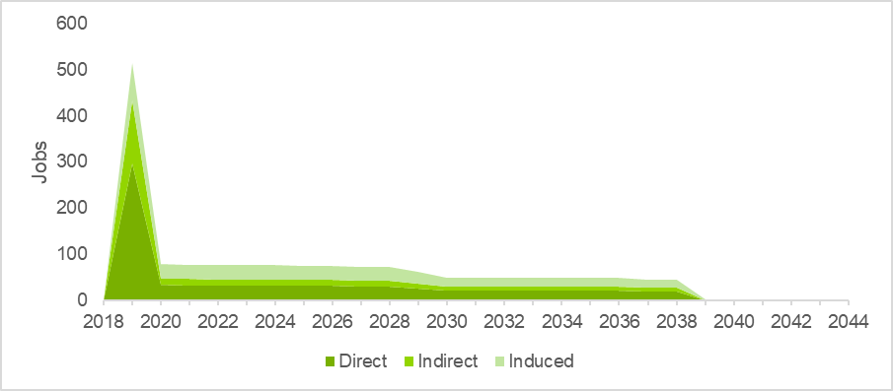Source: Guidehouse analysis of Nicor Gas Tracking data (2019)

The large spike in impacts seen in 2019 results from initial spending triggered by the implementation and management of Nicor Gas’s portfolio in calendar year 2019, including but not limited to program incentives and administrative spending and incremental measure spending resulting from the effects of the portfolio. The impacts beyond 2019 are derived almost entirely from the persisting effects of Nicor Gas’s portfolio in the form of net ratepayer bill savings realized by those who were treated by or participated in Nicor Gas’s 2019 programs. Impacts persist over a similar period as the cumulative persisting annual savings (CPAS) produced by the Nicor Gas portfolio.

Industry Labor Income and Business Sales
Figure 2 presents direct, indirect, and induced effects on labor income and industry output from the 2019 Nicor Gas portfolio. The figure also separates these effects into those resulting from 1) program spending and program-induced spending (incentives, rebates, net incremental costs, program administration, fuel/transportation expenditures etc.) and 2) net ratepayer bill savings.

Figure 2. Nicor Gas Portfolio Labor Income and Industry Output Impacts (2019-2044)
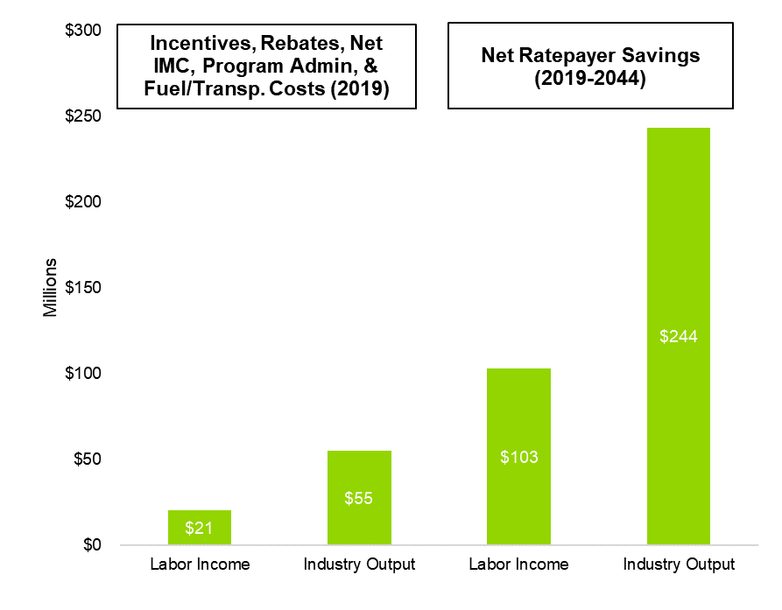
Source: Guidehouse analysis of Nicor Gas Tracking data (2019)

Table 2 presents a summary of the cumulative industry labor income and industry output impacts (“economic impacts”) of the 2019 energy efficiency portfolio investments (2019-2044).

Table 2. Cumulative 2019-2044 Industry Labor Income and Industry Output Impacts of 2019 Nicor Gas Energy Efficiency Portfolio Investments

Impact Type | Labor Income | Industry Output
Direct | $69 M | $150 M
Indirect | $25 M | $66 M
Induced | $30 M | $83 M
Total | $123 M | $299 M
Source: Guidehouse analysis of Nicor Gas Tracking data (2019)

Appendix
Figure 3, Table 3, and Table 4 provide cumulative economic impacts and employment impacts in a format similar to that presented in the 2018 analysis for the purpose of comparison. The evaluation team advises against use of employment impacts reported in job-years for ongoing reporting moving forward. As shown in Figure 1, employment impacts are long-term effects not confined to a particular year, and reporting in job-years can mislead readers as to the effects produced.

Figure 3. Cumulative Economic Impacts (2018-2045)
Rest of IL:
7 Job Years
Labor Income: $0.4M
Industry Output: $1.6M
Utility Service Territory:
1,670 Job Years
Labor Income: $123M
Industry Output: $297M

Source: Guidehouse analysis of Nicor Gas Tracking data (2019)
Table 3: Cumulative Economic Impacts (2019-2044)
Impact Category | Utility Territory | Rest of State | State Total
Job Years | 1,670 Job Years | 7 Job Years | 1,677 Job Years
Labor Income | $123.0 M | $0.4 M | $123.4 M
Industry Output | $297.1 M | $1.6 M | $298.7 M
Source: Guidehouse analysis of Nicor Gas Tracking data (2019)

Table 4: Job-Year Impacts by Category (2019-2044)
Impact Type | Utility Territory | Rest of State | State Total
Direct | 778 Job Years | 0 Job Years | 778 Job Years
Indirect | 344 Job Years | 4 Job Years | 349 Job Years
Induced | 548 Job Years | 3 Job Years | 550 Job Years
Total | 1,670 Job Years | 7 Job Years | 1,677 Job Years
Source: Guidehouse analysis of Nicor Gas Tracking data (2019)

Economic Impact Assessment Methodology
The economic impact assessment for energy efficiency programs follows a three-step process:
- Data collection of the economic activities of the energy efficiency programs
- Economic modeling of these activities using IMPLAN
- Analysis of the results – summarizing and assessing the economic measures (e.g. industry output, labor income, and jobs)

Figure 4. Economic Impact Assessment Methodology
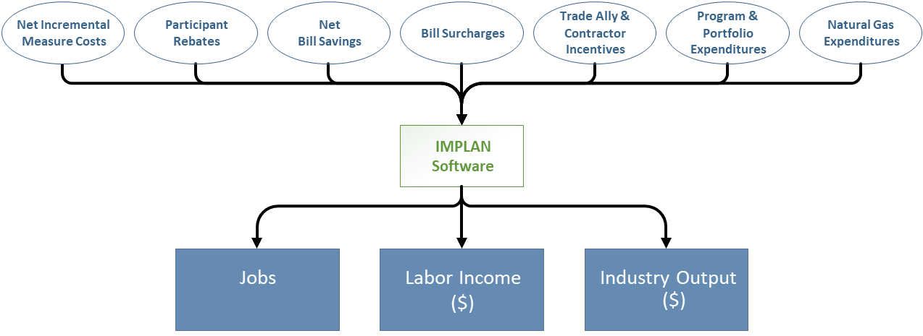
Source: Guidehouse

