Home Energy Reports Impact Evaluation Report
  - Energy Efficiency Plan: Program Year 2023
(1/1/2023-12/31/2023)
Prepared for:
Nicor Gas Company
DRAFT
April 29, 2024
Prepared by:
Carly Olig  Guidehouse | Gilbert Wong  Guidehouse
guidehouse.com

Submitted to:

Nicor Gas Company
1844 Ferry Road
Naperville, IL 60563

Submitted by:

Guidehouse
150 N. Riverside Plaza, Suite 2100
Chicago, IL 60606

Contact:

Ted Walker  Partner  404.602.3463  ted.walker@guidehouse.com  Charles Ampong  Associate Director  608.446.3172  charles.ampong@guidehouse.com | Stu Slote  Director  802.526.5113  stu.slote@guidehouse.com | Laura Agapay-Read  Associate Director  312.583.4178  laura.agapay.read@guidehouse.com
Disclaimer: This report was prepared by Guidehouse for Nicor Gas based upon information provided by Nicor Gas and from other sources. Use of this report by any other party for whatever purpose should not, and does not, absolve such party from using due diligence in verifying the report’s contents. Neither Guidehouse nor any of its subsidiaries or affiliates assumes any liability or duty of care to such parties, and hereby disclaims any such liability.

Table of Contents
1. Introduction 1
2. Program Description 1
3. Program Savings Detail 2
4. Program Savings by Measure 2
5. Impact Analysis Findings and Recommendations 2
Appendix A. Impact Analysis Methodology A-1
A.1 Savings Methodology A-1
Appendix B. Detailed Impact Analysis Results B-1
B.1 Savings B-1
B.2 Uplift Analysis Results B-5
Appendix C. Program Specific Inputs for the Illinois TRC C-1

List of Tables, Figures, and Equations
Table 1. 2023 Volumetric Findings Detail 1
Table 2. 2023 Annual Energy Savings Summary 2

Table A-1. Gas Savings Persistence Factors A-5
Table A-2. 2023 Program Persistence Summary A-7
Table B-1. 2023 Savings Results B-1
Table B-2. 2023 Uplift Adjustment Details, Wave 1 B-5
Table B-3. 2023 Uplift Adjustment Details, Wave 2 B-6
Table B-4. 2023 Uplift Adjustment Details, Wave 3 B-6
Table C-1. 2023 Total Resource Cost Savings Summary C-1

Figure B-1. 2023 Percent Savings and 90% Confidence Interval, Wave 1 B-2
Figure B-2. 2023 Percent Savings and 90% Confidence Interval, Wave 2 B-3
Figure B-3. 2023 Percent Savings and 90% Confidence Interval, Wave 3 B-4

Equation A-1. Lagged Dependent Variable Regression Model A-2
Equation A-2. Linear Fixed Effects Regression Model A-2
Equation A-3. Current Year Uplift Calculation A-3
Equation A-4. Legacy Uplift Calculation A-5

Introduction
This report presents the results of the impact evaluation of the Nicor Gas Home Energy Report (HER) Program, including a summary of the energy impacts for the total program, as well as relevant measure and program structure details. The appendices provide the impact analysis methodology and details of the total resource cost (TRC) inputs. Program year 2023 covers January 1, 2023 through December 31, 2023.

Program Description
The HER Program is designed to generate energy savings by providing residential customers with information about energy use and conservation strategies. Program participants receive information from regularly mailed and emailed home energy reports, including:
- Assessment of how their recent energy use compares to their past energy use
- Tips on how to reduce energy consumption, some of which are tailored to the customer’s circumstances
- Information on how their energy use compares to that of neighbors with similar homes
An important feature of the Nicor Gas HER program is that it is designed as a randomized controlled trial (RCT). To estimate changes in energy use due to the program, customers in each target group of residential customers were randomly assigned to either the recipient group or the control (non-recipient) group. Customers may opt out of the program at any time but cannot opt in due to the RCT design. An implication of the RCT design is that the savings estimates are intrinsically net of free-ridership and most spillover bias.

The Nicor Gas HER program included three waves in 2023. Wave 1 was launched in October 2019, Wave 2 was launched in September 2020, and Wave 3 was also launched in September 2020. Table 1 shows active accounts at the beginning of the evaluation period, January 2023 for Waves 1 through 3.

Table 1. 2023 Volumetric Findings Detail
Wave | Participant Count | Control Count
Wave 1 | 127,207 | 37,037
Wave 2 | 173,827 | 57,925
Wave 3 | 186,105 | 61,990
Source: Guidehouse analysis of Nicor Gas program tracking and customer billing data.

Program Savings Detail
Table 2 summarizes the energy savings the HER Program achieved in 2023. These savings reflect adjustments for uplift, as well as removing savings persisting from 2019 to 2022 per the Illinois Statewide Technical Reference Manual (IL-TRM). Note that savings for Wave 3 were not statistically significant, resulting in no claimable CY2023 savings, because of this there are no adjustments for uplift or persistence for this wave. Additionally, since the RCT design inherently estimates savings that are net of participant spillover and free ridership, neither the evaluation team nor the implementer estimated gross savings, and there is no gross realization rate and no net-to-gross (NTG) ratio. Guidehouse added non-participant spillover (NPSO) to its initial savings estimate using the deemed factor of 1.048. Across the three waves, the realization rate is 66%.
Table 2. 2023 Annual Energy Savings Summary
Wave | Ex Ante Savings (therms) | Verified Unadjusted Savings  (therms) | Total Uplift* Adjustment  (therms) | Total Persistence† Adjustment (therms) | Verified Adjusted Savings | NPSO  (therms) | Final  Verified Savings (therms) | Verified Realization Rate‡
Wave 1 | 432,724 | 1,001,139 | 85,420 | 548,216 | 367,502 | 17,640 | 385,143 | 91%
Wave 2 | 81,943 | 349,828 | 110,294 | 73,831 | 165,703 | 7,954 | 173,657 | 94%
Wave 3 | 332,951 | 0 | - | - | 0 | - | 0 | 0%
Total or Weighted Average | 847,618 | 1,350,967 | 195,714 | 622,047 | 533,206 | 25,594 | 558,800 | 66%
Note: Totals may not sum due to rounding.
* The uplift adjustment accounts for savings caused by uplift into other programs which must be removed from the HER program to avoid double counting. The adjustment accounts for both uplift in the current program year and from prior program years where the measures uplifted into are still generating savings. These adjustments are described in Appendix A.1.3.
† The persistence adjustment reduces the savings by the amount attributable to sending reports in 2019 to 2022 and is prescribed in the Adjustments to Behavior Savings to Account for Persistence measure in the IL-TRM. See IL-TRM, Measure 6.1.1, Volume 4, Version 11.0. This is also described in Appendix A.1.4.
‡ The verified realization rate compares final verified savings with ex ante savings.
Source: Guidehouse evaluation team analysis.

Program Savings by Measure
The HER Program includes a single measure, behavioral savings, and so the program savings and measure savings are the same. Detailed savings are presented in Appendix B.

Impact Analysis Findings and Recommendations
Finding 1. Overall across all three waves, Guidehouse found an energy savings realization rate of 66% compared with the program implementer ex ante savings estimate. This analysis is driven by the fact that savings from Wave 3 are included in the ex ante savings but cannot be claimed as these were not statistically different from zero at the 90% confidence level. The lack of statistical significance was found by both Guidehouse and the implementer. The point estimate for Wave 3 savings was 0.11% and the 90% confidence bound ranged from -0.02% to 0.24%. The lack of statistical significance is driven by the low savings rather than the size of the wave.

Recommendation 1a. If possible, in future program years, the implementer should account for statistical significance in the ex ante savings values. Precedent is that savings from a pooled model must be statistically different from 0 at the 90% confidence level to be claimed.

Recommendation 1b. The program and implementation teams should consider whether there are further interventions that could be done to drive more savings for Wave 3. If Wave 3 continues to deliver savings that are not statistically significant, the program and implementation teams should consider whether it makes sense to keep this wave in the program.

Finding 2. Wave 2 has relatively low savings (0.20%), though it did have a pause in treatment (i.e., were not sent reports) in 2022. More continuous treatment could increase savings, but if savings fall slightly (as happened with Wave 3 in 2023 compared to 2022) this wave could wind up not being statistically significant.

Recommendation 2. The program team should continue to monitor savings for Wave 2 to anticipate where savings will plateau, and determine whether additional interventions (for example, more reports) may be needed to drive further savings.

Impact Analysis Methodology

Savings Methodology
This section details the methodology employed for developing custom savings estimates for 2023. These estimates were used for verifying savings for both waves.

Data Cleaning
The evaluation team removed customers and data points from the analysis in several steps:
- Excluded data from outside of the period of examination and relevant pre-period for each wave
- Removed exact duplicate observations
- Aggregated bills that ended in the same month
- Excluded observations with a bill length greater than 90 days
- Excluded outlier observations, defined as observations with average daily usage outside plus or minus one order of magnitude from the median
- For the lagged dependent variable (LDV) model, removed observations that did not have a usage value in the same month of the pre-period

Across both waves, these cleaning steps removed no entire customers and less than 2% of observations (after subsetting to the relevant analysis period), evenly distributed across participants and controls. This result suggests that the evaluation team’s cleaning steps did not introduce non-random biases into the data.

Modeling Methodology
The evaluation team used LDV and linear fixed effects regression (LFER) models to estimate program savings. Both approaches should, in principle, produce unbiased estimates of program savings under a wide range of conditions, but Guidehouse prefers the LDV results for two reasons. First, savings estimates produced by the LDV model tend to be more accurate and more precisely estimated than those from the LFER model based on experience analyzing similar HER programs’ impacts and findings from the academic literature. Second, the implementer uses a similar model for its evaluation, which makes the two sets of results more comparable. Although the LDV and LFER models are structurally very different, these should generate similar program savings estimates, assuming the RCT is well balanced with respect to the drivers of energy use. Guidehouse used the LDV results for reporting total program savings for 2022, while the LFER provided a robustness check.
Lagged Dependent Variable Model
The LDV model controls for non-treatment differences in energy use between treatment and control customers using lagged energy use as an explanatory variable. The model frames energy use in calendar month t of the post-program period as a function of both the treatment variable and energy use in the same calendar month of the pre-program period. The underlying logic is that systematic differences between control and treatment customers will be reflected in differences in their past energy use, which is highly correlated with their current energy use. Formally, the model is shown in Equation A-1.
Equation A-1. Lagged Dependent Variable Regression Model
$$ADU_{kt}= β_{1}Treatment_{k}+ \sum_{J}{β_{2}Month_{jt}}+\sum_{J}{β_{3}Month_{jt}∙ADUlag_{kt}}+ ε_{kt}$$
Where:
${ADU}_{kt}$ is average daily consumption of therms by household k in bill period t
${Treatment}_{k}$ is a binary variable taking a value of 0 if household k is assigned to the control group, and 1 if assigned to the treatment group
${Month}_{jt}$ is a binary variable taking a value of 1 when j = t and 0 otherwise
${ADUlag}_{kt}$ is household k’s energy use in the same calendar month of the pre-program year as the calendar month of month t
$ε_{kt}$ is the cluster-robust error term for household k during billing cycle t; cluster-robust errors account for heteroskedasticity and autocorrelation at the household level

The coefficient β₁ is the estimate of average daily therms energy savings due to the program.
Linear Fixed Effects Regression Model
The LFER model used by the evaluation team is one in which the average daily consumption of therms by household k in bill period t, denoted by ADU_{kt} is a function of the following three terms:
- The binary variable Treatment_{k.}
- The binary variable Post_{t}, taking a value of 0 if month t is in the pre-treatment period, and 1 if in the post-treatment period
- The interaction between these variables, Treatment_{k} ·Post_{t}

Formally, the LFER model is shown in Equation A-2.
Equation A-2. Linear Fixed Effects Regression Model
$${ADU}_{kt}=α_{0k}+α_{1}{Post}_{t}+α_{2}{Treatment}_{k}∙{Post}_{t}+ε_{kt}$$

Coefficient α_{0k} captures all household-specific effects on energy use that do not change over time, including those that are unobservable. Coefficient α₁ captures the average effect across all households of being in the post-treatment period. The effect of being both in the treatment group and in the post period, i.e., the effect directly attributable to the program, is captured by the coefficient α₂. In other words, whereas the coefficient α₁ captures the change in average daily therms use across the pre- and post-treatment for the control group, the sum α₁+α₂ captures this change for the treatment group and so α₂ is the estimate of average daily therms energy savings due to the program.

Accounting for Uplift in Other Energy Efficiency Programs
Accounting for Uplift in 2023
The home energy reports sent to participating households included energy-saving tips, some of which encouraged participants to enroll in other Nicor Gas energy efficiency (EE) programs. If participation rates in other EE programs were the same for HER participant and control groups, the savings estimates from the regression analysis are already “net” of savings from the other programs, as this indicates the HER Program had no net effect on participation in the other EE programs. However, if the receipt of reports increased participation rates of recipients relative to controls in other EE programs, then the combined savings across all programs would be lower than indicated by the simple summation of savings in the HER and the other EE programs. For instance, if the HER Program increases participation in another EE program, the resulting increase (“uplift”) in savings may be allocated to either the HER Program or the EE program, but cannot be allocated to both programs simultaneously. When the HER Program decreases participation in other programs, there is no issue of double counting, and no adjustment to the savings total is made.

As data permitted, Guidehouse used a difference-in-difference (DID) statistic to estimate uplift in other EE programs. To calculate the DID statistic, Guidehouse calculated the difference between the HER treatment and control groups in average EE program savings per customer in the post period, and subtracted the same difference from the pre-period. For instance, if the EE program savings during 2023 is five therms for the treatment group and three therms for the control group, and the savings during the year before the start of the HER Program is two therms for the treatment group and one therm for the control group, then the DID statistic is one therm, as reflected in Equation A-3

Equation A-3. Current Year Uplift Calculation
(2023 treatment group savings – 2023 control group savings) – (pre-year treatment group savings - pre-year control group savings) = DID statistic
(5 − 3) − (2 − 1) = 1

The DID statistic generates an unbiased estimate of uplift when the baseline average savings is the same for the treatment and control groups, or when these values are different due only to differences between the two groups in time-invariant factors, such as the square footage of the residence.

An alternative statistic that generates an unbiased estimate of uplift when the baseline average savings in the EE program is the same for the treatment and control groups, is a simple difference in savings during 2023. Guidehouse uses this alternative statistic –the “post-only difference” (POD) statistic – in cases where the EE program did not exist for the entire pre-program year.

Guidehouse examined the uplift associated with four other Nicor Gas programs: Energy Savings Kits (ESK), Home Energy Efficiency Rebates (HEER), Home Energy Savings (HES), market rate Multi-Family (MF), and Income Eligible (IE).

Accounting for Legacy Uplift
The uplift adjustment methodology above only accounts for uplift which occurs in the current program year because EE program tracking files in any given program year only capture the new measures installed in that year, regardless of the expected measure life. However, for other EE programs that include measures with multiyear measure lives, the HER Program savings capture the portion of savings due to uplift in each year of that program’s measure life. For instance, a measure with a 10-year measure life that was installed in 2019 would generate savings captured in the HER Program savings not just in 2019, but in 2020 through 2028 as well.
Consider the following example. A household receiving home energy reports through the HER Program enrolls in the HES Program in CY2022. The uplift adjustment subtracts HES CY2022 Program savings to avoid double counting. In 2023, this household still receives savings from the HES Program because it has a 13-year measure life. However, the 2023 HER uplift adjustment does not remove these savings because the 2023 adjustment only accounts for measures installed in 2023, the initial year the household entered a program. When only relying on the uplift adjustment, HES second-year savings would be included in the 2023 HER Program’s savings, which is inconsistent with Illinois’ practices of only crediting utilities with first-year EE program savings. Legacy uplift removes double counted energy savings from programs that include measures with multiple-year measure life.
The evaluation team accounts for legacy uplift by subtracting the double counted savings from previous years, adjusted for the average annual move out rate, from 2023 HER savings through the measure lives of measures from other EE programs. The legacy uplift adjustment is shown in Equation A-4.
Equation A-4. Legacy Uplift Calculation
$${HER \text{Savings}}_{\text{PY}}^{\text{Adjusted}}\text{ = }{HER \text{Savings}}_{\text{PY}}^{\text{Unadjusted}} \text{- }{\text{Uplift Savings}}_{\text{PY}} \text{-}\sum_{\text{i}\text{=1}}^{\text{PY-1}}{{\text{"Live" Legacy Uplift Savings}}_{\text{i} }\text{∙ }{\left(\text{1 - MOR}\right)}^{\text{PY - }\text{i}}}$$

Where, “Live” Legacy Uplift Savings refers to uplift savings where the other EE programs’ measure lives have not yet run out (i.e., where measure life exceeds the difference between PY and i) and MOR refers to the move out rate. To streamline the analysis, instead of using individual measure lives in developing legacy uplift savings, and subsequently removing measures one-by-one once these reach the end of their EULs, the evaluation team calculated EULs at the program level by weighting measure-specific EULs by savings. Once the program reaches its weighted average measure life (WAML), it is removed from the legacy uplift calculation.
The legacy uplift adjustment removes double counted savings from the CY2020 to CY2022 evaluations for the ESK, HEER, HES, MF, and IE programs.

Accounting for Savings Persistence and Participant Retention
Continued implementation of HER programs in Illinois and across the country has demonstrated persistence of savings beyond the first year, leading Illinois to adopt a measure persistence framework in Version 11.0 of the IL-TRM. This framework assumes that savings persist over seven years, but the persistence decays in each year. The IL-TRM recommends using the persistence factors presented in Table A-1 over the seven-year life to estimate lifetime gas savings for the program.

Table A-1. Gas Savings Persistence Factors
Year | Gas Persistence Factor
Year 1 | 100%
Year 2 | 70%
Year 3 | 49%
Year 4 | 34%
Year 5 | 24%
Year 6 | 17%
Year 7 | 12%
Source: IL-TRM, Measure 6.1.1, Volume 4, Version 11.0.

The persistence factors above apply for the forward-looking cost-effectiveness calculations. However, in removing persistence from prior years, Guidehouse used the persistence factors in effect from those years per IL-TRM v11.0:

…when persistence factors are changed, the evaluation will utilize the persistence factors that were used to calculate claimed savings in previous years to subtract persistence savings from those years. For example, persistence factors changed between CY2021 and 2022; in CY2021 the earlier persistence factors (based on a 5-year measure life) were used to claim savings from CY2021-CY2025, therefore in 2022-CY2025 persisting savings from CY2021 should be subtracted based on those same persistence factors.
In 2023, Wave 1 is in year 5, Wave 2 is in year 4, and Wave 3 is in year 4. Using the applicable persistence, Guidehouse used persistence factors of 70% for savings from 2022, 20% for savings from 2021, 9% for savings from 2020, and 4% for savings from 2019. Per the TRM, the adjustment for persistence also accounts for the program retention rate using a wave-specific prospective retention rate based on the age of the wave. In CY2023, Guidehouse applied a 95% retention rate to all waves.

Table A-2 provides a breakdown of the persistence factors and savings attributed to prior years for all waves. Note that savings for Wave 3 were not statistically significant, resulting in no claimable CY2023 savings and thus no persistence adjustment; numbers shown in Table A-2 show Guidehouse’s persistence calculation for reference even though it is not feeding into claimed savings. The total persistence adjustment (Section E) is calculated as the sum all savings attributed to prior years (Section D) (i.e., D1+D2+D3+D4=E). Each row of section D is calculated by multiplying the corresponding rows of Section A (actual savings), Section B (persistence adjustment factors) and Section C (retention rates) (e.g., A1*B1*C1=D1).

Table A-2. 2023 Program Persistence Summary
Section | Row | Value | Wave 1 | Wave 2 | Wave 3
A | 1 | Actual Savings CY2019 | 50,314 | - | -
 | 2 | Actual Savings CY2020 | 1,164,645 | 1,445 | 39,272
 | 3 | Actual Savings CY2021 | 682,376 | 408,418 | 154,813
 | 4 | Actual Savings CY2022 | 501,563 | - | 259,470
B | 1 | 4-Year Persistence Adjustment Factor | 0.04 | 0.04 | 0.04
 | 2 | 3-Year Persistence Adjustment Factor | 0.09 | 0.09 | 0.09
 | 3 | 2-Year Persistence Adjustment Factor | 0.20 | 0.20 | 0.20
 | 4 | 1-Year Persistence Adjustment Factor | 0.70 | 0.70 | 0.70
C | 1 | Retention Rate – 4 Year | 0.81 | - | -
 | 2 | Retention Rate – 3 Year | 0.86 | 0.86 | 0.86
 | 3 | Retention Rate – 2 Year | 0.90 | 0.90 | 0.90
 | 4 | Retention Rate – 1 Year | 0.95 | - | 0.95
D | 1 | Savings Attributed to 2019 | 1,639 | - | -
 | 2 | Savings Attributed to 2020 | 89,868 | 112 | 3,030
 | 3 | Savings Attributed to 2021 | 123,169 | 73,719 | 27,944
 | 4 | Savings Attributed to 2022 | 333,539 |  | 172,548
E | 1 | Total Persistence Adjustment | 548,216 | 73,831 | 203,522
Source: Guidehouse analysis of Nicor Gas program tracking and customer billing data.

Detailed Impact Analysis Results
This appendix presents detailed savings and aggregated uplift analysis results. Tables with the regression outputs and detailed uplift results are available upon request.

Savings
This appendix presents detailed savings and aggregated uplift analysis results. Tables with the regression outputs and detailed uplift results are available upon request.
Table B-1 summarizes estimated program savings including uplift adjustments. Table B-1 also includes the number of participants, controls, and average savings rates. Both modeled savings and average savings rates include standard error figures. Note that savings for Wave 3 were not statistically significant, resulting in no claimable CY2023 savings; numbers shown in Table B-1 show Guidehouse’s estimated savings for reference even though these are not claimable. Table B-1 reflects claimed savings for CY2023 for Waves 1 and 2.

Table B-1. 2023 Savings Results
Savings Category | Wave 1 | Wave 2 | Wave 3
Treatment Customer Count* | 127,207 | 173,827 | 186,105
Control Customer Count* | 37,037 | 57,925 | 61,990
Percent Savings | 0.53% | 0.20% | 0.11%
Percent Savings Std. Err. | 0.11% | 0.07% | 0.08%
Annualized Customer Savings, therms† | 8.08 | 2.06 | 1.48
Annualized Customer Savings Std. Err. | 1.64 | 0.72 | 1.04
Net Savings Prior to Uplift, therms | 1,001,139 | 349,828 | 268,968
Net Savings Std. Err. | 202,835 | 121,579 | 188,646
2023 Uplift, therms‡ | 12,536 | 24,645 | 3,555
Legacy Uplift, therms‡ | 72,884 | 85,649 | 74,681
2023 Custom Savings Calculation | 915,718 | 239,534 | 190,732
Savings Attributed to Prior Years§ | 548,216 | 73,831 | 203,522
Verified Net Savings, therms|| | 367,502 | 165,703 | -12,790
* These counts are for active customers at the beginning of the evaluation period.
† Annualized savings are average daily savings multiplied by 365, however, total savings are pro-rated for participants that closed their accounts during the evaluation period.
‡ No adjustment was made to total savings for negative uplift, (i.e., cases where the HER Program decreased participation in other programs).
§ Savings attributed to prior years are those deducted for persistence from 2019, 2020, 2021, and 2022 within the IL-TRM framework.
|| Verified Net Savings are equal to Net Savings, Prior to Uplift less 2023 Uplift, Legacy Uplift, and Savings Attributed to Prior Years.
Source: Guidehouse analysis of Nicor Gas program tracking and customer billing data.

Figure B-1 to Figure B-3 show energy savings with 90% confidence intervals for Waves 1, 2, and 3, respectively.

Figure B-1. 2023 Percent Savings and 90% Confidence Interval, Wave 1
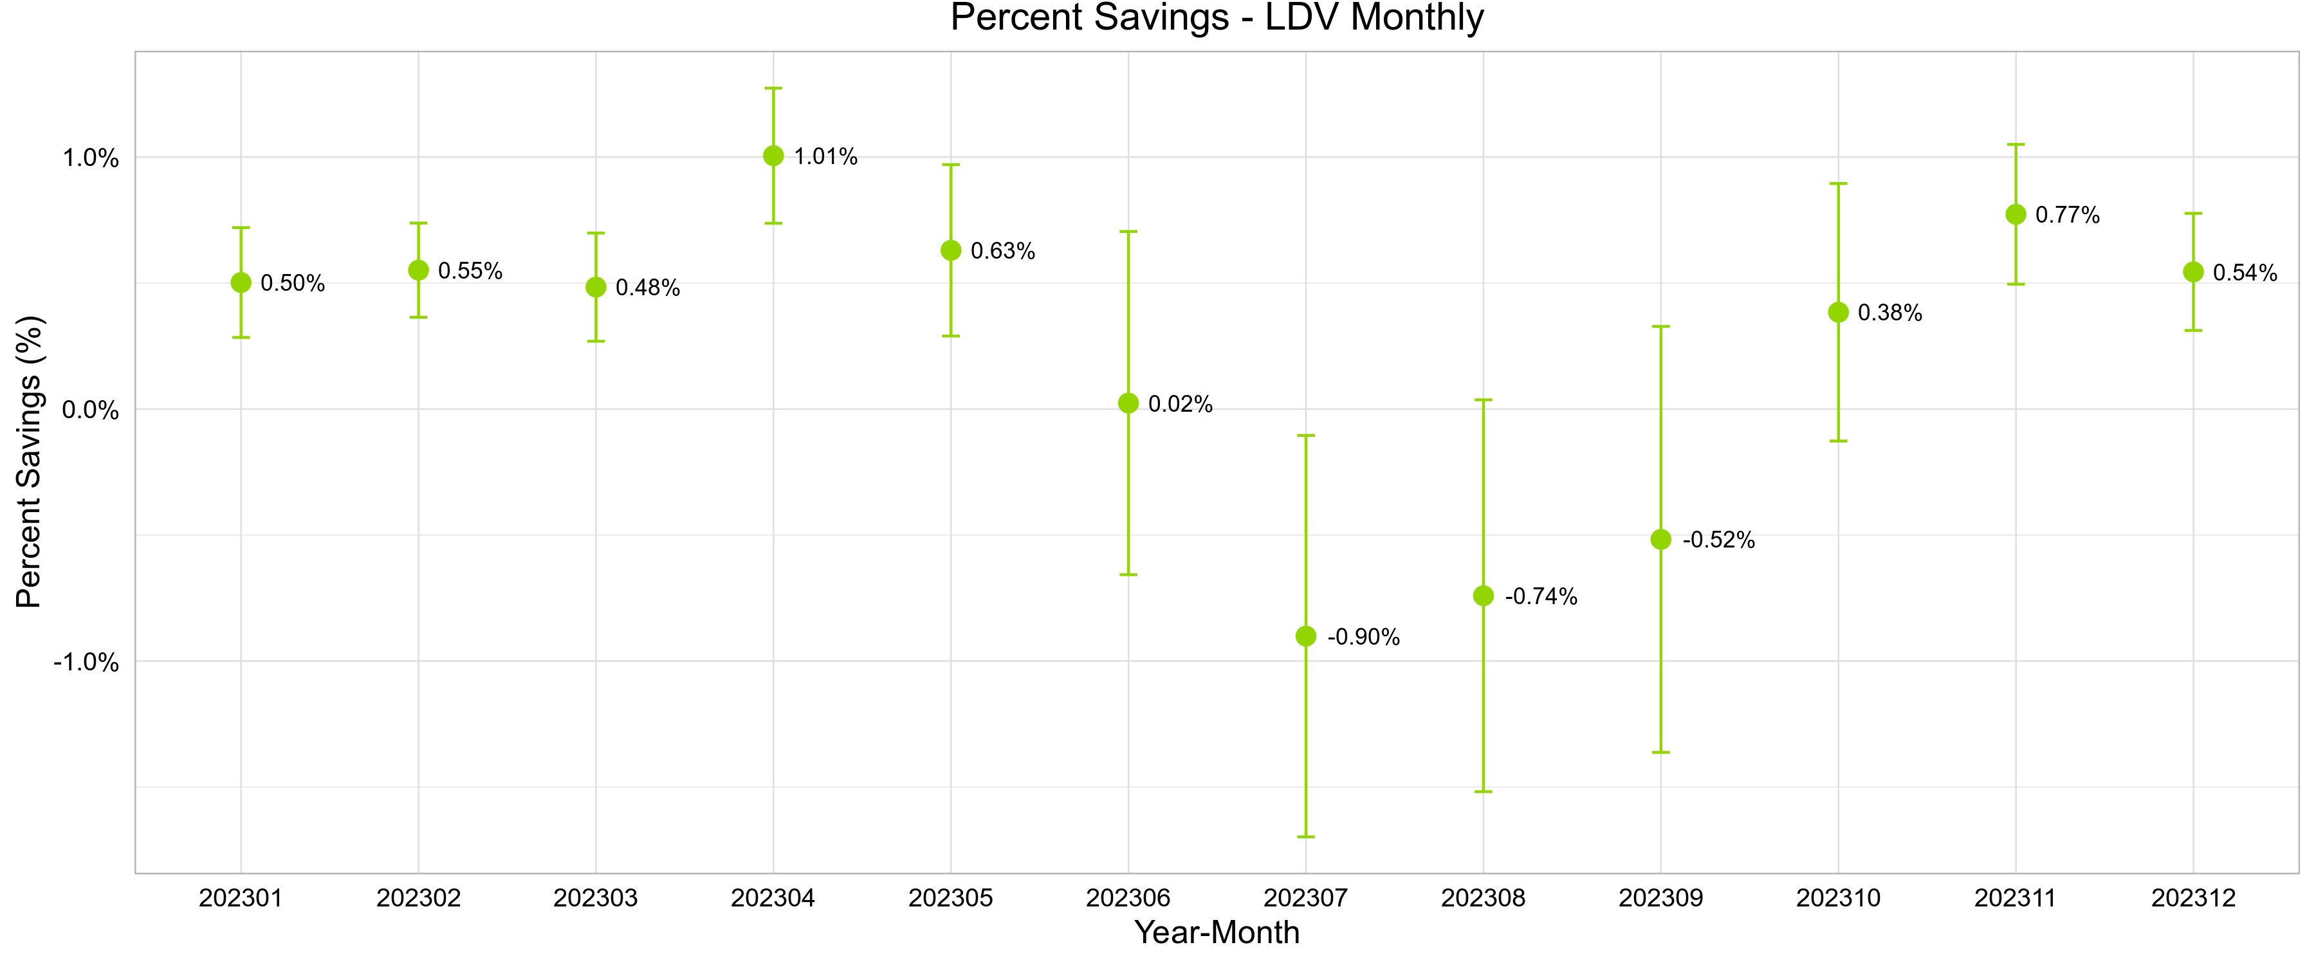
Source: Guidehouse analysis of Nicor Gas program tracking and customer billing data.

Figure B-2. 2023 Percent Savings and 90% Confidence Interval, Wave 2
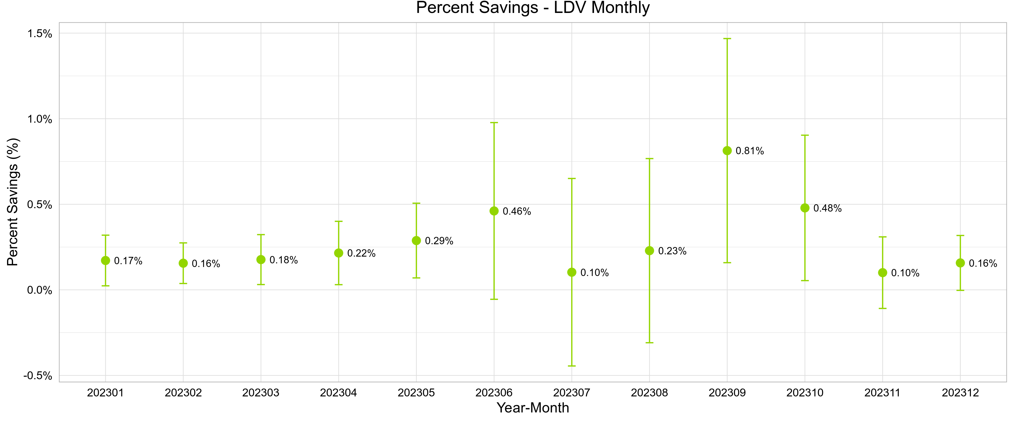
Source: Guidehouse analysis of Nicor Gas program tracking and customer billing data.

Figure B-3. 2023 Percent Savings and 90% Confidence Interval, Wave 3
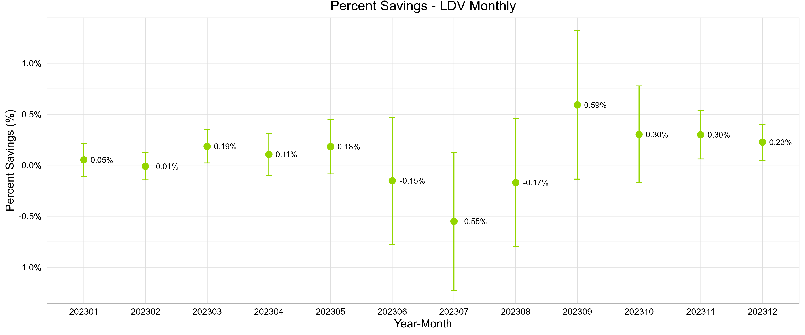

Source: Guidehouse analysis of Nicor Gas program tracking and customer billing data.

Uplift Analysis Results
This section summarizes 2023 uplift results. The uplift of savings in other EE programs was 195,714 therms, or approximately 14% of total savings; this value only includes uplift for Waves 1 and 2, as Wave 3 did not have any claimable savings and thus no uplift adjustment was applied. The uplift can be broken down into uplift in 2023 and legacy uplift from previous program years. The 2023 uplift was 37,181 therms or 3% of total program savings, and the legacy uplift was 158,533 therms or 12% of total program savings. The relatively large portion of savings double counted with other Nicor Gas EE programs suggests that the home energy reports are doing a good job of channeling customers into other EE programs.
Table B-2, Table B-3, and Table B-4 present program savings due to participation in other EE programs in 2023 for each of the HER program waves. Each column provides information on one of five EE Programs for which estimates for deemed savings are available. While these tables show estimates of both positive and negative uplift, only positive values were used to adjust program savings for double counting. For all cases where the EE program did not exist in the pre-program year, the estimate is based on a probability of detection (POD) statistic; otherwise, it is based on a DID statistic. Note that savings for Wave 3 were not statistically significant, resulting in no claimable CY2023 savings and thus no uplift adjustment; numbers in Table B-4 show Guidehouse’s estimated uplift for reference even though it is not feeding into claimed savings.

Table B-2. 2023 Uplift Adjustment Details, Wave 1
Program | ESK | HEER | HES | IE
Median program savings, annual therms per EE participant | 40.54 | 102.51 | 102.51 | 25.477
Number of treatment customers | 129,379 | 129,379 | 129,379 | 129,379
Number of control customer | 37,647 | 37,647 | 37,647 | 37,647
Avg. savings per HER treatment customer, 2023 | 0.14 | 0.61 | 0.10 | 0.21
Avg. savings per HER control customer, 2023 | 0.16 | 0.56 | 0.10 | 0.16
2023 savings difference | -0.02 | 0.05 | 0.00 | 0.05
Avg. savings per HER treatment customer, pre | 0.07 | 0.92 | 0.19 | 0.04
Avg. savings per HER control customer, pre | 0.07 | 0.88 | 0.22 | 0.06
Pre savings difference | 0.00 | 0.04 | -0.03 | -0.02
DID or POD statistic | -0.02 | 0.01 | 0.03 | 0.07
Savings attributable to other programs, therms | -2,774 | 838 | 3,278 | 8,420
Implied change in participation | -68.4 | 8.2 | 32.0 | 330.5
Source: Guidehouse analysis of Nicor Gas program tracking and customer billing data.

Table B-3. 2023 Uplift Adjustment Details, Wave 2
Program | ESK | HEER | HES | IE
Median program savings, annual therms per EE participant | 39.9 | 102.51 | 102.51 | 25.48
Number of treatment customers | 176,501 | 176,501 | 176,501 | 176,501
Number of control customer | 58,830 | 58,830 | 58,830 | 58,830
Avg. savings per HER treatment customer, 2023 | 0.19 | 0.83 | 0.09 | 0.12
Avg. savings per HER control customer, 2023 | 0.20 | 0.74 | 0.11 | 0.12
2023 savings difference | -0.01 | 0.09 | -0.02 | 0.00
Avg. savings per HER treatment customer, pre | 0.55 | 1.09 | 0.16 | 0.08
Avg. savings per HER control customer, pre | 0.53 | 1.11 | 0.15 | 0.10
Pre savings difference | 0.01 | -0.03 | 0.01 | -0.02
DID or POD statistic | -0.03 | 0.12 | -0.02 | 0.02
Savings attributable to other programs, therms | -4,546 | 20,780 | -3,831 | 3,865
Implied change in participation | -113.9 | 202.7 | -37.4 | 151.7
Source: Guidehouse analysis of Nicor Gas program tracking and customer billing data.

Table B-4. 2023 Uplift Adjustment Details, Wave 3
Program | ESK | HEER | HES | IE | MF
Median program savings, annual therms per EE participant | 40.54 | 102.51 | 102.51 | 25.477 | 2819.47
Number of treatment customers | 189,348 | 189,348 | 189,348 | 189,348 | 189,348
Number of control customer | 63,060 | 63,060 | 63,060 | 63,060 | 63,060
Avg. savings per HER treatment customer, 2023 | 0.14 | 0.70 | 0.10 | 0.21 | 0.00
Avg. savings per HER control customer, 2023 | 0.17 | 0.72 | 0.10 | 0.19 | 0.00
2023 savings difference | -0.03 | -0.02 | 0.00 | 0.02 | 0.00
Avg. savings per HER treatment customer, pre | 0.55 | 1.02 | 0.14 | 0.09 | 0.00
Avg. savings per HER control customer, pre | 0.59 | 1.03 | 0.11 | 0.08 | 0.00
Pre savings difference | -0.03 | -0.01 | 0.03 | 0.01 | 0.00
DID or POD statistic | 0.01 | -0.01 | -0.03 | 0.01 | 0.00
Savings attributable to other programs, therms | 1,462 | -2,229 | -4,802 | 2,093 | -447
Implied change in participation | 36.1 | -21.7 | -46.8 | 82.1 | -0.2
Source: Guidehouse analysis of Nicor Gas program tracking and customer billing data.

Program Specific Inputs for the Illinois TRC
Table C-1, the Total Resource Cost savings table for Nicor Gas, includes cost-effectiveness analysis inputs available at the time of finalizing the 2023 HER impact evaluation report. Currently, additional required cost data (e.g., measure costs, program level incentive and non-incentive costs) are not included in Table C-1 and will be provided to include in the evaluation later.

Table C-1. 2023 Total Resource Cost Savings Summary
Savings Category | Nicor Gas
Number of Participants* | 487,139
Effective Useful Life (Years) | 7
Ex Ante Savings (therms) | 847,618
Verified Net Savings (therms) | 558,800
*Note that this count includes all three waves.
Source: Guidehouse analysis of Nicor Gas program tracking and customer billing data.

The implementer designates Wave 1, 2, and 3 as 201910_g, 202009_g, and 202011_g, respectively.
See Appendix A.1.3.
See IL-TRM, Measure 6.1.1, Volume 4, Version 11.0 and Appendix A.1.4.
Smaller waves tend to have larger standard errors because there is less data feeding into the estimate. However, Wave 3 is a healthy size with 186,105 customers.
Across the two models, the parameter estimates were not statistically different for either wave; that is, the estimates for each model are within the 90% confidence bounds for the other model. This result supports the methodological approach, and indicates the results are robust.
One likely reason for this situation is that the LDV model embodies more flexibility than the LFER model, in that the former allows the individual customer control variable to vary seasonally while the latter does not – a particularly attractive feature given the highly seasonal nature of natural gas usage. The LFER model treats all unobserved inter-household heterogeneity affecting households’ energy usage as time-invariant, while the LDV model uses lagged individual controls that can vary over time.
Allcott, Hunt and Todd Rogers, 2014. “The Short-Run and Long-Run Effects of Behavioral Intervention: Experimental Evidence from Energy Conservation.” American Economic Review, 104(10): 3003-37.
In other words, if there are T post-program months, there are T monthly dummy variables in the model, with the dummy variable Month_{tt} the only one to take a value of 1 at time t. These are, in other words, monthly fixed effects.
It is not possible to avoid double-counting of the savings generated by programs for which tracking data are not available, such as upstream programs.
Where the averages are calculated over all treatment and control group customers, not just those who participated in other EE programs.
Other EE program savings were pro-rated to the program participation date assuming a flat load shape.
Including single family, multifamily, and public housing authority.
Tracking data files are set up this way because, in conformity with the IL-TRM, Section 3.2, savings are first-year savings, not lifetime savings.
Because HER Program participants are dropped from that program when they move, other EE programs’ savings are no longer captured in the HER Program savings from that point forward.
For all waves, Guidehouse used the actual savings from CY2020 and CY2021 to subtract from CY2023 actual savings. Normalized savings were not used (and were not even calculated for CY2022).
Documentation on this realization rate was shared with Nicor Gas, the program implementer, and Illinois Commerce Commission staff in June 2023 in Retention Rates- Behavior Savings_2023-06-16.pptx.
See Section A.1.3 for more information about the programs considered. Note that MF was considered for Waves 1 and 2, but there was no crossover participation between MF and HER in 2023.
See Section A.1.3 for more information on POD and DID statistics.

