To: | Erin Daughton, Jim Fay, Vince Gutierrez, Molly Lunn, Rebecca McNish, Jacob Stoll, ComEd  Jennifer Morris, Illinois Commerce Commission  Celia Johnson, Stakeholder Advisory Group Facilitator  Illinois Stakeholder Advisory Group Non-Energy Impact Working Group
CC: | Jeff Erickson, Randy Gunn, Guidehouse
From: | Patricia Plympton, Guidehouse  Dr. Katherine Johnson, Johnson Consulting Group
Date: | April 30, 2020
Re: | Review of States’ Methodologies to include Monetized Non-Energy Impacts in Cost-Effectiveness Tests

Introduction
In December 2016, the Illinois General Assembly passed the Future Energy Jobs Act, which contains language on including additional non-energy benefits (now described as non-energy impacts (NEIs)) in energy efficiency programs’ total resource cost (TRC) tests.

“A total resource cost test compares the sum of avoided electric utility costs, representing the benefits that accrue to the system and participant in the delivery of those efficiency measures and including avoided costs associated with reduced use of natural gas or other fuels, avoided costs associated with reduced water consumption, and avoided costs associated with reduced operation and maintenance costs, as well as other quantifiable social benefits…”.

FEJA also contains language regarding not requiring income eligible programs to meet the TRC test:

Demonstrate that its overall portfolio of measures, not including low-income programs described in subsection (c) of this Section, is cost-effective using the total resource cost test.

Currently, the Illinois Technical Reference Manual (TRM) includes several deemed monetized values for societal, utility and participant NEIs. The NEI values are linked to state or federal sources and were added to the TRM via a stakeholder vetting process. The TRM quantifies the following NEIs to include in TRC tests:

- Societal: Avoided use of water (water savings) from energy efficiency programs: Water savings are based on measurements consistent with federal standards. The value of the savings is determined by what Illinois customers would have paid for the water saved.

- Utility: Avoided environmental costs: Environmental costs are the dollar per kilowatt-hour ($/kWh) quantification of the benefits ComEd has achieved by generating electricity from renewable sources rather than conventional electric generation from coal or gas-fired plants. This NEI includes the dollar value of reduced carbon emissions associated with switching to renewable energy sources. These values are based on the Energy Information Administration’s (EIA’s) Annual Energy Outlook 2020 report.

- Participant: Reduced O&M costs: This is a deemed value based on the estimated savings from reduced labor and materials that occur once a building has received energy efficiency improvements. For example, switching to longer-lived lighting reduces the number of times custodial personnel must replaces light fixtures.

Following FEJA’s passage, ComEd and the Illinois Stakeholder Advisory Group (SAG) prioritized researching NEIs associated with the income eligible energy efficiency programs because substantial NEIs are typically associated with these programs. This prioritization is captured in the ComEd 2018–2021 Energy Efficiency and Demand Response Plan Settlement Stipulation.

ComEd agrees to work in good faith to consult and reach consensus with the Income-Qualified Advisory Committee on issues of importance to the Committee, including but not limited to the following: Development of program information and practices for Income-Qualified programs, including the identification and reflection of non-energy benefits (“NEBs”) such as comfort, health and safety, reduced tenant turnover, reduced shut-offs, reduction in revenue collection costs, and lower energy burden in Income-Qualified measures and programs.

Prior to FEJA’s passage, the SAG considered expanding the number of NEIs included in the TRM but did not reach consensus. Stakeholders provided the following feedback on including additional NEIs in the TRM:

- Base calculations for NEIs on reputable studies.
- Ensure NEIs quantities are reproducible.
- Establish a logical connection between the NEIs and the related energy efficiency measures.
- Quantify both negative and positive NEIs.
- Use Illinois-specific data rather than a generic adder.

Beginning in 2017, Guidehouse, on behalf of ComEd, conducted research to quantify and monetize societal, utility and participant NEIs associated with ComEd’s energy efficiency programs. While societal NEIs are associated with all programs in ComEd’s portfolio, utility and participant NEIs are associated with two comprehensive income eligible programs. Guidehouse developed an NEI research plan and incorporated the feedback listed above from the earlier SAG NEI working group.

Guidehouse used the following research methods:

Societal NEIs
- Quantify and monetize societal health NEIs using regional-specific power generation emissions data from the U.S. Environmental Protection Agency’s Avoided Emissions and Generation Tool (AVERT) and Co-Benefits Risk Assessment (COBRA) model.
Utility NEIs
- Quantify and monetize utility NEIs using ComEd payment history for participants in two income eligible programs by conducting a regression-based analysis.

Participant NEIs
- Quantify participant health and productivity NEIs associated with two income eligible programs using a participant survey based on questions from a national U.S. Department of Energy (DOE) Weatherization Assistance Program (WAP) study. [Surveys will begin when ComEd resumes program implementation.]
- Monetize participant health NEIs using data from a hospital network in northern Illinois. Monetize participant productivity NEIs using average hourly-wage information for Illinois as well as lost productivity per year in Illinois due to sleep problems .

At the May 5, 2020 SAG NEI Working Group meeting we will present our early findings from our societal and utility NEI research and provide an update on the planned participant NEI research.

Determining how to use the results of the NEI research in ComEd’s programs’ TRC tests is the next step in this process. This memo presents the methodologies and values used in other states to include monetized NEIs in their cost-effectiveness tests and planning processes and offers recommendations for ComEd’s and SAG’s consideration.

NEIs in Other States’ Cost-Effectiveness Tests and Planning Activities
Guidehouse conducted a literature search and industry interviews to determine which states used similar research methodologies to quantify and monetize NEIs for cost-effectiveness tests and program plans as the research we are conducting on behalf of ComEd. In addition to Illinois, eleven states use monetized NEIs in their cost-effectiveness tests: Arizona, Delaware, District of Columbia, Maryland, Massachusetts, Minnesota, New York, Rhode Island, Vermont, Washington, and Wisconsin. Guidehouse selected the states that use region-specific or state-specific research to quantify and monetize NEIs to use in cost-effectiveness (C/E) tests or program plans, as shown in Table 1.

Table 1. Examples of States’ Use of Quantified and Monetized NEIs
States | Societal NEIs Included in: | Utility NEIs Included in: | Participant NEIs included in:
Wisconsin | C/E Tests
Idaho | EE Program Planning
Washington | EE Program Planning
Maryland |  | C/E Tests | C/E Tests
Massachusetts |  | C/E Tests | C/E Tests
Rhode Island |  | C/E Tests | C/E Tests
Source: Guidehouse analysis

Wisconsin uses region-specific research to quantify and monetize societal NEIs to use in their cost-effectiveness tests. In addition, two states use region-specific research to quantify and monetize societal NEIs to use in their planning processes —Idaho and Washington. Three states use state-specific or region-specific research to quantify and monetize utility and participant NEIs to use in their cost-effectiveness tests: Maryland, Massachusetts, Rhode Island. The following describes the individual state methodologies and NEI values used in cost-effectiveness tests and utility program plans.

SOCIETAL NEIs
The EPA developed two tools that estimate the monetary benefits of reduced emissions from fossil-fuel based electricity generation: AVoided Emissions and geneRation Tool (AVERT) and CO-Benefits Risk Assessment (COBRA). AVERT translates the energy impacts of energy efficiency programs into emission reductions (i.e. reduced PM2.5, NOx, SO2, and CO2). AVERT was first released in 2014 and has been thoroughly reviewed, well documented and tested. EPA has:

- Conducted external and internal peer reviews.
- Benchmarked AVERT against an industry standard electric power sector model – PROSYM.
- Worked with states to beta-tested the tool for functionality, appropriate uses, and clarity of user manual.

The COBRA model was updated in 2017 to use the emissions reductions results from AVERT to estimate changes in health outcomes. COBRA quantifies changes in air quality, calculates the changes in health outcomes, and calculates monetary values associated with the changes in health outcomes. COBRA is a peer reviewed screening tool that establishes the air quality, human health, and associated economic impacts of various state- and county-level emission reduction scenarios.

The following figures illustrate the modeling processes for AVERT and COBRA.

Figure 1. AVERT Modules and Inputs

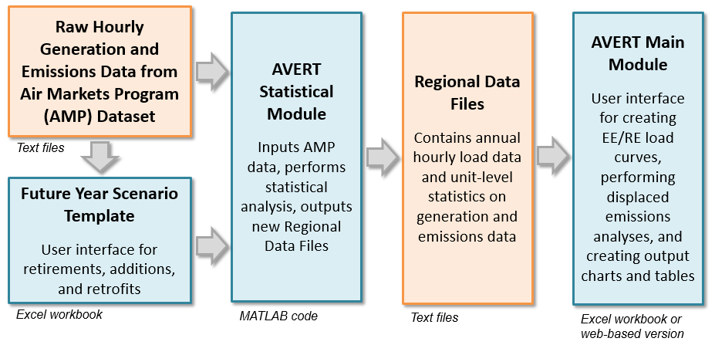
Figure 2. COBRA Inputs and Outputs
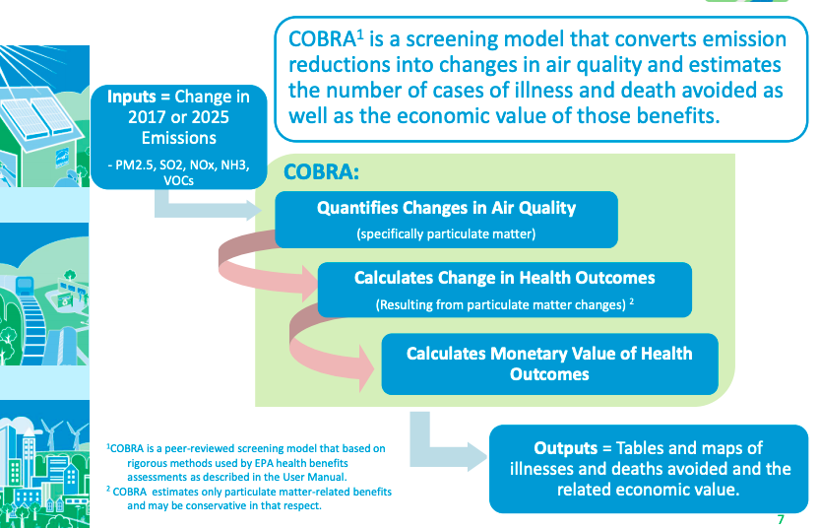

COBRA estimates the number of health incidents avoided and the related economic value for the following conditions:

- Infant and Adult Mortality
- Non-fatal Heart Attacks
- Hospital Admissions related to Respiratory and Cardiovascular Conditions
- Acute Bronchitis
- Upper and Lower Respiratory Symptoms,
- Asthma Exacerbations (attacks, shortness of breath, & wheezing
- Asthma Emergency Room visits
- Minor Restricted Activity Days
- Work Loss Days
Note, these estimates are calculated separately as Societal NEIs, so they are benefits that accrue in addition to the Participant NEIs associated with ComEd’s income eligible programs.

Since 2016, Wisconsin utilities have used the societal NEI results from AVERT in their cost-effectiveness tests by including the monetized emissions reductions in the TRC tests as shown in Table 2.

Table 2. Monetized Societal NEIs from AVERT used in Wisconsin Utilities’ Cost-effectiveness Tests
Program Year | Residential Programs’ Societal NEIs | Non-Residential Programs’ Societal NEIs | Total:
CY2015 Emissions Benefits | $25,235,521 | $85,344,610 | $110,581,131
CY2016 Emissions Benefits | $33, 448, 073 | $70,655, 200 | $104,103,273
CY2017 Emissions Benefits | $27,784,615 | $72,107,782 | $99,892,397
Source: Focus on Energy CY2016 Program Evaluation Appendix from portfolio-level modeling within AVERT; and Focus on Energy CY2017 Program Evaluation

In addition, Avista Utilities in Idaho and Washington used COBRA in their energy efficiency program planning. Following the protocols set forth by the Northwest Power and Conservation Council’s (NPWCC)’s Northwest Technical Forum (NTF), Avista Utilities used COBRA to monetize the health benefits of reducing wood stove usage. These values were included in Avista Utilities’ Biennial Conservation Plan presented to the Washington Utilities and Transportation Commission.
Table 3 summarizes these values.

Table 3. Monetized Societal NEIs from COBRA used in Idaho and Washington Utilities’ Plans
Societal NEI | Idaho and Washington
Reduced PM_{2.5}
Low Estimate  High Estimate | $0.02/kWh  $0.24/kWh
Sources: Abt Associates 2018, Human Health Benefits of Reducing Residential Wood Smoke Emissions in Avista Corporation’s Service Territory – Final Report.” and DeYoung 2017, ACEEE Energy Efficiency

Utility NEIs
The utility NEIs include benefits associated with the reduced arrearages, utility disconnection notices and actual disconnects and reconnects as well as reduced participation in programs such as ComEd CARES (i.e., alternative payment plans and bill forgiveness).

Three states quantified and monetized utility NEIs and used these values in their cost-effectiveness tests, as shown in Table 4. Maryland monetized reduced customer arrearages for income eligible customers. Massachusetts developed a robust set of monetized utility NEIs by conducting primary research with income eligible program participants. Rhode Island modified values from its statewide TRM and established monetized values for utility NEIs associated with reduced arrearages, disconnections and reconnections for their income eligible programs. These values are reported in the state’s TRM and included in Rhode Island’s state-specific cost-benefit test.

Table 4. Examples of Monetized Utility NEIs Used in Cost-Effectiveness Tests – Per Household
Utility NEI Type | Maryland | Massachusetts | Rhode Island | Average
Financial and Accounting | $2.55-$25.00 | 2.61-$39.90 | $2.62-$3.74 | $13.00
Carrying Costs on Arrearages |  | $1.50-$4.00 |  | $2.50
Reduced income eligible participation in alternative payment programs |  | $3.00-$25.00 |  | $13.00
Disconnections/reconnections |  | $0.10-$3.65 |  | $0.65
Notices |  | $0.05-$1.50 |  | $0.60
Customer calls/collections |  | $0.40-$1.50 |  | $0.90
Sources: Malone et al, 2019; NEEP 2017.

Participant NEIs
Participant NEIs include reduced medical costs associated with reduced asthma symptoms and thermal stress as well as reduced missed days of work. The U.S. Department of Energy’s (DOE) conducted a national assessment of the participant NEIs associated with its Weatherization Assistance Program (WAP). The DOE WAP assessment included a comprehensive participant survey which participants completed before participation and one year following participation. Three states—Maryland, Massachusetts and Rhode Island—used the same methodology to conduct participant NEI studies which quantified and monetized values used in cost-effectiveness tests. Table 5 shows the participant NEI values per household.

- Maryland conducted primary research to monetize participant NEIs, which were subsequently approved by the Maryland Public Service Commission. The Investor-Owned Utilities in Maryland also include monetized participant benefits of $30 per year for insulation and duct sealing associated with the Home Performance with ENERGY STAR Program.
- Massachusetts conducted primary research to determine the participant NEIs associated with income eligible programs including reduced effects of asthma, cold- and heat-related thermal stress, missed days of work, deaths, and fire damage. These monetized values are provided in the statewide TRM. Massachusetts utilities include these monetized values in their programs’ TRC tests.
- Rhode Island monetized specific health benefits such as fewer colds and viruses, improved indoor air quality and ease of maintaining healthy relative humidity from weatherization. These monetized values are provided in the statewide TRM. Rhode Island includes these values in its state specific cost-benefit test

Table 5. Examples of Monetized Participant Health NEIs- Per Household
Participant NEI type | Maryland | Massachusetts | Rhode Island | Average
Comfort | $26.00-$105.00 | $31.00-$125.00 | $1.42-$125.00 | $69.00
Health & Safety | $3.02-$100.50 | $4.00-$45.00 | $0.13-$45.00 | $33.00
Reduced missed days of work |  | $149.45
Sources: Three³ and NMR Group 2018; Malone et al 2019; NEEP 2017.

Recommendations
Based on our review of the current practices that other states use to include monetized NEIs in cost-effectiveness tests, we submit the following recommendations for ComEd’s and SAG’s consideration:

Recommendation #1: Include monetized Societal NEIs results from a COBRA analysis in ComEd portfolio programs’ TRC tests.

Recommendation #2: Include monetized Utility NEIs associated with ComEd’s Income Eligible Multifamily – Retrofit program and Single-Family – Retrofit program in these programs’ TRC tests.

Recommendation #3: When availability and if statistically significant, include the monetized Participant NEIs associated with ComEd’s Income Eligible Multifamily – Retrofit program and Single-Family – Retrofit program in these programs’ TRC tests.

FEJA (Illinois Future Energy Jobs Act). Public Act 099-0906. www.ilga.gov/legislation/publicacts/99/PDF/099-0906.pdf. (passed December 7, 2016).
IL SAG. Illinois Statewide Technical Reference Manual for Energy Efficiency, Version 8.0. Illinois Commerce Commission. Springfield: IL. s3.amazonaws.com/ilsag/2020_IL-TRM_Version_8.0_dated_October-17-2019_Final_Volumes_1-4_Compiled.pdf.
EIA (Energy Information Administration). 2020. Annual Energy Outlook 2020. Washington, DC: EIA. www.eia.gov/pressroom/presentations/sieminski_12162013.pdf.
ComEd. 2017. Commonwealth Edison Company’s 2018-2021 Energy Efficiency and Demand Response Plan. Docket No. 17-0312, June 30. Springfield, IL: Illinois Commerce Commission (ICC). www.icc.illinois.gov/docket/files.aspx?no=17-0312&docId=254601.
IL SAG (Illinois Stakeholder Advisory Group). 2016. Documentation of TAC Review of Non-Energy Benefits - Memorandum to Technical Advisory Committee. Springfield, IL: s3.amazonaws.com/ilsag/IL-TAC_Documentation-of-TAC-Review-of-Non-Energy-Benefits_Memo_02-09-2016.pdf.
https://www.bls.gov/regions/midwest/news-release/occupationalemploymentandwages_chicago.htm Accessed April 30, 2020.
https://www.ncbi.nlm.nih.gov/pmc/articles/PMC5627640/ Accessed April 30, 2020.
Database of State Efficiency Screening Practices (DSESP), 2020. “National Energy Efficiency Screening Project, https://nationalefficiencyscreening.org/ Accessed: April 4, 2020.
https://www.epa.gov/sites/production/files/2019-05/documents/avert_overview_and_training_05-20-19_508.pdf. Accessed: April 30, 2020.
https://www.epa.gov/statelocalenergy/how-cobra-works. Accessed: April 30, 2020.
https://www.epa.gov/statelocalenergy/avert-tutorial-how-avert-works Accessed: April 30, 2020.
DeYoung, R. 2017. “Public Health Benefits of Energy Efficiency Programs,” ACEEE National Conference as Energy Efficiency as a Resource, on behalf of the Environmental Protection Agency; (https://www.aceee.org/sites/default/files/pdf/conferences/eer/2017/DeYoung_Session2D_EER17_Oct_31.pdf)
https://www.focusonenergy.com/sites/default/files/Wisconsin Focus on Energy CY 2016 Appendices.pdf and https://www.focusonenergy.com/sites/default/files/WI%20FOE%202015%20to%202016%20Econ%20Impact%20Report-%20Final.pdf
Abt Associates 2018, Human Health Benefits of Reducing Residential Wood Smoke Emissions in Avista Corporation’s Service Territory – Final Report.” and DeYoung 2017, ACEEE Energy Efficiency
DeYoung, R. 2017.
Avista Utilities 2017, “Public Comments in Docket UE-171091 (Avista Utilities proposal for Achievable Conservation Potential and the 2018-2019 Biennial Conservation Plan), November 28. https://www.utc.wa.gov/Pages/Default.aspx
Northeast Energy Efficiency Partnership (NEEP), 2017. “Non-Energy Impacts Approaches and Values: an Examination of the Northeast, Mid-Atlantic, and Beyond”. https://neep.org/sites/default/files/resources/NEI%20Final%20Report%20for%20NH%20updated%2010.4.17.pdf
Malone, E. Woolf, T, & Letendre, S. 2019. “New Hampshire Cost-Effectiveness Review: Application of the National Standard Practice Manual to New Hampshire,” New Hampshire Evaluation, Measurement & Verification (EM&V) Working Group. October 14.
DSESP 2020. Accessed: April 24, 2020.
Three³ and NMR Group, 2018. “Low-Income Multifamily Health- and Safety-Related NEIs Study (TXC 50) Preliminary Findings Report Final Preliminary Findings Report.” Massachusetts Program Administrators October 15.
DSESP, 2020. Accessed: April 26, 2020.
Oak Ridge National Laboratory 2014., “Weatherization Works- Summary of Findings from the Retrospective Evaluation of the Department of Energy’s Weatherization Assistance Program, Managed by UT-Battelle for the US Department of Energy.” (DOE WAP Study 2014) September. https://www.energy.gov/eere/wap/downloads/weatherization-assistance-program-national-evaluation. Accessed: April 24, 2020.
Three³ and NMR Group, 2018.
Malone et al, 2019.
NEEP, 2017.
Ibid.
DSESP, 2020. Accessed: April 26, 2020.
Three³ and NMR Group, 2018.
DSESP, 2020. Accessed: April 26, 2020.
Ibid.

